Submitter Guide to

ODE CTE Data Collections
  - An ODE CTE Data Team Publication

Contents

Table of Contents
1 Contents 1
2 Introduction 3
3 CTE Program Yearly Update 4
4 CTE Spring Collections 25
5 Appendix A: Code Tables 42
6 Appendix B: Resources & Glossary 53

Table of Figures
Figure 1 Central Login Webpage 5
Figure 2 Central Login Applications List 6
Figure 3 CTE IS Home Page within the Application 6
Figure 4 CTE IS Home Page - Main Menu 6
Figure 5 CTE IS Yearly Update Section 7
Figure 6 CTE Program Page 7
Figure 7 CTE Program Page 8
Figure 8 CTE IS Program page - Additional Components of a High-Quality Program of Study 9
Figure 9 CTE IS Program page - Teacher Grid 10
Figure 10 CTE IS Program Page - Teacher Grid Editor 10
Figure 11 CTE Program – Teacher Grid Notes part 1 11
Figure 12 CTE Program – Teacher Grid Notes part 2 12
Figure 13 CTE IS Contacts in the Main Menu 13
Figure 14 CTE IS Contacts Sorting and Editing 13
Figure 15 CTE IS Editing Contact Records 14
Figure 16 CTE IS Program Page - Community College Grid 15
Figure 17 CTE IS Program Page - Community College Grid Additions 15
Figure 18 CTE Program Matrix Form 18
Figure 19 CTE Program Page Save Changes Pop-up Box 18
Figure 20 Matrix Form - Edit Matrix Button 18
Figure 21 Matrix Form – Edit Matrix Verification 19
Figure 22 CTE Program Page – Matrix Completed Field 20
Figure 23 Matrix Form – CTE Program’s Course Sequence 20
Figure 24 Matrix Form – Editing Courses 20
Figure 25 Matrix Form - Add Course 21
Figure 26 Matrix Form - Add Course Fields 21
Figure 27 Matrix Form - Submit to RC 22
Figure 28 CTE Program Submission Complete 22
Figure 29 CTE Program Recall Submission screenshot 23
Figure 30 Important Dates for CTE Spring Collections 25
Figure 32 Links section of CTE Spring Collections Page 26

Table of Tables
Table 1 Fall Collection Due Dates and Associated Workflow Statuses for Yearly Update 24-25. 4
Table 2 Snip of Institution Fields from CTE Student Data Map 28
Table 3 CTE Twist on Attending School 28
Table 4 Example CTE Sites / Institutions 29
Table 5 Snip of Institution Fields from CTE Student Data Map 37
Table 6 CTE Twist on Attending School 38
Table 7 Example CTE Sites / Institutions 39
Table 8 CIP Codes Mapped to Program Name, CLA code, and Trad code. 42
Table 9 CTECrsGrdCd Lookup Table for Course 24-25 44
Table 10 CTSO Codes for CTE Student 24-25 45
Table 11 CTE IRC Portfolio Lookup Table for CTE Student 24-25 46
Table 12 CTE WBL Type Code Lookup for CTE Student 24-25 51
Table 13 WBL Hours Code Lookup for CTE Student 24-25 52
Table 14 CTE Year End Status Code Look-up Table 52

Introduction
Audience
- CTE Data Managers
- CTE Data Submitters
- CTE Local Admin
- CTE Regional Coordinators
- Perkins Grant Managers for Direct-Recipient School Districts
Scope
This document covers data submission only. For other CTE data information, please the the appropriate ODE District Site page(s):
CTE System Home Page
CTE Spring Collections Home Page
Perkins CTE 90% Report Validation Home Page

CTE Program Yearly Update
The CTE Program Yearly Update is an annual collection that takes place each fall for state approved CTE programs to review and update program offerings on record with ODE. Program offerings that should be updated at this time include CTE courses and supporting details on the components that make each CTE program high quality. This collection is completed through the CTE Information System.
All state approved CTE programs of study must participate in the yearly update, whether program changes are necessary or not. CTE Programs of Study reported to ODE as dormant do not have to complete a yearly update. If a decision is made for a CTE program to enter dormancy, ODE must be notified using the Dormant CTE Program Notification. This is a critical step in reporting the CTE courses that will be offered across the state and is used as the foundation for CTE student participation data submission in the state. Failure to provide updated program and course information during the Program Yearly Update may lead to difficulties with CTE data submission inaccuracies during the Spring CTE Student and Course Collections and could impact accountability and funding systems.
District Site Application Page: The CTE Information System Application Home
Table 1 Fall Collection Due Dates and Associated Workflow Statuses for Yearly Update 24-25.
Key Date | CTE Information System Operations
08/28/2025 | CTE Program Yearly Update Opens (ALL updates must be completed during the fall update for the current school year)  All active, approved CTE programs and newly approved 23-24 applications move to ‘Waiting for Updates’ status for the 24-25 school year.
10/31/2025 | All approved CTE programs are reviewed by the school level CTE IS users (Lead Teachers/ Local Admin) with the appropriate CTE Regional Coordinator. All updates are complete, and every program has moved to the next status, ‘Submitted to RC’.
12/05/2025 | All approved CTE programs are reviewed by the Regional Coordinators (if necessary, with the appropriate ODE Content Specialists). All updates are complete, and every program has moved to the next status, ‘Submitted to ODE’.
01/09/2025 | All CTE program updates are reviewed by ODE’s Content Specialists (if necessary, with the appropriate CTE Regional Coordinator). All updates are complete, and every program is in the ‘Accepted’ status.  CTE Program Yearly Update Closes

How-to Access the CTE IS

Yearly Update
How-to access the CTE Program Yearly Update Collection.
- Login to your account through the Central Login on the ODE District Site.
  - If you do not have a Password or cannot log in, please contact your District Security Administrator.
  - If you do not know the District Security Administrator, please contact the district office, or click on “Locate your District Security Administrator” on the login page.
Figure 1 Central Login Webpage
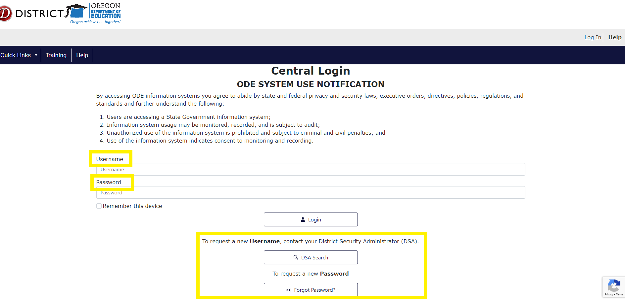
- Click / select the “CTE Information System – [your institution name]” on your Central Login Applications list.
  - School level users must select the “CTE Information System – [High School]” option. If the only option is “CTE Information System – [School District]”, contact your District Security Administrator and ask for them to correct the permissions that were set up.
  - Regional Coordinators should select the “CTE Information System – [ESD]” option.
Figure 2 Central Login Applications List
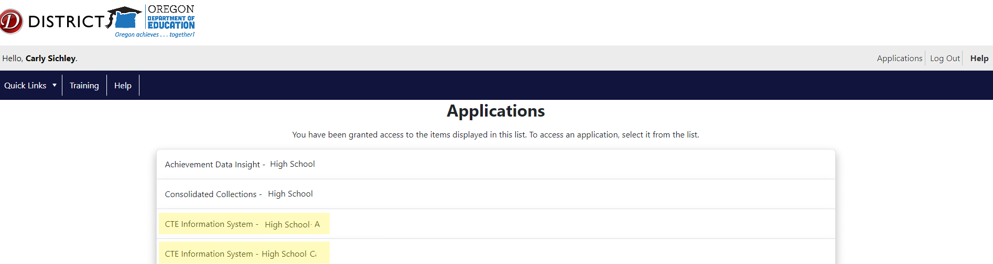
- Verify that you are logged into the correct institution in the blue header bar of the CTE IS Home Page. Text reads: [Your Name [Selected Institution] (Institution ID [X]).” Every time you log into the CTE IS application, you’ll be directed to the Home Page.
Figure 3 CTE IS Home Page within the Application
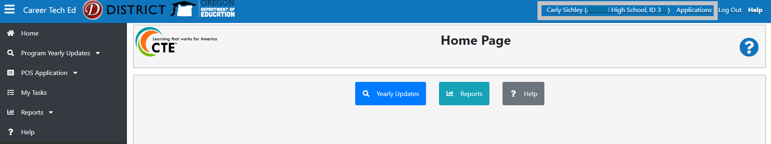
- From the CTE IS Home Page, select the relevant user option on the vertical, black menu bar on the left side of the screen.
Figure 4 CTE IS Home Page - Main Menu
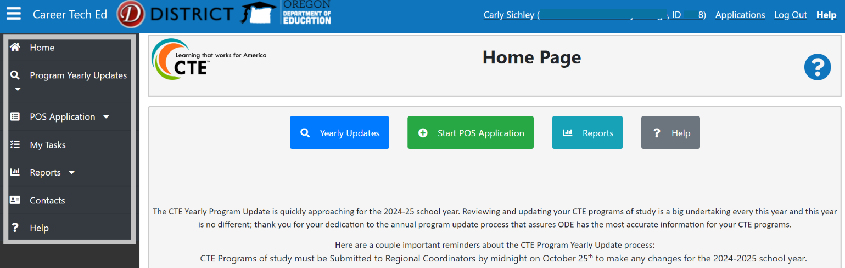

How-to View CTE Programs
- Select “Program Yearly Updates>Yearly Updates” in the black bar menu to view the CTE programs approved at the institution listed in the blue bar at the top of your CTE IS screen.
  - On the Yearly Updates page, approved CTE programs are listed in a grid. At the top of the grid there are seven (7) status tabs.
- Click the status tabs at the top of the Yearly Updates grid to find the correct CTE program.
- Click View to open and review a specific CTE program.
  - Right click the View button to open the CTE program in a new browser tab to retain any filtering or sorting of the programs in “My Tasks”.
Figure 5 CTE IS Yearly Update Section
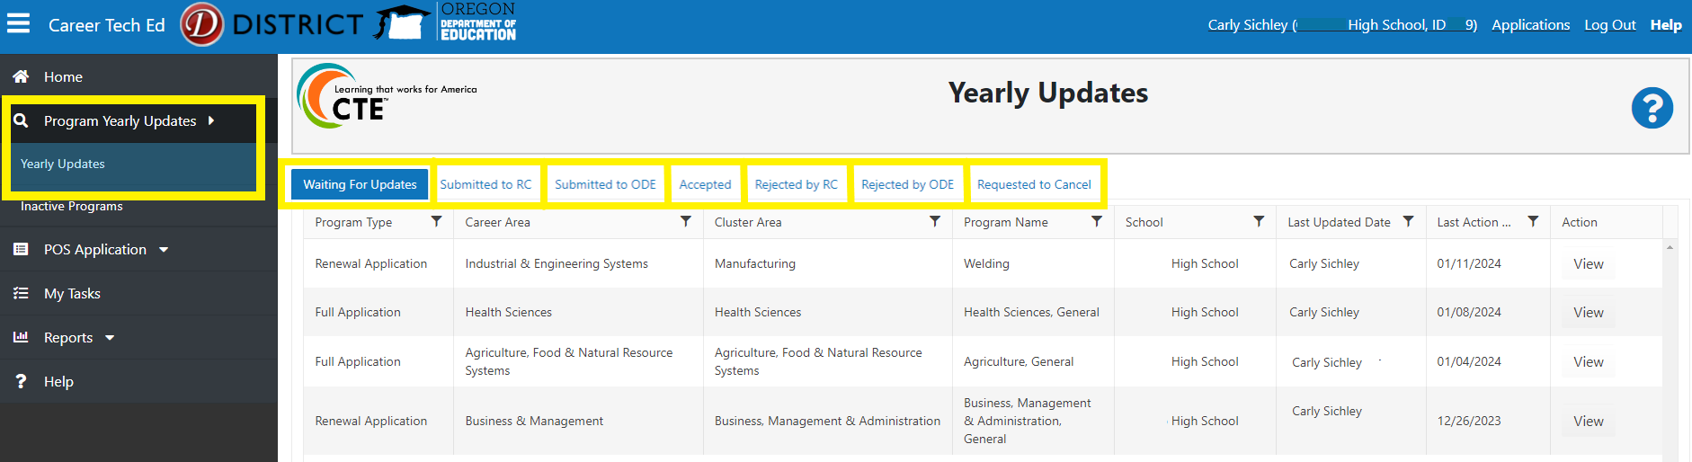

Yearly Update Tasks
- Select “My Tasks” in the black bar menu to locate the CTE programs awaiting your review specifically for the institution listed in the blue bar at the top of your CTE IS screen.
    - On the “My Tasks” page there are two tabs at the top of a program grid. Make sure you’re viewing the Yearly Update Tasks tab.
    - If there are no CTE programs listed in the grid of My Tasks and you’ve verified you’re logged in the CTE IS as the High School, select to “Program Yearly Updates>Yearly Updates” in the main menu and look at each of the status tabs to locate what status the CTE program is currently in.
Figure 6 CTE Program Page
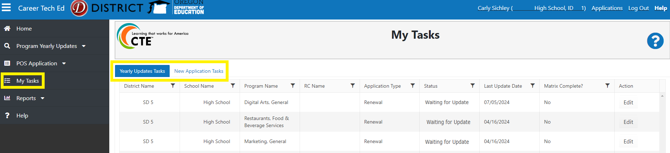
- Click edit to open the CTE program for editing. Right click the Edit button to open the CTE program in a new browser tab to retain any filtering or sorting of the programs in “My Tasks”
- Select the program; CTE program page will open, and you’ll begin your review for the CTE Programs Yearly Update.
- Certain fields on the CTE program page are grayed out because they cannot be edited as part of the Program Yearly Update. This information was provided as part of the CTE program’s application and remains static until a renewal application is submitted.
Figure 7 CTE Program Page
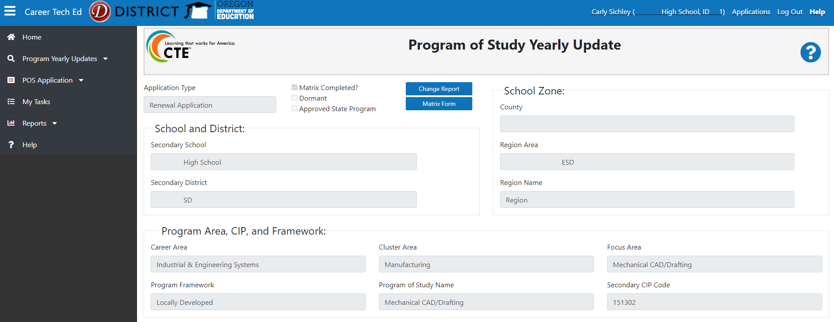
The CTE program has four (4) sections that must be reviewed and updated as needed for the current school year to complete each user’s part in the Program Yearly Update collection
- Additional Components of a High-Quality Program of Study
- Teacher Grid
- Community College Grid
- Matrix Form

Update Additional Components of a High-Quality Program of Study
The Additional Components of a High-Quality Program of Study section is where an approved CTE program’s offerings are provided for Work-based Learning, Student Leadership Opportunity, and Industry Recognized Credentials. The four application fields (Work-Based Learning, Student Leadership Opportunity, Secondary Industry Recognized Credentials, and CC Industry Recognized Credentials) in this section can be filled out by either a School Level User or RC. School Level Users can edit the section until the CTE program has been submitted to the RC and RCs can edit the section until they’ve submitted the CTE program to ODE.
Figure 8 CTE IS Program page - Additional Components of a High-Quality Program of Study
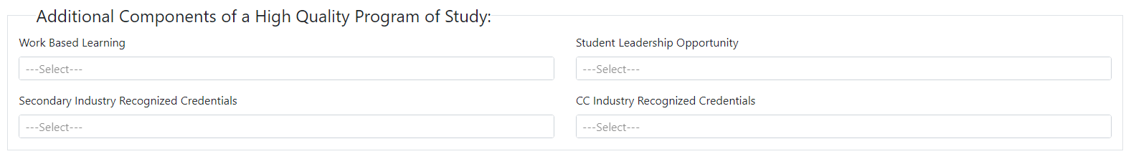
Click in the Work Based Learning, Student Leadership Opportunity, Secondary or CC Industry Recognized Credentials boxes to see a drop-down list of associated options. Each of these fields allow multiple selections so programs should select all that apply.
Work-based Learning is a critical bridge that connects the classroom to the world of work and helps learners make informed decisions about their educational and career goals. Select each work-based learning opportunity from the drop-down offered to students participating in the CTE program.
Student leadership opportunities are a required element of CTE Programs of Study. Select the Career and Technical Skills Organization or “Locally Developed Student Leadership” option from the drop down that is associated with the CTE Program. CTE Programs that select “Locally Developed Student Leadership” need to describe how the student leadership opportunities offered are meeting the Criteria for Developing Student Leadership in the Student Supports Service comment box.
Industry Recognized Credentials, licenses, and certifications offered as part of a CTE program are intended to equip learners with tools that will help them navigate post-secondary education and training as well as entry into career. CTE teachers should collaborate with their CTE Regional Coordinator, community college partner, and partners in industry to select and implement credentials that offer the highest value for learners in terms of advancement for future education, training, and career prospects. Select each Industry Recognized Credentials from the drop-down offered to students participating in the CTE program. Details for each CTE IRC is available in the CTE Industry Recognized Credentials Guide or in the CTE Data Management Guide that is available on the CTE System Home Page and the CTE Spring Collections Home Page, and the Perkins CTE 90% Report Validation Home Page.

Update Teacher Grid
CTE program contacts are added to the program using the Teacher Grid. School level users can review the teacher grid to ensure the contacts listed are current; however, only the CTE Regional Coordinator role can add or edit the Teacher Grid of a CTE program.
The Teacher Grid has three contact types: Lead Teacher, Additional Teacher, and Local Administrator. Every CTE POS is required to have a Lead Teacher entered onto the Teacher Grid but adding Additional Teacher and Local Admin contacts is optional. Lead Teacher contacts are required in a full Program of Study’s Teacher Grid, the new Lead Teacher must be added before the previous Lead Teacher can be removed.
Figure 9 CTE IS Program page - Teacher Grid
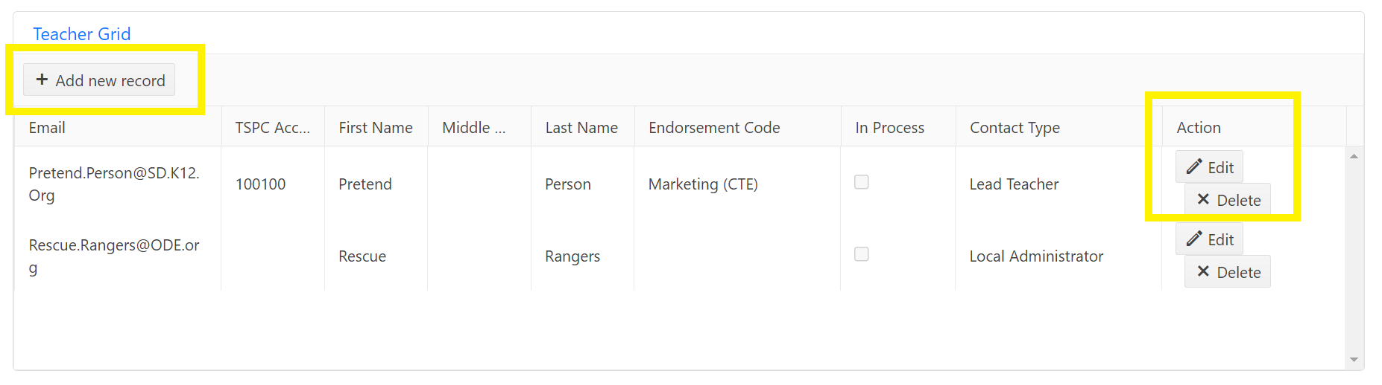
- Click the add new record button. A pop-up box titled Teacher Editor will appear on the screen.
- Input the contacts email first.
  - If the email matches with any existing contact records in the CTE IS, the TSPC Account, First Name and Last Name fields will populate based to match the existing information.
Figure 10 CTE IS Program Page - Teacher Grid Editor
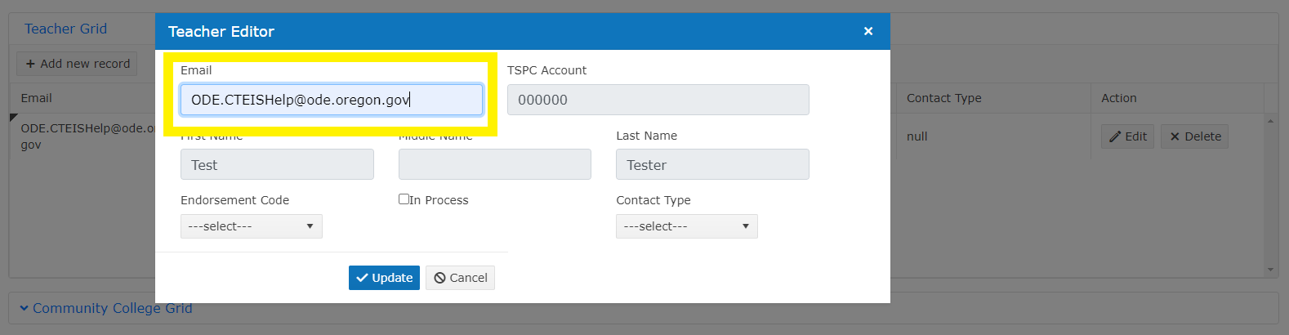
- Input the TSPC Account number for Lead Teacher and Additional Teacher contacts. Local Admin contacts do not need to have a TSPC Account number entered.
- Input the First Name and Last Name of the program contact.
- Select the Endorsement Type for Lead Teacher and any Additional Teacher contacts in the drop down. Local Admin contacts do not need to have an Endorsement Type entered.
- Check the In Process box if Endorsement Type being added for the contact is currently in process with either ODE or TSPC.
- Select the Contact Type (Lead Teacher, Additional Teacher, Local Admin) for the program contact being entered into the Teacher Grid.
- Click the Update button to save the program contact information.
Contacts added to a CTE program’s Teacher Grid receive an email notification with a brief explanation that they’ve been added to a CTE program as a Lead Teacher or Local Admin and how to access the program information in the CTE IS.
When any contact is added to the Teacher Grid who does not already have CTE IS permissions granted by their DSA, a yellow message populates above the Teacher Grid on the CTE program page, informing CTE program viewers that the newly added contact does not have CTE IS access.
Figure 11 CTE Program – Teacher Grid Notes part 1
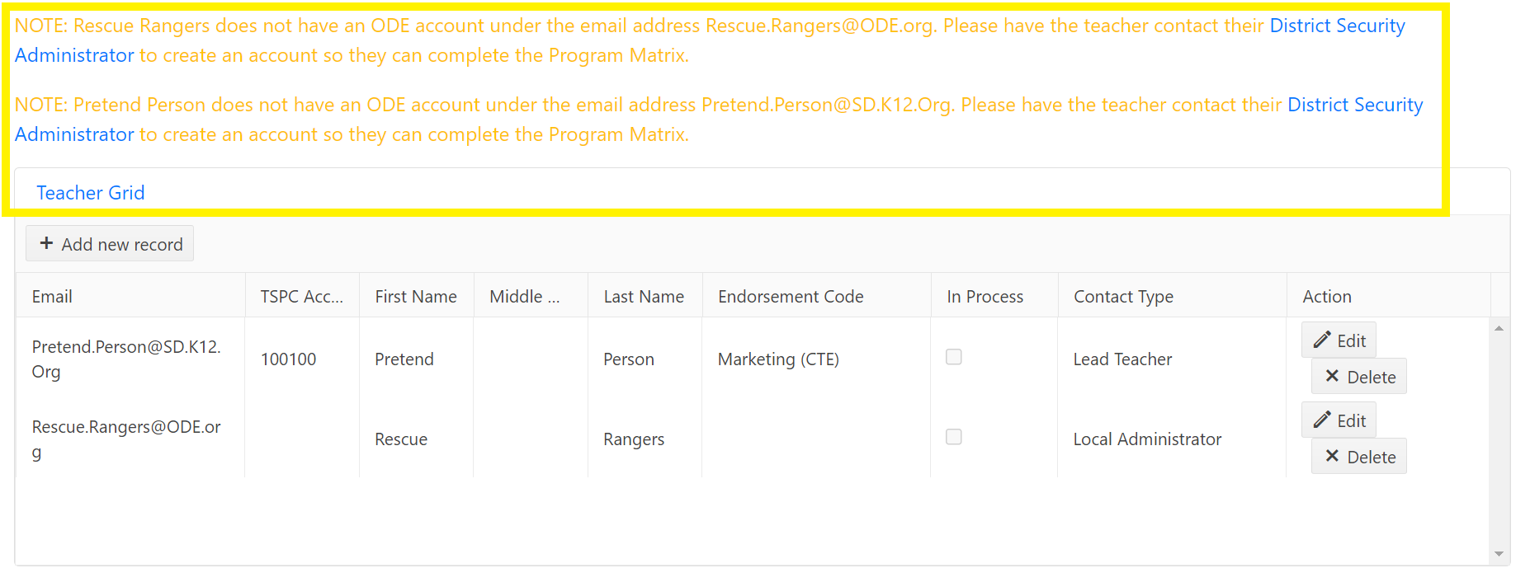
When a Lead Teacher contact is added to the Teacher Grid with an Endorsement Code not aligned with the CTE Focus Area, a red warning message populates above the Teacher Grid on the CTE program page. The warning message will not prohibit the CTE program to complete the CTE Program Update process or have a negative impact on the CTE program data. This message is meant to inform the ODE Content Specialist in case a conversation is needed.
Figure 12 CTE Program – Teacher Grid Notes part 2
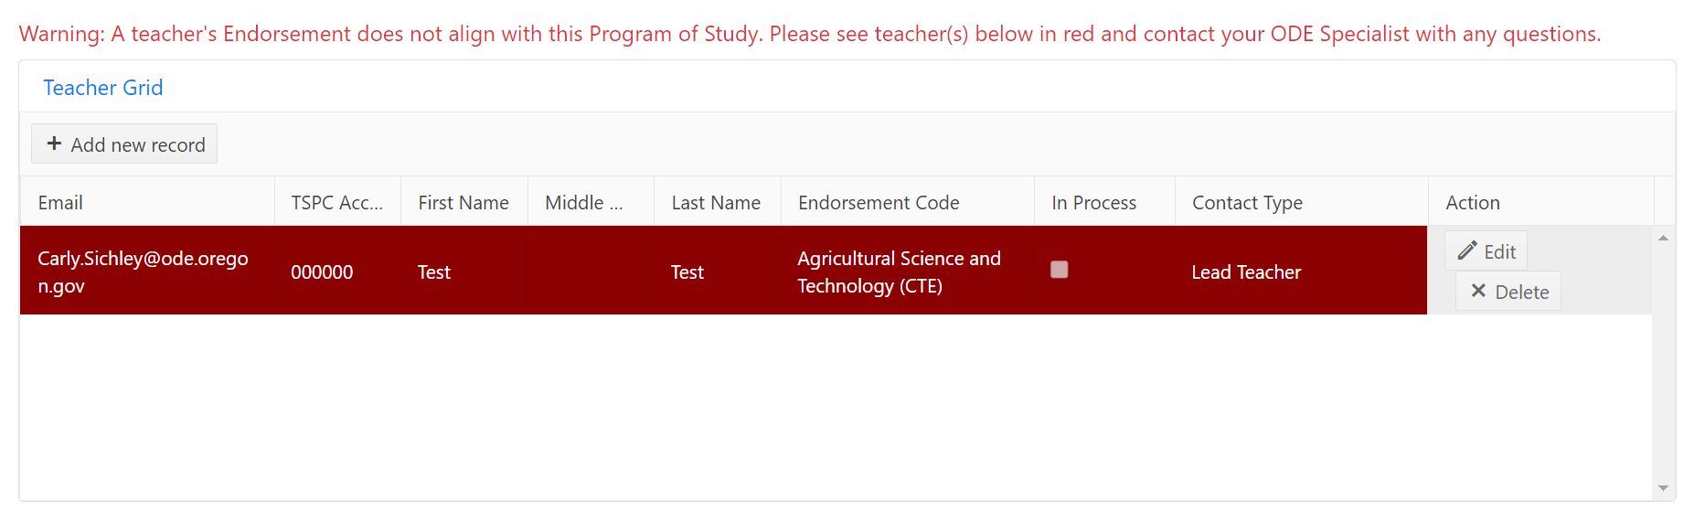

Update Contact Details
When program contact records have inaccurate information, RCs need to update the details instead of creating a new contact record. Contacts listed in the Teacher Grid can have their endorsement code and Contact Type edited in the Teacher Grid; however, editing the email, TSPC account number, and name must happen in the “Contacts” section of the Main Menu in the black bar on the left side of the CTE IS screen. Updating contact records in Contacts ensures that every CTE program with the contact listed in the Teacher Grid gets updated with the new information and decreases duplicate contact entries in the CTE IS.
- Click Contacts in the main menu of the CTE IS.
Figure 13 CTE IS Contacts in the Main Menu
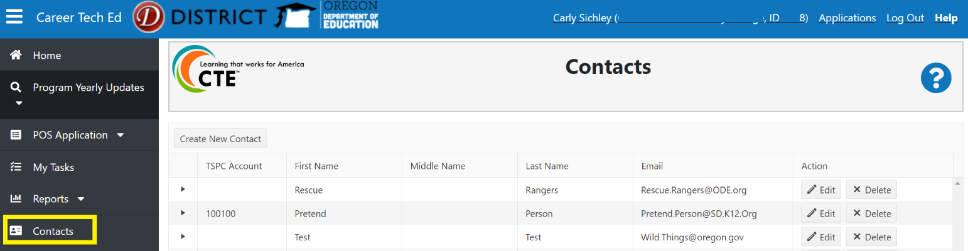
- Click the filter button in the title columns to search for a specific contact or to sort the contacts alphabetically. Search the complete Contacts grid using the numbers at the bottom of the page until the desired contact is located.
- Click the arrow on the right side of the row to expand the contact record and see each instance where the individual is listed as a contact for a CTE program.
- Click Edit to enable editing abilities.
Figure 14 CTE IS Contacts Sorting and Editing
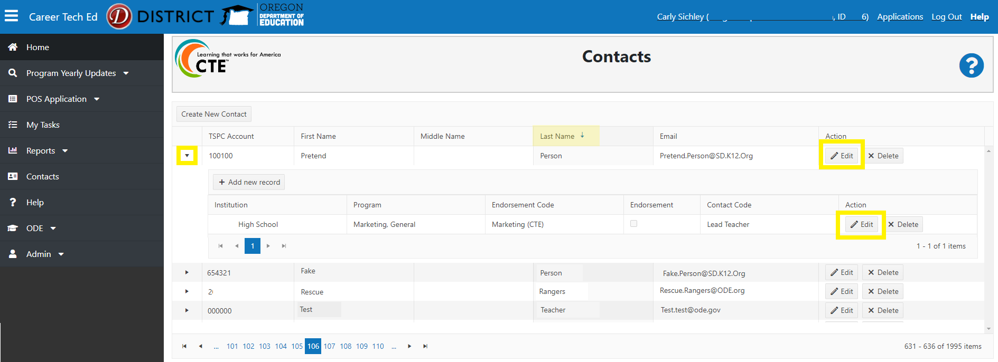
- Click Update after edits have been made to save the changes.
Figure 15 CTE IS Editing Contact Records
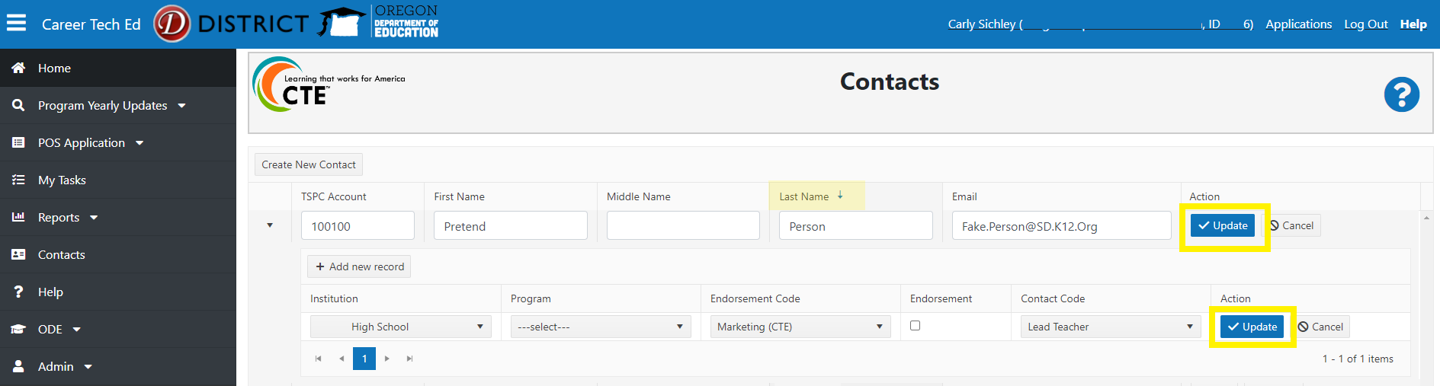
After the contact’s information (Name, TSPC Account number, and Email) is updated, the changes will reflect in the Teacher Grid of each program where the contact is listed.

Update Community College Grid
Alignment between secondary and postsecondary programs is a required element of any state approved CTE Program of Study. The Community College Grid is where secondary programs indicate which postsecondary program(s) they have aligned with. Every POS is required to include the aligning postsecondary program information in the Community College Grid before it can be submitted to ODE and complete the Program Yearly Update.
School level users can view a program’s Community College Grid to ensure the CC program(s) listed are current but only the CTE Regional Coordinator role can update the Community College Grid.
- Click Community College Grid to expand the Community College Grid and view aligning postsecondary program information.
- If the CC program listed in the Community College Grid is the correct aligning postsecondary program, no further steps are needed.
Figure 16 CTE IS Program Page - Community College Grid
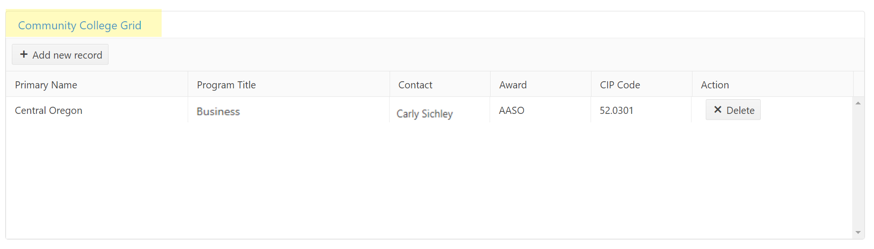
- Click the Add new record button to add new and/or additional CC programs to the Community College Grid.
Figure 17 CTE IS Program Page - Community College Grid Additions
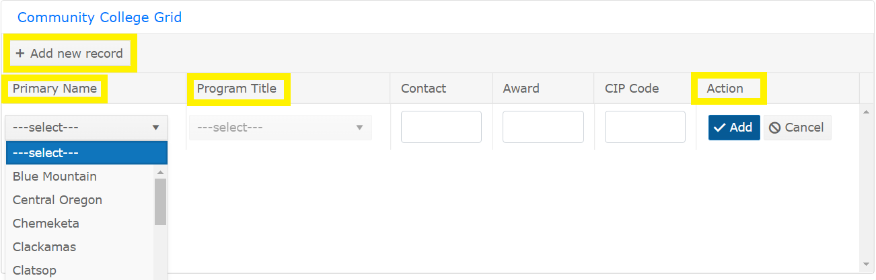
- Select the aligning CC name in the Primary Name drop down. After the CC name is selected, the Program Title field is enabled.
- Select the aligning CC program title in the Program Title drop down. The Contact, Award and CIP Code fields will populate based on the selected CC Program Title.
- Click the Add button to save the aligning postsecondary program information.
- Click Delete on any CC programs listed in the Community College Grid that is no longer aligned with the secondary program.
- Repeat steps 28 through 33 until the Community College Grid accurately displays all the current aligning postsecondary program information for the secondary program.
The Community College program offerings available in the Community College Grid are provided to ODE by a HECC/CCWD report.
For information about specific CC programs available or missing in the Program Title field of the CC Grid, contact Kasena.Dailey@hecc.oregon.gov.

Update the Matrix Form
A CTE program’s matrix is where most of the review is needed for the Program Yearly Update. Detailed review of a program’s Matrix Form during the Program Yearly Update every year by both school level users and RCs ensures an accurate listing of approved CTE courses.
A program’s CTE courses added to the Matrix Form serve as validation for all CTE course records submitted to ODE during the CTE Course collection completed by secondary schools each spring. An inaccurate Program Yearly Update will interfere with the affected program’s ability to submit submission errors to the spring CTE Collections, causing long term effects to the accumulation of CTE program data.
All CTE IS users with access to a CTE program can view the Matrix Form, but the matrix must be completed by a School Level User. Start-up programs require only one course entry on the matrix form while a full POS requires three (3) nonduplicative credits worth of courses. A completed Matrix Form is required for every CTE program prior to submission.
Having the CTE course details for each CTE program from the Student Information System readily available will make completing the matrix form much simpler for the school level user. Each Matrix Form has a download option that will download all the program’s course details from the matrix to an excel spreadsheet. The downloaded matrix form is a helpful tool for reviewing a CTE program’s existing course information prior to starting your updates, or for comparing the course data in the CTE IS and Student information system.
A programs full course sequence is important to always have available, and a POS needs to have three credits so removing one of those courses could cause a problem if the program only offers three credits total, and we don’t want to run the risk that next year, the course doesn’t get added back to the matrix. So only delete retired courses from the Matrix Form. If your program teaches courses on an alternating or rotating schedule, you don’t have to remove the course from the matrix even if this is its off year.
- Click the Matrix Form button at the top of the program page when you’re ready to review a program’s course information. If the Matrix Completed checkbox is checked, it’s because the matrix was completed when the program or application was last approved.
Figure 18 CTE Program Matrix Form
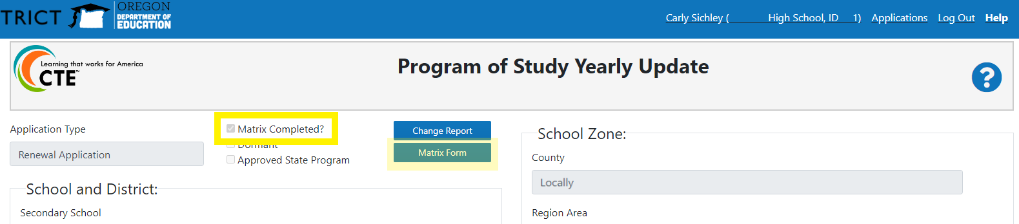
- To ensure changes made to the CTE program page are saved, opening the Matrix Form will prompt users to save changes if needed.
- Select either Save option (Yes, Save Changes or No, Don’t Save) in the dialog pop-up box.
Figure 19 CTE Program Page Save Changes Pop-up Box
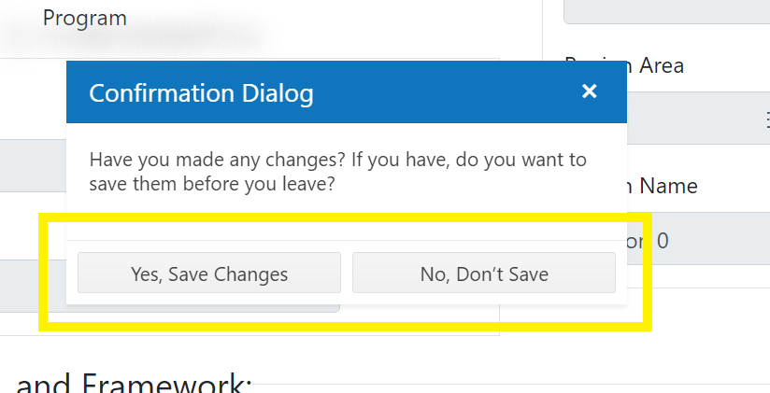
- The CTE Program’s Matrix Form will open in a viewable format for all system users. Only school level users have Matrix Form editing abilities. Once the Matrix Form has been opened for edits, existing courses can be edited or deleted, and new courses can be added. Editing existing courses or deleting existing courses from the matrix form during the 24/25 Program Yearly Update does not impact previous year’s approved CTE course information.
- Click the Edit Matrix button in the top left corner of the Matrix Form.
Figure 20 Matrix Form - Edit Matrix Button
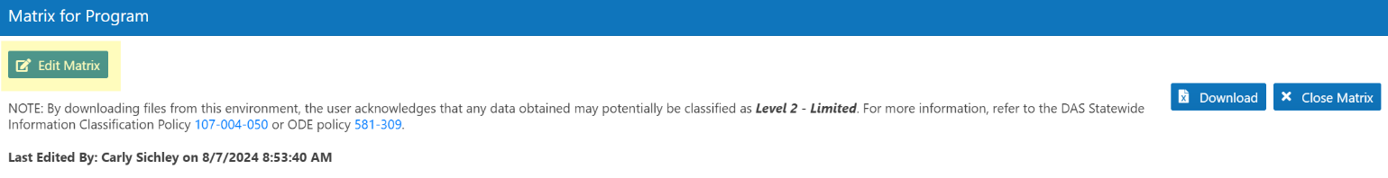
- Select OK in the pop-up box to enable editing and submission functionality.
- Each course added to the matrix form must include the following details
  - Course Number (required): Match the course number assigned in the school's student information system.
  - Course Name (required): Should match the student course handbook.
  - Skill Level (required): Introductory, Intermediate, or Advanced (See the CTE Policy Guidebook, pg. 109, for Skill Level definitions).
  - Credits (required): Credit amount students are awarded if they receive a passing grade in the course.
  - NCES Code (required): Select the code that matches the NCES code assigned in the school’s student information system that best fits the content being taught. See the Course to Endorsement Catalog for questions about NCES codes.
  - Course Description (required): Should reflect what is published for students and the community in public-facing materials like curriculum guides, syllabi and websites. Descriptions should be clear and concise and accurately describe the essential learning students will experience in the CTE course. Content may include such elements as capstone projects, work-based learning experiences and student leadership opportunities.
    - Note: If courses are part of a sequence, differences between introductory, intermediate and advanced levels must be documented.
    - Note: If the course is college credit bearing, that must also be stated. Language directly “copied and pasted” from NCES course code descriptions does not provide information tailored to a specific course in a specific program.
  - College Credit (not a required field): Check this box if a course articulates with a course from the postsecondary institution or is taught in partnership with a postsecondary institution and students may receive credits at both high school and college.
  - Articulated CC Course (optional): Enter the course information at the postsecondary institution that articulates with the secondary course. If the CC Credits box is checked, this field is enabled.
- After clicking ok, the Matrix Completed checkbox on the program page will no longer be checked.
Figure 21 Matrix Form – Edit Matrix Verification
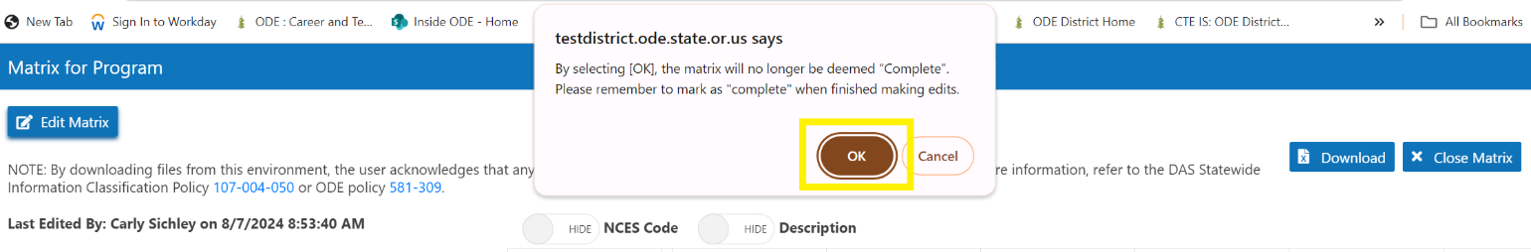
Figure 22 CTE Program Page – Matrix Completed Field
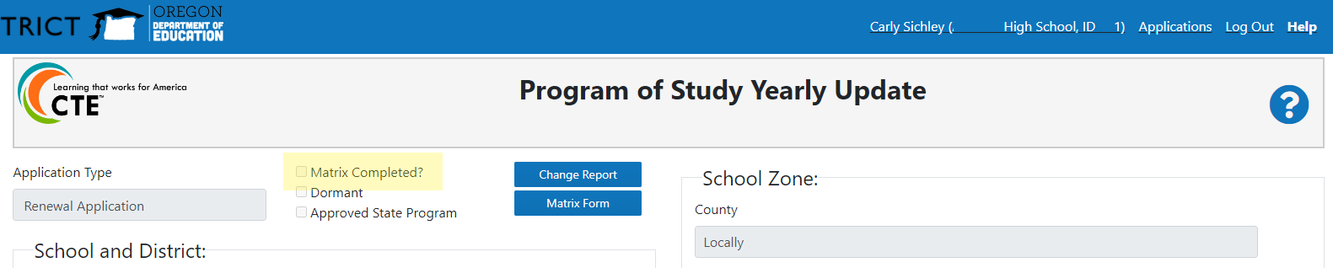
A CTE Program’s existing courses are shown on the Matrix Form by skill level, starting with introductory and moving to Advanced. Each course added to the Matrix Form has eight (8) fields, six (6) of which are required.
- To edit or remove a course, click the Edit or Delete button above the specific course in the Action row near the top of the Matrix Form. The course fields will open for editing at the bottom of the matrix form.
Figure 23 Matrix Form – CTE Program’s Course Sequence
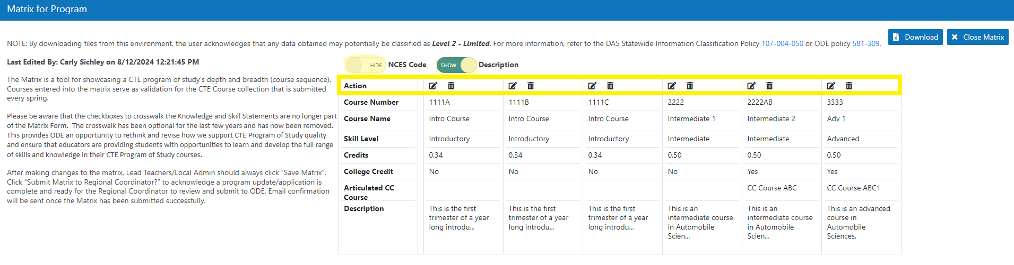
- Edit necessary field(s)
- Click the Update button once the information is entered to save the updated course information.
  - The Cancel button will close the add course fields without saving any entered information.
- Repeat all applicable steps above until all the courses offered within the program of study have been added to the matrix and all ended courses have been removed.
Figure 24 Matrix Form – Editing Courses
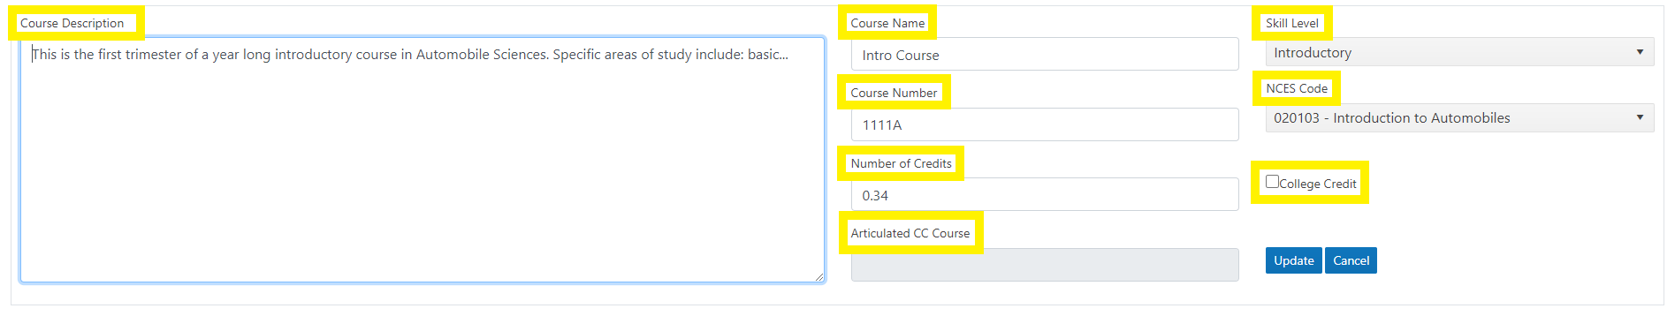
- To add a course, click the Add Course button. The course fields will open at the bottom of the matrix form.
Figure 25 Matrix Form - Add Course
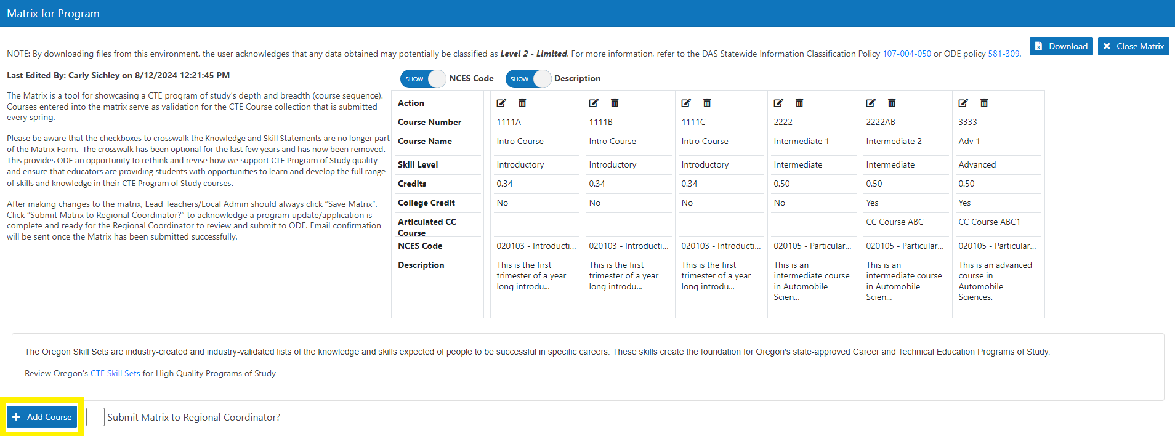
- Add the associated course details to each of the field(s).
Figure 26 Matrix Form - Add Course Fields
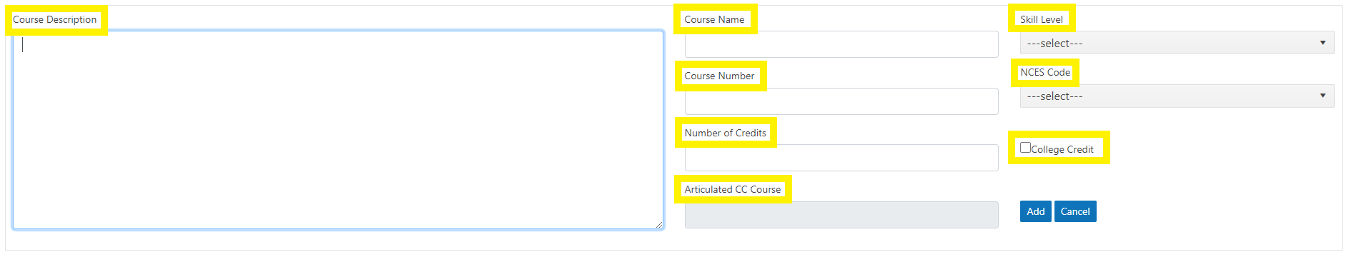
- Click the Add button to save the course details. Alternatively, Click the Cancel button to close the add course fields without saving any entered information.
- Follow steps all applicable steps above until the Matrix Form is up to date with the CTE program’s course listing for the current school year.

Submit the CTE Program Yealy Update
When a School Level User has completed their review and updates, the CTE program must be submitted to the RC.
- Click the Submit Matrix to Regional Coordinator checkbox on the Matrix Form to submit the application to the RC.
Figure 27 Matrix Form - Submit to RC
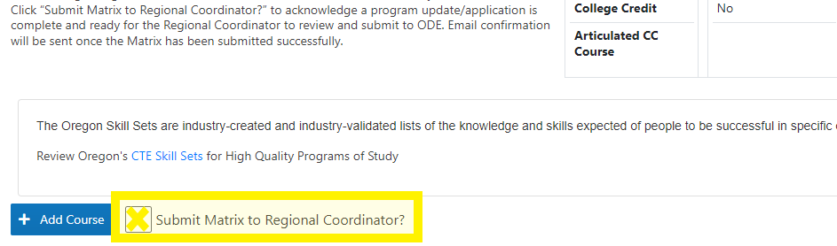
After the CTE program is successfully submitted to the RC, the system will display a green message box beside the Submit Matrix to Regional Coordinator box verifying that the submission is complete.
Figure 28 CTE Program Submission Complete
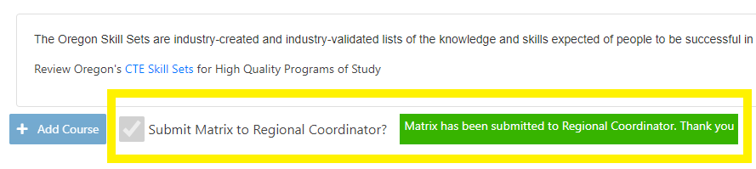
Additionally, when the CTE program is submitted to the RC, a system generated email from ODE Helpdesk with subject line, “School Title, Program Title – Matrix Complete,” is generated and sent to the contacts listed in the CTE program’s Teacher Grid and the RC. The email informs RCs that there is a CTE program awaiting their review and provides School Level Users with a record that they’ve completed the program update for the program unless otherwise notified.
If CTE programs are submitted to RC and then additional updates need to be made, school level users can Recall the program. CTE Programs that have been submitted are still available to School Level Users and can be found by browsing the six (6) status in Program Yearly Updates>Yearly Updates. Once the CTE program is found, the user can open the program and click the Recall Program button found on the Matrix Form then repeat steps 35 through 42.
Figure 29 CTE Program Recall Submission screenshot
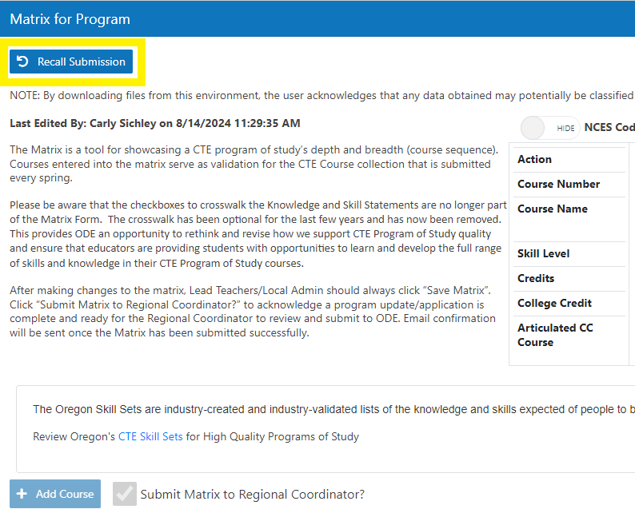

CTE Program Yealy Update Submission Follow-up
Once the School Level User has submitted the CTE program to the RC, the program’s status will change from “Waiting for Updates” to “Submitted to RC” and they will no longer have the program in their Tasks.
Regional Coordinators will see the submitted program in their tasks and have editing access to some fields. At that time, the RC reviews the updates and either “Submits” the program to ODE’s review or “Rejects” the program for additional edits.
Once the Regional Coordinator has submitted the CTE program to ODE, the program's status will change from “Submitted to RC” to “Submitted to ODE” and they will no longer have the program in their Tasks. When the application is submitted, an automatic email from ODE Helpdesk will go out to anyone listed on the teacher grid, as well as the Regional Coordinator and the Education Specialist, with the subject line, “School Title, Program Title – Submitted to ODE”.
CTE Programs that have been submitted are still available to School Level Users and RCs in Program Yearly Updates>Yearly Updates. CTE IS users can browse the six (6) status in Yearly Updates to find a CTE program.
When program updates are accepted by the ODE Content Specialist, an automatic email from ODE Helpdesk will go out to anyone listed on the teacher grid, as well as the Regional Coordinator and the Education Specialist, with the subject line, “School Title, Program Title – CTE Application Approved”. The CTE program will always be available for viewing in the Accepted tab of Program Yearly Updates>Yearly Updates

CTE Spring Collections
The CTE Spring Collections, CTE Student and CTE Course, are submitted through “Consolidated Collections – [your institution name]” on your Central Login Applications list. Submission responsibility is at the CTE Site-level, but many school districts have district-level data managers who submit on behalf of the CTE Sites. Please check with your CTE coordinator and/or local CTE data team regarding the arrangement your institution follows.
Preparation for CTE Spring Collections XX-YY begins as early as August XX and should begin no later than February YY.
The CTE Spring Collections Home Page contains links to the ODE resources for this collection. The Collection page is the primary resource for in-year collection information and submissions. Collection pages display important dates for the relevant collection and house links to documents, historical institution reports, instructions, file templates, and more. Sample screen snips are below.
The Approved CTE Programs Detail Report shows CIP codes and CTE Class Numbers by institution.
The CTE System Home Page (aka CTE IS) is another valuable resource in preparing for CTE Student and CTE Course collections. This is a web interface (like Consolidated Collections). It houses program and course information for each secondary CTE Site (school, learning center, etc. directly providing secondary Perkins CTE programs). Find instructions for accessing the interface in this document’s section Fall Collection, CTE Program Update.
Figure 30 Important Dates for CTE Spring Collections
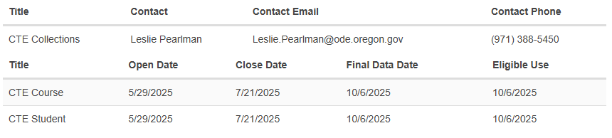

Figure 32 Links Section of CTE Spring Collections Page
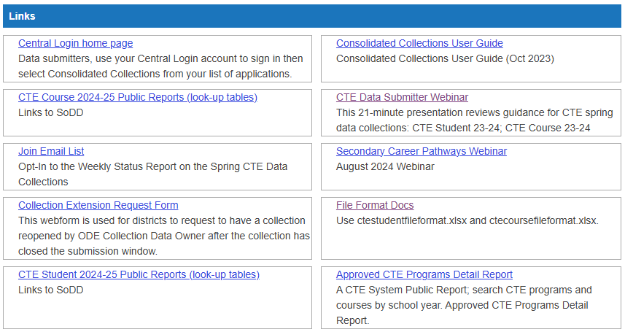

Over-reporting
If there is over-reporting in CTE Program Yearly Update, CTE Student and/or CTE Course, ODE will only process valid records. CTE Data Event guidance and CTE Data Management Best Practices guidance are on the CTE System Home Page, the CTE Spring Collections Home Page, and throughout the ODE District Site. Each CTE Site must ensure that data are tracked effectively and produce accurate representation of each program’s offerings and activity without over-reporting. Ensure:
- Each CTE Local Admin knows the ODE DCC cycles of announcing data changes and local processes on following up on changes are documented.
- Each CTE Local Admin and CTE Lead Teacher is clear on data tracking and reporting requirements for Secondary CTE according to local documentation of processes.
- SIS Report settings are accurate for: CTE Yearly Program Update, CTE Student, and CTE Course

CTE Student
The Spring CTE Collections Home Page hosts information Student Data file basic template and sample regrouped column templates available in the CTE Student Data Submitter Workbook in the documents section.

Students to Include in CTE Student
For all CTE Sites, CTE Student collection requires one (1) row per student in the entire school regardless of whether the student engages with CTE.
Student enrollment data – enter this for all CTE Site students grade 9 and up. There are three categories of students in the CTE Student Data Collection. For each category, different data must be entered into the CTE Student Data collection. They are:

Category 1 Students
Students who attended any class(es) onsite for at least 20 days but did not engage in an approved CTE Program of Study (POS)

Category 2 Students
Students who attended any class(es)for at least 20 days in a CTE start-up or an approved CTE Program of Study but DID NOT participate in any of the following in the collection year.
- participated in a CTE Student Leadership Organization.
- engaged in a CTE WBL (CTE Work-Based Learning) experience.
- Attempted completion of an approved CTE Industry Recognized Credential Portfolio (CTE IRC).

Category 3 Students
Students who attended any class(es) in a CTE start-up or an approved CTE Program of Study AND DID any of the following in the collection year.
- participated in a CTE Student Leadership Organization.
- engaged in a CTE WBL (CTE Work-Based Learning) experience.
- Attempted completion of an approved CTE Industry Recognized Credential Portfolio (CTE IRC).

Data Needed for FULL STUDENT BODY of the CTE Site
The following data are required for all Category 1, Category 2, and Category 3 students.

SSID Data with a CTE Twist
In CTE Collections, the submitting CTE Site uses its own institution ID as the Attending School Institution ID for all students being reported. And use the related District Institution ID as the Attending District.
Even for Category 1, Category 2, and Category 3 students whose SSID master record specifies a separate Attending School, the reporting CTE Site’s ID set must be used for all records.
Table 2 Snip of Institution Fields from CTE Student Data Map
Col | Field Name | Data Element Name | Width | Data Type | Zero Padded | Req
C | ResdDistInstID | Resident District Institution Identifier | 10 | int | Y | Y
D | ResdSchlInstID | Resident School Institution Identifier | 10 | int | Y | Y
E | AttndDistInstID | Attending District Institution Identifier | 10 | int | Y | Y
F | AttndSchlInstID | Attending School Institution Identifier | 10 | int | Y | Y
Table 3 CTE Twist on Attending School
Col | Field Name | Standard Data Element Description | CTE Difference
C | ResdDistInstID | ODE assigned Institution Identifier for the Resident District. The District responsible for the education of the student and also is the basis on which the State School Fund, the Common School Fund, and the County School Fund are distributed to local districts. Special provisions apply as defined in ORS 339.133, 338.155(1), and 338.165. | none
D | ResdSchlInstID | ODE assigned Institution Identifier for the Resident School. The School responsible for the education of the student and also is the basis on which the State School Fund, the Common School Fund, and the County School Fund are distributed to local districts. Special provisions apply as defined in ORS 339.133, 338.155(1), and 338.165. | None
E | AttndDistInstID | ODE assigned Institution Identifier for the Attending District. The District where the student is receiving instruction and where state assessments are administered. | ODE assigned Institution Identifier for the Attending District. The District associated with the Attending CTE Site where the student is a Category 1, Category 2, or Category 3 attendee.
F | AttndSchlInstID | ODE assigned Institution Identifier for the Attending School. The School where the student is receiving instruction and where state assessments are administered. | ODE assigned Institution Identifier for the Attending School. The CTE Site where the student receives any amount of non-CTE or CTE instruction / is a Category 1, Category 2, or Category 3 attendee.
Table 4 Example CTE Sites / Institutions
School District ID | School District Name | School ID | School Name | Offers CTE
x001 | Pretend SD | x104 | Imaginary Middle & High School | N
x001 | Pretend SD | x105 | Pretend High School | Y
x002 | Sample SD 1 | x101 | Artificial High School | N
x002 | Sample SD 1 | x102 | Fake Technical Academy | Y
x002 | Sample SD 1 | x103 | Fantasy Charter School | Y
x002 | Sample SD 1 | x106 | Sample High School | Y

Example 1
Example 1: A student does not enroll in CTE courses; their resident school is a CTE Site (ID = x106); they attend 20 or more days in the school year.
This student is entered in a total of 1 row in CTE Student (by institution x106 or its school district) with the following data in institution fields.
SSID | … | ResdDistInstID | ResdSchlInstID | AttndDistInstID | AttndSchlInstID | …
k001 | … | x002 | x106 | x002 | x106 | …

Example 2
Example 2: A student’s resident school (x101) is not a CTE Site; they do not enroll in CTE courses at any institution; they enroll in a non-CTE course at an institution that is a CTE Site (x102) and are there 20 or more days in the school year.
This student is entered in a total of 1 row in CTE Student (by institution x102 or its school district) with the following data in institution fields.
SSID | … | ResdDistInstID | ResdSchlInstID | AttndDistInstID | AttndSchlInstID | …
k002 | … | x002 | x101 | x002 | x102 | …

Example 3
Example 3: A student enrolls in at least 1 CTE course-section at their resident school (x105), a CTE Site; they attend their resident school 20 or more days in the school year. They enroll in at least 1 CTE course-section at a 2nd CTE Site (x103); they attend the 2nd CTE Site 20 or more days in the school year; they enroll in a non-CTE course at a 3rd CTE Site; they attend the 3rd CTE Site 20 or more days in the school year.
This student is entered in a total of 3 rows in CTE Student from 3 CTE Sites across 2 School Districts
- 1 row by institution x105 (or x001).
- 1 row by institution x103 (or x002).
- 1 row by institution x106 (or x002).
with the following data in institution fields.
SSID | … | ResdDistInstID | ResdSchlInstID | AttndDistInstID | AttndSchlInstID | …
k003 | … | x001 | x105 | x001 | x105 | …
k003 | … | x001 | x105 | x002 | x103 | …
k003 | … | x001 | x105 | x002 | x106 | …

CTE Academic Disadvantage Data
Col AY, CTEAcdmDsvntgFg: An Academically Disadvantaged Flag of Y indicates a student who is academically disadvantaged and requires special services and assistance in order to succeed. May include students who score at or below the 25th percentile on a standardized achievement or aptitude test, who have a high school grade point average (GPA) of less than 2.0 on a 4.0 grade scale, or who fail to attain minimum academic competencies.

CTE Year End Data
Col AZ, CTEYrEndStsCd: The Career and Technical Education (CTE) Year End Status Code indicates the student's status as of the end of the school year.

WBLTypCd
Use code “Z” to indicate “Not Applicable” as applies; the fields WBLTypCd1, WBLTypCd2, WBLTypCd3, and WBLTypCd4 may not be blank for any CTE Student records.
- Col BE, WBLTypCd1
- Col BG, WBLTypCd2
- Col BI, WBLTypCd3
- Col BK, WBLTypCd4

Additional Data for Category 3 Students
The following data are needed, as applicable, to Category 3 students.

CTSO Data
CTSO (CTE Student Leadership Org) fields are left blank if the student did not participate in a CTSO.
If the student participated in a CTSO in the collection-year, submit this information using CTSO Codes in Appendix A or in the Consolidated Collections Reports Tab. Data Map Fields:

- Col BA, CTEStdntLdrshpOrgnz1Cd
- Col BB, CTEStdntLdrshpOrgnz3Cd
- Col BC, CTEStdntLdrshpOrgnz3Cd
- Col BD, CTEStdntLdrshpOrgnz4Cd

CTE IRC Data
Not all CTE-engaged students work toward CTE IRC portfolios. Each CTE IRC portfolio, by nature of their contained certifications, may only be completed once for each student even across different years of CTE Student collections. Most CTE IRC portfolios take multiple terms or even multiple years to complete. All CTE IRC fields are left blank if the student did not attempt CTE IRC portfolio completion in the school year for a CTE program at the CTE Site.
If the student attempted completion of a CTE IRC Portfolio in the collection-year, submit this information using CTE IRC Lookup Tables in Appendix A or in the Consolidated Collections Reports Tab. Data Map Fields:

- Col BM, IRCCd1
- Col BN, IRCAdminDt1
- Col BO, IRCCIPCd1
- Col BP, IRCPassCd1
- Col BQ, IRCCd2
- Col BR, IRCAdminDt2
- Col BS, IRCCIPCd2
- Col BT, IRCPassCd2

IRCCd
CTE Industry Recognized Credential (IRC) Portfolio Code
CTE IRC Portfolio codes (IRCCd) are available in Consolidated Collections Reports Tab, the ctestudentfileformat, and in Appendix A table, IRC Codes. If you have any difficulty locating your desired IRC code, please contact the ODE Content Area Specialist associated with the program the IRC is associated with at your institution.
Report IRC only in the school year they were completed. Do not report credentials that have already been reported as earned for a student. Do not report an IRC a student has not yet completed. Each underlying CTE IRC (not just IRC code) are eligible to report earned only once per student, ever.
Report IRC CIP Code only for the Program that student has engaged in CTE class(es) for, are taking the IRC as part of, and are approved for the IRC Code. If an IRC Code is not approved for the CIP of the program that student is in (has already taken courses in), it is not eligible for reporting to CTE Student.

IRCAdmnDt
Date of final testing or of awarded credential. All IRCCd must be reported with an associated IRC Administration date. All attempted CTE IRC portfolio completions must be reported through the CTE Student XX-YY if completed (or attempted completion and did not pass) between 08/16/XX and 08/15/YY. Any credentials for which the final determining qualification testing/completion that occurs after submission of CTE Student XX-YY and before 08/16/YY may only be reported in CTE Student XX-YY.

IRCCIPCd
CTE POS CIP code for which the CTE IRC was earned.

IRCPassCd
CTE IRC pass code indicating whether the student passed the credentialing process – both failed and passed CTE IRC attempts should be reported for each year. All IRCCd must be reported with an associated IRC Pass Indicator. If the student attempted to complete a CTE IRC in the collection-year, submit data; submit CTE IRC that were attempted but not met with “D” as the IRC Pass Code.

CTE WBL Data
CTE WBL is integrated to a specific CTE program (i.e., a CIP code) for the student. Not all work-based learning qualifies as CTE WBL. For additional CTE WBL resources, visit ODE’s work-based learning webpage where you can also find contact information for the ODE CTE WBL Specialist.
Submit this information using CTE WBL Lookup Tables in Appendix A or in the Consolidated Collections Reports Tab. Data Map Fields:
- Col BE, WBLTypCd1 – required; use code “Z” if CTE WBL is Not Applicable
- Col BF, WBLHrsCd1
- Col BU, WBLCIPCd1 – required if reporting a CTE WBL Type Code other than Z
- Col BG, WBLTypCd2 – required; use code “Z” if a 2nd CTE WBL is Not Applicable
- Col BH, WBLHrsCd2
- Col BV, WBLCIPCd2 – required if reporting a CTE WBL Type Code other than Z
- Col BI, WBLTypCd3 – required; use code “Z” if a 3rd CTE WBL is Not Applicable
- Col BJ, WBLHrsCd3
- Col BW, WBLCIPCd3 – required if reporting a CTE WBL Type Code other than Z
- Col BK, WBLTypCd4 – required; use code “Z” if a 4th CTE WBL is Not Applicable
- Col BL, WBLHrsCd4
- Col BX, WBLCIPCd4 – required if reporting a CTE WBL Type Code other than Z

WBLTypCd
CTE WBL Types - CTE WBL has been categorized into 6 types of measurable experiences for Perkins V and can be submitted in the CTE Student collection.
The CTE Work-Based Learning Type Codes (WBLTypCd) are available in Consolidated Collections Reports Tab, the ctestudentfileformat, and in Appendix A table, WBL Type Codes.

WBLHrsCd
The CTE Work-Based Learning Hours Code (WBLHrsCd) is not required when reporting CTE WBL; it is optional. The CTE Work-Based Learning Type Codes (WBLTypCd) are available in Consolidated Collections Reports Tab, the ctestudentfileformat, and in Appendix A’s WBL Type Codes.

WBLCIPCd
CTE POS CIP code to which the CTE WBL was integrated.

Prep Checklist Example, CTE Student
Best practice includes pulling a sample submission report from your SIS earlier in spring, before the collections open and before grades are in or school is out. Use the fall semester (or fall & winter quarters’) data for preliminary checks. When the end-of-year report is simulated earlier in the year, teachers are still onsite and can take part in reviewing their programs’ CTSO, CTE WBL, and CTE IRC information and registrars can review (each) CTE Site student body for point-in-time completeness.
Repeat the process as end-of year grades/data are available to prepare the true submission.
Example Checklist of basic pre-collection CTE Student preparation for EACH CTE SITE
- Review notes regarding previous institution-specific data submission sticking points and review sample report for correct data handling to avoid those issues in the upcoming collection.
- Pull a preliminary submission report from your SIS before the collections open and before school is out.
- Make sure all secondary students (9th-12th grade) onsite for 20 or more days in the school year are included with the CTE Site Institution ID as the AttndSchlInstID. This is for all students not only the students engaged in CTE.
- Review the CTSO Data entries for accuracy and completeness.
- For EACH CTE Start-up and POS, review the CTE IRC entries for accuracy and completeness.
  - Ensure all CTE IRC Portfolio completion attempts are reported with accurate Administration Dates.
  - Ensure all CTE IRC shared across multiple programs are ONLY REPORTED for ONE PROGRAM. Neither Perkins nor Secondary Career Pathways permit reporting any CTE IRC in more than one CTE program for a given student even if the portfolio is approved in multiple programs. In cases of duplicated CTE IRC reporting, only one submission per student per CTE IRC portfolio is included in CTE Site Validation Reports, SCP point reports, and other ODE processing.
  - Ensure CTE IRC are only reported for students who test to complete the credential portfolio in coordination with a CTE program they take courses in.
- For EACH CTE Start-up and POS, review the CTE WBL entries for accuracy and completeness.
  - Ensure all CTE WBL are reported.
  - Ensure all CTE WBL are ONLY REPORTED for ONE PROGRAM and as ONE TYPE. Neither Perkins nor ODE permit reporting any CTE WBL experience in more than one CTE program for a given student even if the portfolio is approved in multiple programs.
  - Ensure CTE WBL are only reported for students whose CTE WBL in coordination with a CTE program they take courses in.
- If the SIS report used to prepare the CTE Student needs updating, contact your institution’s reports design team and/or your SIS rep for assistance editing the report assembly.

CTE Course
Note: CTE Course collection uses the student information submitted in the same year’s CTE Student collection to verify each record. This means CTE Course cannot be performed prior to the institution’s complete submission to CTE Student.

Records to Include in CTE Course
CTE Course requires one (1) row per CTE course attempt per student for the applicable school year regardless of whether the student completed and/or passed the course.
Why include class withdrawal experiences and non-passing grades in this collection? CTE Course inclusion of incomplete course attempts, student withdrawals from class, and failing grades are essential to equity assessments and must be reported.

Data Needed for ALL CTE Course Attempts
- SSID / Student Core with the CTE twist on Attending District & Attending School
- CTE Course-Section Data
  - CIP code of associated program
  - Course name/number
  - Course section
  - Teacher name
- Student Outcome Data
  - Course-section credit – not GPA-weighted credit
  - Grade earned in course. Include enrollments with non-passing grade codes.

SSID-core Data with a CTE Twist
In CTE Collections, the submitting CTE Site uses its own institution ID as the Attending School Institution ID for all students being reported. And use the related District Institution ID as the Attending District. Even for students whose SSID master record specifies a separate Attending School, the reporting CTE Site’s ID set must be used for all records.
Table 5 Snip of Institution Fields from CTE Student Data Map
Col | Field Name | Data Element Name | Width | Data Type | Zero Padded | Req
C | ResdDistInstID | Resident District Institution Identifier | 10 | int | Y | Y
D | ResdSchlInstID | Resident School Institution Identifier | 10 | int | Y | Y
E | AttndDistInstID | Attending District Institution Identifier | 10 | int | Y | Y
F | AttndSchlInstID | Attending School Institution Identifier | 10 | int | Y | Y
Table 6 CTE Twist on Attending School
Col | Field Name | Standard Data Element Description | CTE Difference
C | ResdDistInstID | ODE assigned Institution Identifier for the Resident District. The District responsible for the education of the student and also is the basis on which the State School Fund, the Common School Fund, and the County School Fund are distributed to local districts. Special provisions apply as defined in ORS 339.133, 338.155(1), and 338.165. | none
D | ResdSchlInstID | ODE assigned Institution Identifier for the Resident School. The School responsible for the education of the student and also is the basis on which the State School Fund, the Common School Fund, and the County School Fund are distributed to local districts. Special provisions apply as defined in ORS 339.133, 338.155(1), and 338.165. | None
E | AttndDistInstID | ODE assigned Institution Identifier for the Attending District. The District where the student is receiving instruction and where state assessments are administered. | ODE assigned Institution Identifier for the Attending District. The District associated with the Attending CTE Site where the student is a Category 1, Category 2, or Category 3 attendee.
F | AttndSchlInstID | ODE assigned Institution Identifier for the Attending School. The School where the student is receiving instruction and where state assessments are administered. | ODE assigned Institution Identifier for the Attending School. The CTE Site where the student receives any amount of non-CTE or CTE instruction / is a Category 1, Category 2, or Category 3 attendee.
Table 7 Example CTE Sites / Institutions
School District ID | School District Name | School ID | School Name | Offers CTE
x001 | Pretend SD | x104 | Imaginary Middle & High School | N
x001 | Pretend SD | x105 | Pretend High School | Y
x002 | Sample SD 1 | x101 | Artificial High School | N
x002 | Sample SD 1 | x102 | Fake Technical Academy | Y
x002 | Sample SD 1 | x103 | Fantasy Charter School | Y
x002 | Sample SD 1 | x106 | Sample High School | Y

Example
A student enrolls in 3 CTE course-sections at their resident school (x105), a CTE Site; they attend their resident school 20 or more days in the school year. They enroll in at 3 CTE course-sections at a 2nd CTE Site (x103); they attend the 2nd CTE Site 20 or more days in the school year; they enroll in a non-CTE course at a 3rd (x106) CTE Site; they attend the 3rd CTE Site 20 or more days in the school year.
This student is entered in a total of 6 rows in CTE Course from 2 CTE Sites across 2 School Districts
- 3 rows by institution x105 (or x001).
- 3 rows by institution x103 (or x002).
with the following data in institution fields.
SSID | … | ResdDistInstID | ResdSchlInstID | AttndDistInstID | AttndSchlInstID | …
k003 | … | x001 | x105 | x001 | x105 | …
k003 | … | x001 | x105 | x001 | x105 | …
k003 | … | x001 | x105 | x001 | x105 | …
k003 |  | x001 | x105 | x002 | x103 | …
k003 |  | x001 | x105 | x002 | x103 | …
k003 |  | x001 | x105 | x002 | x103 | …

CTE Course-Section Data
There are 4 data fields for Course-Section data.
  - CIP code of associated program
  - Course number
  - Course section as applicable
  - Teacher name
Q: What is a Course-Section?
A: Each grading period is a Course-Section and must be reported separately from any Course-Sections sharing the same Course.
- Ex: Fall and spring grading each for a course entered as 1 credit in Program Update? Submit 2 rows with 0.5 credit each to reflect the two grading periods.
- Ex: Fall, winter, and spring grading each for a course entered as 1 credit in Program Update? Submit 3 rows with credit values 0.34, 0.33, and 0.33 to reflect the three grading periods.

Student Outcome Data
There are 2 data fields for Student Outcome data.
- Course-section credit – not GPA/weighted credit; enter the course-section’s specific value of credit available for any grade (except F which must be reported in the system as 0 credits).
- Grade earned; as an equity accountability requirement, ALL Course ATTEMPTS must be in this submission including those with a W, I, or non-passing grade.

Prep Checklist Example, CTE Course
Best practice includes pulling a sample submission report from your SIS earlier in spring, before the collections open and before grades are in or school is out. Use the fall semester (or fall & winter quarters’) data for preliminary checks. When the end-of-year report is simulated earlier in the year, teachers are still onsite and can take part in reviewing their programs’ course activity for point-in-time completeness.
Repeat the process as end-of year grades/data are available to prepare the true submission.
Example Checklist of basic pre-collection CTE Course preparation for EACH CTE SITE
- Review notes regarding previous institution-specific data submission sticking points and review sample report for correct data handling to avoid those issues in the upcoming collection.
- Pull a preliminary submission report from your SIS in EARLY SPRING, before the collections open and before school is out.
- Check field entries against the CTE Site’s Approved Programs List.
- Ensure all active CTE program CIP codes are included and correct and in the correct number format.
- FOR EACH CTE PROGRAM, check the Course-Sections reported for accuracy and completeness.
- Ensure all CTE course numbers and sections active in the current school year are all represented and have the appropriate CTE Teacher Name represented.
- Ensure all CTE courses shared across multiple programs are ONLY REPORTED for ONE PROGRAM. Neither Perkins nor Secondary Career Pathways permit reporting any class /experience in more than one CTE program for a given student even if the course is approved in multiple programs. In cases of duplicated entries, only the last-submitted record’s CIP code will have the credits attributed to it in ODE processing.
- FOR EACH CTE Course-Section, check earned grades for accuracy and completeness. Ensure all enrollments are reported; do not filter out records of student CTE course attempts that did not result in a passing grade. Include student enrollments that resulted in failing grades, incompletes, no-passes, and withdraws.
- FOR EACH CTE Course-Section, check credit values for accuracy and completeness. Review credit values and ensure the credit offered by the course-section is reported directly and not a GPA-scaled amount. All students in each course-section should be reported with the same number in the credit column (except F grades which are assigned 0 (zero) credit).
- If the SIS report used to prepare the CTE Course submission needs updating, contact your institution’s representative for SIS assistance.

Appendix A: Code Tables

CIP Codes
Table of CIP Codes for use, as applicable by student record, in CTE Student WBLCIPCd* and IRCCIPCd* fields and in CTE Course field, CTEProgCIPCd.
Table 8 CIP Codes Mapped to Program Name, CLA code, and Trad code.
CIP Cd | Program Name | CLA Cd | Trad Cd
10000 | Agriculture, General | AG | M
10101 | Agribusiness Systems | AG | M
10201 | Power, Structure and Technology (Ag Mechanics) | AG | M
10601 | Plant Systems | AG | M
10901 | Animal Systems | AG | M
30101 | Natural Resources Systems | AG | M
30104 | Environmental Services | AG | M
30501 | Forestry & Forest Products | AG | M
90402 | Journalism & Broadcasting | AC | NA
100304 | Animation, Interactive Technology, Video Graphics, and Special Effects | AC | NA
110103 | Information & Technology, General | AC | M
110201 | Programming & Software Development | AC | M
110801 | Web & Digital Communications | AC | NA
111003 | Information Technology, Networks, and Cybersecurity | AC | M
120401 | Personal Care Services | HR | F
120504 | Restaurants, Food & Beverage Services | BM | NA
130101 | Education, General | HR | NA
131206 | Teacher Education (All Levels) | HR | F
131210 | Early Childhood Education | HR | F
140101 | Engineering Technology, General | IE | M
144201 | Mechatronics | IE | M
150399 | Electrical Systems | IE | M
150805 | Mechanical Systems | IE | M
151301 | Design/Pre-Construction | IE | M
151302 | Mechanical CAD/Drafting | IE | M
220000 | Legal Services | HR | NA
261201 | Biotechnology Research & Development | HE | NA
430102 | Corrections Services | HR | NA
430104 | Law, Public Safety & Security, General | HR | M
430107 | Law Enforcement Services | HR | M
430213 | Emergency & Fire Management Services | HR | NA
440000 | Human Services, General | HR | NA
440401 | Public Management & Administration, General | HR | NA
460000 | Architecture & Construction, General | IE | M
460201 | Carpentry | IE | M
470000 | Automotive and Heavy Equipment, General | IE | NA
470600 | Automotive Service Technology | IE | M
470603 | Collision Repair and Refinishing | IE | M
470605 | Heavy Equipment Service Technology | IE | M
480000 | Manufacturing, General | IE | NA
480500 | Precision Metals | IE | NA
480508 | Welding | IE | M
480700 | Woodworking | IE | NA
490101 | Aeronautics | IE | M
490399 | Marine Transportation | IE | NA
500101 | Performing Arts | AC | NA
500102 | Digital Arts, General | AC | NA
500409 | Graphic Design | AC | NA
500502 | Technical Design & Production | AC | NA
500602 | Film & Video | AC | M
500702 | Visual Arts | AC | NA
510000 | Health Sciences, General | HE | NA
510904 | Emergency Services (EMT) | HE | NA
512201 | Public Health | HE | NA
520201 | Business, Management & Administration, General | BM | F
520301 | Accounting | BM | NA
520304 | Accounting and Finance | BM | NA
520401 | Operations Management | BM | NA
520701 | Small Business Management | BM | M
520803 | Banking Services | BM | F
520901 | Hospitality & Tourism, General | BM | NA
520906 | Travel & Tourism | BM | NA
521201 | Business Information Management | BM | NA
521401 | Marketing, General | BM | NA

Course Grade Codes, CTECrsGrdCd
Table of course grade codes for use as applicable in the required CTE Course field CTECrsGrdCd.
Table 9 CTECrsGrdCd Lookup Table for Course 24-25
CTE Course Grade Code | CTE Course Grade Name | CTE Course Grade Description
P | P | Passed
N | N | Not Passed
A | A | A (Often 4.0, 90%-100%)
B | B | B (Often 3.0, 80%-89%)
C | C | C (Often 2.0, 70%-79%)
D | D | D (Often 1.0, 60%-69%)
F | F | F (Often 0.0, 59% or below)
I | I | Incomplete
W | W | Withdrew

CTSO Codes
Table of CTSO Codes for CTE Students active in a CTSO in the collection year.
Table 10 CTSO Codes for CTE Student 24-25
Code | Name | Description | Effective | End
 | Not Applicable | Not Applicable | 07/01/2004
A | DECA | Delta Epsilon Chi Association - International association of high school and college students studying marketing, management and entrepreneurship in business, finance, hospitality and marketing sales and service. | 07/01/2004
B | FBLA-PBL | Future Business Leaders of America-Phi Beta Lambda - Mission is to bring business and education together in a positive working relationship through innovative leadership and career development programs. | 07/01/2004
C | FFA | Future Farmers of America - Dedicated to making a positive difference in the lives of students by developing their potential for premier leadership, personal growth and career success through agricultural education. | 07/01/2004
D | FCCLA | Family, Career and Community Leaders of America - Promote personal growth and leadership development through Family and Consumer Sciences education. | 07/01/2004
E | SkillsUSA-VICA | Vocational Industrial Clubs of America - Partnership of students, teachers and industry working together to ensure America has a skilled work force. | 07/01/2004
F | HOSA | Health Occupations Students of America - Promote career opportunities in health care and to enhance the delivery of quality health care to all people. | 07/01/2004
G | AOFC | Associated Oregon Forestry Clubs - Organization for students preparing for a future in forestry and natural resources related industries. | 07/01/2004
X | Other | Other Student Leadership Organizations | 07/01/2004

IRC Portfolio Codes
Table of CTE IRC Portfolio codes for use as applicable in the CTE Student 23-24 IRCCd* fields.
Table 11 CTE IRC Portfolio Lookup Table for CTE Student 24-25
CTE IRC Portfolio Code | CTE IRC Portfolio Name
0CREDAC001 | Adobe Certified Associate
0CREDAC002 | Cisco Certified Entry Networking Technician
0CREDAC003 | CompTIA A+
0CREDAC004 | CompTIA Network+
0CREDAC005 | CompTIA Server+
0CREDAC006 | CompTIA Security+
0CREDAC007 | Microsoft MTA
0CREDAC008 | Microsoft MCSA
0CREDAC009 | Oracle Certified Associate PL/SQL
0CREDAC010 | Oracle Certified Associate Java
0CREDAC011 | CIW Web Foundations Associate
0CREDAC012 | Autodesk Maya Certified User
0CREDAC013 | Autodesk 3Ds Max Certified User
0CREDAC014 | CompTIA Fundamentals+
0CREDAC015 | Apple Swift
0CREDAC016 | Microsoft 365 Fundamentals
0CREDAC017 | Microsoft Azure Fundamentals
0CREDAC018 | Microsoft Dynamics Fundamentals
0CREDAC019 | Unity Certified User: Programmer
0CREDAC020 | Arduino Certification used for an AIC POS
0CREDAG001 | Wildland Fire Red Card Certification used for an AFN POS
0CREDAG002 | Ag Good Recordkeeping and Student Selections Portfolio
0CREDAG003 | Elanco Veterinary Medical Applications Certification
0CREDAG004 | FFA Statewide Degree
0CREDAG005 | Ducks Unlimited Ecology Conservation & Management Certification
0CREDAG006 | Shielded Metal Arc Welding (SMAW) intro used for an AFN POS
0CREDAG007 | Gas Metal Arc Welding (GMAW) intro used for an AFN POS
0CREDAG008 | Flux-Cored Arc Welding (FCAW) intro used for an AFN POS
0CREDAG009 | ECHO / Briggs & Straton - Small Gas Engine Certification
0CREDAG010 | Gas Tungsten Arc (GTAW) AKA Tungsten Inert Gas (TIG) Welding intro for AFN POS
0CREDAG011 | Oxyfuel Cutting intro used for an AFN POS
0CREDAG012 | Plasma Cutting intro used for an AFN POS
0CREDAG013 | Carbon Arc Gouging intro used for an AFN POS
0CREDAG014 | Shielded Metal Arc Welding (SMAW) advanced used for an AFN POS
0CREDAG015 | Gas Metal Arc Welding (GMAW) advanced used for an AFN POS
0CREDAG016 | Flux-Cored Arc Welding (FCAW) advanced used for an AFN POS
0CREDAG017 | Gas Tungsten Arc (GTAW) AKA Tungsten Inert Gas (TIG) Welding advanced for AFN POS
0CREDAG018 | Oxyfuel Cutting advanced used for an AFN POS
0CREDAG019 | Plasma Cutting advanced used for an AFN POS
0CREDAG020 | Carbon Arc Gouging advanced used for an AFN POS
0CREDBM001 | MOS Certification Expert
0CREDBM002 | NRAEF ProStart Certification
0CREDBM004 | Intuit Quickbooks Certified User
0CREDBM005 | AHLEI Certified Hospitality Tourism Management Professional (CHTMP)
0CREDBM006 | SWA professional Comms Certification
0CREDBM007 | PMI Project Management Ready
0CREDBM008 | Stukent Social Media Certification plus Stukent Digital Marketing Certification
0CREDBM009 | ServSafe Manager Certificate
0CREDHE001 | Oregon CAN
0CREDHE002 | Oregon Certified Pharmacy Tech
0CREDHE003 | Oregon EMS Provider License used for an HS POS
0CREDHE004 | Radiation Health and Safety (RHS) Exam
0CREDHE005 | National Academy for Sports Medicine Certified Personal Trainer (NASM-CPT)
0CREDHE006 | National Health Science Assessment
0CREDHE007 | Medical Assistant Certification (CCMA)
0CREDHE008 | Phlebotomy Technician Certification (CPT)
0CREDHE009 | Certified EKG Technician (CET)
0CREDHE010 | Certified Electronic Health Records Specialist (CEHS)
0CREDHE011 | Pharmacy Technician (CPhT)
0CREDHE012 | Certified Billing & Coding Specialist (CBCS)
0CREDHE013 | Certified Patient Care Technician/Assistant (CPCT/A)
0CREDHE014 | Clinical Medical Assistant Certification from NOCTI or AMCA
0CREDHE015 | Nursing Assistant Certification from NOCTI or AMCA
0CREDHE016 | Dental Assisting (NOCTI) Certification
0CREDHE017 | Biotechnology (NOCTI) Certification
0CREDHE018 | Diagnostic Services (NOCTI) Certification
0CREDHE019 | Health Informatics (NOCTI) Certification
0CREDHE020 | Healthcare Core (NOCTI) Certification
0CREDHE021 | Heartsaver First Aid CPR AED Training (AHA)
0CREDHE022 | Oregon Community Emergency Response Team (OR CERT)
0CREDHE023 | Wilderness First Aid (ECSI)
0CREDHE024 | Oregon State Search and Rescue
0CREDHE025 | Stacked Health Science Credentials Portfolio
0CREDHE026 | Traditional Health Worker Certification: Peer / Youth Support Specialist
0CREDHE027 | Biotechnician Assistant Credentialing Exam
0CREDHR001 | Oregon Board of Cosmetology – Esthetician License
0CREDHR002 | Oregon Board of Cosmetology – Barbering License
0CREDHR003 | Oregon Board of Consmetology - Hair Design License
0CREDHR004 | Oregon Board of Consmetology - Nail Technology License
0CREDHR005 | Steps Plus Portfiolio
0CREDHR006 | ETS Praxis ParaPro Assessment Portfolio
0CREDHR007 | FEMA Basic Portfolio
0CREDHR008 | Wildland Fire Red Card Certification used for an HR POS
0CREDHR009 | Oregon EMS Provider License used for an HR POS
0CREDHR010 | 321insight ParaSharp Training Certification
0CREDHR011 | ACT WorkKeys National Career Readiness Certificate Portfolio
0CREDIE001 | ADDA Apprentice Architectural Drafter
0CREDIE002 | ADDA Certified Architectural Drafter
0CREDIE003 | NCCER CORE with Intro to Craft Skills Carpentry Level One
0CREDIE004 | Autodesk Revit Architecture Certified User
0CREDIE005 | Chief Architect Certified User
0CREDIE006 | ASE Student Certification - Brakes
0CREDIE007 | ASE Student Certification - Maintenance and Light Repair
0CREDIE009 | ADDA Apprentice Mechanical Drafter
0CREDIE010 | ADDA Certified Mechanical Drafter
0CREDIE011 | Autodesk AutoCAD Certified User
0CREDIE012 | Autodesk Inventor Certified User
0CREDIE013 | Certified SolidWorks Associate - Academic
0CREDIE014 | Shielded Metal Arc Welding (SMAW) intro used for an IES POS
0CREDIE015 | Combo MSSC Certified Production Technician and Safety
0CREDIE016 | NIMS Machining Level 1
0CREDIE017 | NIMS Metalforming Level 1
0CREDIE018 | Completion of BOLI-Approved Pre-Apprenticeship Construction
0CREDIE019 | Completion of BOLI-Approved Pre-Apprenticeship Manufacturing
0CREDIE020 | Autodesk Fusion 360 Certified User
0CREDIE021 | MSI Manufacturing Technician 1 (MT1)
0CREDIE022 | AWS SENSE Level 1
0CREDIE023 | Option of CITF Career Connections
0CREDIE025 | ASE Student Certification in electrical / electronic systems
0CREDIE026 | ASE Student Certification in engine performance
0CREDIE027 | ASE Student Certification in suspension and steering
0CREDIE028 | ASW SENSE Level 2
0CREDIE029 | Arduino Certification used for an IES POS
0CREDIE030 | Gas Metal Arc Welding (GMAW) intro used for an IES POS
0CREDIE031 | Flux-Cored Arc Welding (FCAW) intro used for an IES POS
0CREDIE032 | Gas Tungsten Arc (GTAW) AKA Tungsten Inert Gas (TIG) Welding intro for IES POS
0CREDIE033 | Oxyfuel Cutting intro used for an IES POS
0CREDIE034 | Plasma Cutting intro used for an IES POS
0CREDIE035 | Carbon Arc Gouging intro used for an IES POS
0CREDIE036 | Shielded Metal Arc Welding (SMAW) advanced used for an IES POS
0CREDIE037 | Gas Metal Arc Welding (GMAW) advanced used for an IES POS
0CREDIE038 | Flux-Cored Arc Welding (FCAW) advanced used for an IES POS
0CREDIE039 | Gas Tungsten Arc (GTAW) AKA Tungsten Inert Gas (TIG) Welding advanced for IES POS
0CREDIE040 | Oxyfuel Cutting advanced used for an IES POS
0CREDIE041 | Plasma Cutting advanced used for an IES POS
0CREDIE042 | Carbon Arc Gouging advanced used for an IES POS
0CREDIE043 | Ford Automotive Career Exploration
0CREDIE044 | Toyota T-Ten Technician
0CREDIE045 | Freightliner Get Ahead Diesel Technician Training and Certification
0CREDIE046 | Snap-on Meter Certification 525F

Trad Codes
TradCd | Code Name | Description
NA | Not Applicable | Indicates that no gender group comprises 75% or more of the workforce in fields associated with this CIP Code.
F | Female | Indicates that female workers comprise 75% or more of the workforce in fields associated with this CIP Code.
M | Male | Indicates that male workers comprise 75% or more of the workforce in fields associated with this CIP Code.
X | Nonbinary | Would indicate that nonbinary workers comprise 75% or more of the workforce in fields associated with this CIP Code.

WBL Type Codes
Table of CTE WBL Type codes for use in the required CTE Student 23-24 WBLTypCd* fields.
Table 12 CTE WBL Type Code Lookup for CTE Student 24-25
CTE WBL Type Code | CTE WBL Type Name | CTE WBL Type Description
A | Cooperative Work Experience | Offered for academic credit at a secondary or postsecondary level, they combine classroom studies with structured work-related experiences, mostly for those enrolled in CTE programs, but may also be part of a transfer program.
B | Clinical | Practicum | Internship | A limited duration professional learning experience that offers meaningful, practical work to learn about a particular industry or occupation, gain professional skills, and make connections; supervised work evaluated; experience may be paid/unpaid
C | Pre-Apprenticeship | An OSATC approved program designed to prepare individuals to enter and succeed in a Registered Apprenticeship program
F | Service-Learning | Structured, sustained learning experiences in organized community service projects that meet actual community needs, linked to classroom learning outcomes and career related knowledge and skills through a cycle of service and reflection.
H | School Based Enterprise Experience | An entrepreneurial operation in a school setting that provides goods/services. Student manages and operate the enterprise as a hands-on learning laboratory with interaction with industry, business, or community professionals.
K | Workplace Simulation | An experience that replicates workplace tools, processes, and/or environments that offer students realistic hands-on opportunities to practice, reinforce, and grow technical, employability, and academic knowledge at current educational institution.
Z | Not Applicable | Not Applicable

WBL Hours Codes
Table of CTE WBL Hours codes for use as applicable in the optional CTE Student 23-24 WBLHrsCd* fields.
Table 13 WBL Hours Code Lookup for CTE Student 24-25
CTE WBL Hours Code | CTE WBL Hours Name | CTE WBL Hours Description
0-25 | 0-25 hours | 0-25 hours
26-50 | 26-50 hours | 26-50 hours
51-75 | 51-75 hours | 51-75 hours
76-100 | 76-100 hours | 76-100 hours
101-125 | 101-125 hours | 101-125 hours
126-150 | 126-150 hours | 126-150 hours
151-175 | 151-175 hours | 151-175 hours
176-200 | 176-200 hours | 176-200 hours
200+ | More than 200 hours | More than 200 hours

Year End Status Codes
Table 14 CTE Year End Status Code Look-up Table
Code | Name | Description | Effective | End
E | Returning | Student is planning to return to school next year and is not a senior. | 07/01/2004
F | Returning Senior | Student is planning to return to school next year and is a senior. | 07/01/2008
A | Graduating | Student is graduated or will be graduating. | 07/01/2004
D | Left School - Transfer | Student left school to transfer to another school. | 07/01/2004
B | Left School - Job | Student left school to take a job. | 07/01/2004
C | Left School - Other | Student left school for another reason. | 07/01/2004

Appendix B: Resources & Glossary

CTE Data Resource Hubs
Approved CTE Programs Detail Page – searchable & exportable public list of approved CTE programs
DCC Listserv - Any school district or CTE site level CTE data manager should sign up for the Data Collections Committee (DCC) listserv to get all the DCC updates on meetings, collection openings and requirements, and other important OFIT Office of Finance and Information Technology) news.
CTE Spring Collections Home Page: Hosts the CTE Data Submitter Guide, important dates, webinar registration, and more resources related to preparing and completing data submissions to ODE in the Program Yearly Update and the CTE Spring Collections.
CTE System (CTE IS) Home Page (for CTE Program Yearly Update and Program Applications): Hosts the CTE Data Submitter Guide, important dates, webinar registration, and more resources related to preparing for and completing the CTE Program Yearly Update and CTE Program Applications.
ODE CTE Data web page - has links to secondary and postsecondary CTE resources
Perkins CTE 90% Report Validation Home Page homepage: Hosts the CTE Data Reports Handbook, important dates, webinar registration, and more resources related to accessing and evaluating CTE Data Reports.
Collection SSID User Guide (04/19/24)
Search for your DSA If a DSA needs help granting CTE IS app or Consolidated Collections app permissions, they can contact the Helpdesk either by email or on the Helpdesk webpage for assistance.
District Home - ODE District Site
CTE Policy Guidebook
Matrices resources for reference (You do not fill these in.) 2021 Course-to-Standards and Matrices Smartsheet
Feedback form for the CTE System
CTE IS video tutorial

Resources for Integrated Technologies
Consolidated Collections Application User Guide (October 2023)
SSID User Guide (April 2024)
For CTE Information System / Program Update / CIP code or CTE course number questions, contact: ODE.CTEISHelp@ode.state.or.us or Carly Sichley, CTE Program Quality Analyst at Carly.Sichley@ode.oregon.gov
For CTE Student and CTE Course Questions, contact: Rebecca Amodeo, CTE Data Analyst at Rebecca.Amodeo@ode.oregon.gov

Abbreviations in this Document

CIP code – “The Classification of Instructional Programs (CIP) provides a taxonomic scheme that supports the accurate tracking and reporting of fields of study and program completions activity.” – NCES CIP Code page.
CTE – Career and Technical Education administered under a Perkins framework, including Secondary Career Pathways.
DSA – District Security Administrator (also known as: SA for Security Administrator)
IS – shorthand for the new CTE Information System
LA – Local Admin
LT – Lead Teacher
POS – Program of Study
RC – CTE Regional Coordinator

Glossary
Attending school / district – This term specifies the relationship between a school /district institution and an individual student. A school / district is a student’s attending institution if the student is NOT in that institution’s fall or spring enrollment data BUT USES the institution for any class (or select multiple classes). An individual student may have multiple attending institutions.
Approved Programs Webpage – This is a public report developed each school year from the information in the CTE IS. It is not complete/updated until the close of the Program Update for the respective school year.
Community College and High School Alignment – A CTE System report accessible to all users at any time of year including all listed alignments between specific secondary CTE Programs of Study and Oregon Community College postsecondary CTE programs. The report can be filtered for individualized results by Community College or High Schools.
Consolidated Collections – This is the application (online interface) used for the two (2) spring CTE data collections. It is accessed through login to the ODE District Site.
CTE IS – This is the CTE Information System aka the CTE System, the application (online interface) used for the fall CTE data collection, the Program Yearly Update.
CTE Site – A CTE Site is any school, learning center, or other institution directly providing secondary CTE programming. Please note that school districts are not CTE Sites in Oregon.
Decision Chart – A CTE System report accessible to all users at any time of year including all the approved programs of study in Oregon. The report can be filtered for individualized results by school year, CTE Regions, individual high schools, and Career Learning Area and can also be downloaded.
District Site – This is the website run by ODE that facilitates access to web applications used to submit to data collections and to view some data reports. It contains both public reports and resources that can be accessed without login as well as institution-specific access (via login) to the applications where data collections occur. AKA ODE District Site.
Entry – This is any data entered to the system, whether by File Upload or Web Submission. Entries must pass all system auto-validations without incurring error flags (aka validation errors) before they are counted as “records.”
File Format a.k.a. Consolidated Collection File Layouts – A file format document is a file (CSV/XML files) that shows the structure and types of data that need to be submitted to the collections. Each ODE Consolidated Collections collection has its own file format. Visit the ODE File Format Home Page for all current file formats.
Home Pages on the ODE District Site – The collection page is a web page for each spring CTE collection, CTE Student and CTE Course, each year that serves as a clearinghouse for files, training recordings, and other important collection info and resources.
PII – This acronym stands for “personally identifiable information.” All individuals working with student information must be knowledgeable of and comply with ODE privacy policies. Click here for the ODE page linking relevant privacy policies. All education institutions must also follow all applicable federal and state policies.
Programs About to Expire – A CTE IS report accessible to all users at any time of the year that displays all CTE programs, and their respective end dates. The report can be filtered for individualized results by CTE Region and Expiration year and can also be downloaded.
Program Contacts – A CTE IS report accessible to users with Regional Coordinator permissions at any time of the year that displays teacher and local admin listed on program teacher grids and their contact information. The report can be filtered for individualized results by CTE Region, School District, individual high schools, Career Learning Area, and Career Cluster Area and can also be downloaded.
Record(s) – This term only applies to entries that have passed all system validations free of error flags.
Resident school / district – This term specifies the relationship between a school / district institution and an individual student. A school / district is a student’s resident institution if the student IS in that institution’s fall or spring enrollment data even if the student participates in individual courses at other institutions. A student may only have one (1) resident school / district (unless a mid-year transfer occurs then the student may have separate resident schools for the opening and for the closing of the school year).
Secure File Transfer Application – This ODE service allows FERPA-compliant sending of files that contain personal identifiable information (PII) to anyone who has a business need to receive it. NEVER USE EMAIL to send attachments, screenshots, or in-body information that can reveal PII.
Validation Errors – A validation error shows up during the process when submitted data does not match what is in the system. Validation errors can be viewed under the “Error Management” menu within the option “Review Queue”. Separate validations apply to each collection. Validation errors are not the only types of errors that can occur in data submissions; the validation errors are only available to indicate if a business rule (from the Business Rules tab of the collection’s file format document) has been violated.
Verifying the Submission – This is a four-step process at the end of your collections submission that includes: 1) resolve all error-flagged entries, 2) confirm there are no outstanding House Keeping items, 3) review submission for errors that cannot be identified by collection interfaces nor by ODE (these are errors that require institution-specific knowledge to identify), and 4) confirm submission verification. This process is separate for each the CTE Student and CTE Course collections.

The checkboxes that were historically used to crosswalk the Knowledge and Skill Statements to each course are no longer part of the Matrix Form effective Yearly Update 24-25.
Login permissions (access to the applications) are administered by the School District’s Security Administrator (DSA). To gain access to CTE Student and/or CTE Course in Consolidated Collections, request permissions from your DSA.
For information through a programmatic lens, see the ODE CTE IRC Portfolio Page.
This preparation is performed at the local level and does not require logging into CTE Student.
See Spring Collections -> Consolidated Collections -> Submit Data to ODE for guidance on that step.
These data components represent many errors that slow down the CTE spring data submissions processes as well as large-scale submission issues such as omitting potentially large amounts of CTE data the institution intended to report.
This preparation is performed at the local level and does not require logging into CTE Course.
See Spring Collections -> Consolidated Collections -> Submit Data to ODE for guidance on that step.
These data components represent many errors that slow down the CTE spring data submissions processes as well as large-scale submission issues such as omitting potentially large amounts of CTE data the institution intended to report.
This information is also available as reports when logged into the CTE System/Program Update.

