Submitter Guide to

ODE CTE Data Collections
  - An ODE CTE Data Team Publication

Content
Content 1
Introduction & FAQ 2
The Three CTE Data Collection Events 3
Common across ALL CTE Collections 3
Fall Collection, CTE Program Update 5
Resources & FAQ 5
CTE IS Permissions by Role 7
CTE IS Tasks by Role 8
CTE IS Interface Instructions: 9
Spring Collections 12
Resources & FAQ for Spring Collection Commonalities 12
Pre-Collection Guidance 17
CTE Student 18
CTE Course 40
Post-Collection Guidance 58
Slides from Presentations 62
CTE Program Update 62
CTE Student and CTE Course 73
Glossary 86
Abbreviations in this Document 86
Links & Contact Info 89

Introduction & FAQ
This document has been compiled by the ODE CTE Data Team for use by those who submit secondary CTE data from the school, school district, or ESD level to ODE.
This Data Submitter Guide contains
- Pertinent data management information from resources (linked throughout) such as
  - training session handouts
  - pertinent excerpts from ODE Consolidated Collections Student-Level Collections – SSID – User Guide (2016) and the ODE File Format User Guide (2010)
- CTE-specific notes, instructions, and context.
This document is updated two (2) times each CTE collections cycle: once for each Program Update and once for the CTE spring collections. Additional updates may occur in the event of modifications to legislation or ODE CTE data management.
This document covers data submission only; please see the Perkins V-Based Data Reports Manual (ODE 2023) for information on reports created with data submitted in CTE collections. Additional FAQ are in the Common across ALL CTE Collections and collection-specific sections.

FAQ:
- Q: When are the CTE data collections?
  - A: Fall: CTE Program Update; Spring/Summer: CTE Student and CTE Course.
- Q: Which data are submitted in the collections?
  - A: ONLY data pertaining to the CURRENT school year are entered in each CTE data collection.
- Q: How / where are the CTE data submitted?
  - A: Submissions to CTE data collections are performed using their respective application in the submitter’s District Site login account. Login permissions (access to the applications) are administered by the school/district’s DSA (district security administrator), not by the ODE data team. One exception to this is the set of three (3) Regional Coordinators housed at Oregon Community Colleges; for those RCs, the ODE CTE Data Team acts in place of DSA.

The Three CTE Data Collection Events
The fall and spring CTE collections are part of a unified cycle.
The three (3) CTE Data Collections
- CTE Program Update
- CTE Student
- CTE Course
These distinct collections have many points of intersection and are all important to the CTE data reporting for each year.
Errors in the fall CTE Program Update will interfere with data approval when the same institution submits to the spring data collections (CTE Student and CTE Course) at the end of that school year.
Incorrect (including incomplete) submission to spring collections negatively impacts programs’ and institutions’ ability to track activity in a manner that supports appropriate access to funding the following fall and beyond.
Table 1 CTE Data Collection Open and Close Dates in Calendar Year 2023.
Open Date | Due Date | CTE Collection
05/11/2023 | 07/10/2023 | CTE Student 22-23 open
05/11/2023 | 07/10/2023 | CTE Course 22-23 open
08/24/2023 |  | CTE Program Yearly Update opens for 2023/2024 school year updates
 | 10/27/2023 | CTE Program Yearly Updates due for Schools (ALL updates must be completed during the fall update for the current school year)
 | 12/08/2023 | CTE Program Yearly Update reviews due for CTE Regional Coordinators (ALL updates must be completed during the fall update for the current school year)
 | 01/12/2024 | CTE Program Yearly Update approvals due for ODE Content Specialists (ALL updates must be submitted and approved during the fall update for the current school year) and the Program Yearly Update collection closes.

Common across ALL CTE Collections
Login-Specific Access to Actions and Reports – The way you login to either collection interface dictates the information you can access and which actions you can take in the system. Both systems are accessed through specific institution. As an example, not all actions, report generation in particular, are available at the district level that are available at the school level. CTE IS logins are specific to institution, institution level, and assigned CTE IS role for that institution and institution level combo. Consolidated Collections logins are specific to institution and institution level.
Collections Access – Contact your DSA to get collections app access. Use the CTE Information System for Program Update and use Consolidated Collections for CTE Student and CTE Course.
Collection Dates and Deadlines – There are three (3) important dates for each CTE data collection for secondary institutions offering CTE programs. This is true even for institutions with dormant and otherwise inactive CTE programs.
1. Open Date
2. Close Date
3. Eligible Use Date
Collection Resources – Resources are linked in their relevant sections throughout this guide.

Fall Collection, CTE Program Update
There is one (1) CTE data collection in the fall, the CTE Program Update.
The CTE Program Yearly Update is an annual collection of data related to the structure and sequence of approved CTE programs of study. These data include approved CTE courses and supporting details on the elements that make a program high quality. This collection supports both programmatic and data related CTE information.
All state approved CTE programs of study are required to participate in the yearly update whether program changes are needed or not. Failure to provide updated program and course information during the Program Yearly Update may lead to data submission inaccuracies and errors during the Spring CTE Student and Course Collections.

Resources & FAQ
The web page for the CTE Information System application is here.
The CTE Information System is an application that launched in the 2021-2022 school year and consolidates several CTE program application and approval processes into a central location.
A matrix in the CTE IS needs distinct course numbers for each part of a series.
Enter ONLY one (1) course number on a program matrix during the Fall Update for a multi-term course that has a single course number but is subdivided into sections in your Student Information System. Then, in the spring CTE Course collection, specify applicable section IDs with their appropriate proportion of the total credits for the year-long course.
FAQ:
- Q: How does the Program Update relate to the spring CTE data collections?
  - A: Course numbers from the Yearly Update validate entries in the spring CTE Course and CTE Student collections. Course numbers entered incorrectly in or left out during the Yearly Update will cause errors that prevent submission to spring collections including errors that permanently impact state reporting on the institution’s CTE program activity.
    - Note: Course numbers and CIP codes with leading zeros on a program matrix will not match spring collection entries that omit those leading zeros.
- Q: An institution has concerns about a teacher updating course information in their application and the impact that could have on data accuracy for spring collections. Is there a way to avoid potential data errors?
  - A: Any course information entered on the matrix for application submission will still need to be verified and/or updated during the fall yearly program update. This would be the opportunity for the local admin or lead teacher to go through the approved program’s matrix and verify that all the course information is still valid and accurate for the current year.
- Q: Can course information entered on the new CTE application matrix affect the CTE spring collections?
  - A: CTE courses are approved on an annual basis and providing updated course information from one year to another year has no negative effect on historically approved course information. Any new applications won't go into effect until the school year following approval, so courses approved during the yearly program update in the fall are not affected by new CTE applications.
- Q: Can school data personnel approve programs prior to them moving to the Regional Coordinator?
  - A: All CTE programs must go through the same review steps as part of Program Yearly Update starting with the schools, then the Regional Coordinators, and then the ODE Content Specialists. No role can bypass the system required steps of the Program Yearly Update.
- Q: Is the Program Yearly Updates for all programs?
  - A: All approved CTE POSs will need to go through the Program Yearly Update in the fall to at least get all courses and course information, as well as teacher contact information, correctly into ODEs system.
- Q: Teachers and Regional Coordinators get email notifications from ODE regarding the status of programs; what about the Local Admin?
  - A: Automatic email communications are sent when the status of a program changes in the CTE Information System. The email is sent to Lead Teachers and Local Admin listed on a programs Teacher Grid, the RC, and the ODE Content Specialist are included in those emails.
- Q: How will Lead Teachers/Local Admins be informed that they have something that needs to be looked at?
  - A: An email is sent to all Lead Teachers/Local Admin listed on program teacher grids the day the Program Yearly Update opens notifying them that the update is open and where to go to update their programs for the current school year.
- Q: Should schools leave old courses on the matrix if there's a chance they will be offered again?
  - A: Programs should only include CTE courses intended to be taught in the POS. If there is an alternating cycle of offering a course, the intent is still there to teach it, so it should be included. If a course is retired and will not be taught again, that course should be removed. Removing expired courses from a matrix will not negatively affect previous years data because the courses are approved on a year to year basis during the Program Yearly Update.
- Q: Should we be asking our school to set up our yearly classes as A and B semesters?
  - A: A program matrix needs distinct course numbers for each part of a series. Enter ONLY one (1) course number on a program matrix during the Fall Update for a multi-term course that has a single course number but is subdivided into sections in your Student Information System. Then, in the spring CTE Course collection, specify applicable section IDs with their appropriate proportion of the total credits for the year-long course.

CTE IS Permissions by Role
In the CTE Information System, there are three levels of permissions (roles) available to users: Lead Teacher, Local Administrator, or Regional Coordinator.
Each user may have only one role per institution but may have roles at multiple institutions.
Figure 1 Screen snip of DSA view for assigning CTE IS permissions
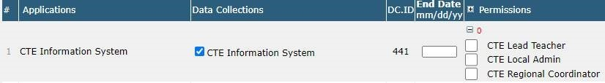
CTE Local Admin
This role can access information for all the CTE Programs associated with the school(s) where they have been granted permissions. Some examples of who might need local admin permissions are an administrative/data person, district CTE coordinator, or school administrator. The Local Admin role is for those who help support program processes like the Program Yearly Update and/or the CTE spring collections to ensure program data accuracy.
If a Local Admin is responsible for multiple schools with CTE Programs, they will need CTE Local Admin permissions assigned at the school-level for each applicable institution. For example, permission is granted for High School A1 and High School A2 and High School A3, not School District AA.
CTE Lead Teacher
The CTE Lead Teacher is the CTE-endorsed teacher who teaches a specific CTE Program of Study or CTE start-up program at an institution (school). Each CTE Lead Teacher only has access to their own program(s). CTE Lead Teachers have a three-part authorization process to access their program information:
- A Regional Coordinator must list the individual as the Lead Teacher in the Teacher Grid of a CTE Program of Study or start-up program at a particular school.
- The District Security Administrator (DSA) must assign technology access to the CTE Information System application in the CTE Lead Teacher’s District Site login.
  - The permission for CTE Lead Teacher must be assigned at the school-level for each applicable institution. For example: permission is granted for High School A1 and High School A2 and High School A3, not School District AA.
- The CTE Lead Teacher email address used by the Regional Coordinator must match the teacher’s email address used by the DSA.
CTE Regional Coordinator (RC)
Far less common than CTE Lead Teacher and CTE Local Admin, the CTE Regional Coordinator is responsible for an entire region of schools. When an RC logs into in, they will see all the CTE programs at schools in their region.
The CTE IS permissions for CTE Regional Coordinator must be given by the DSA at the CTE region level. For example, permissions for Region A given at ESD A.

CTE IS Tasks by Role
The three roles each serve their own purpose within the system and have specific tasks associated with the permissions granted by a District Security Administrator.
The Lead Teacher and Local Admin roles are identical in the tasks they can complete but have one main difference: the Local Administrator can see all programs at an institution, whereas the Lead Teacher can only see the program(s) with which they are associated.
The Regional Coordinator role has some overlapping task options, but the RC also has some very different capabilities.

CTE IS Interface Instructions:
Steps to access the collection interface.
- Login to your account through the Central Login on the ODE District Site.
  - If you do not have a Password or are unable to log-in, please reach out to the District Security Administrator.
  - If you do not know the District Security Administrator, please contact the district office or click on “Locate your District Security Administrator” on the login page.
- Click / select the CTE Information System application for the appropriate institution.
- Verify that you are logged into the correct institution in the blue header bar. Text reads: [Your Name [Selected Institution] (Institution ID [X]).”
- Click the appropriate task option on the vertical, black menu bar on the left side of the screen.
Figure 2 CTE IS Home Page screenshot
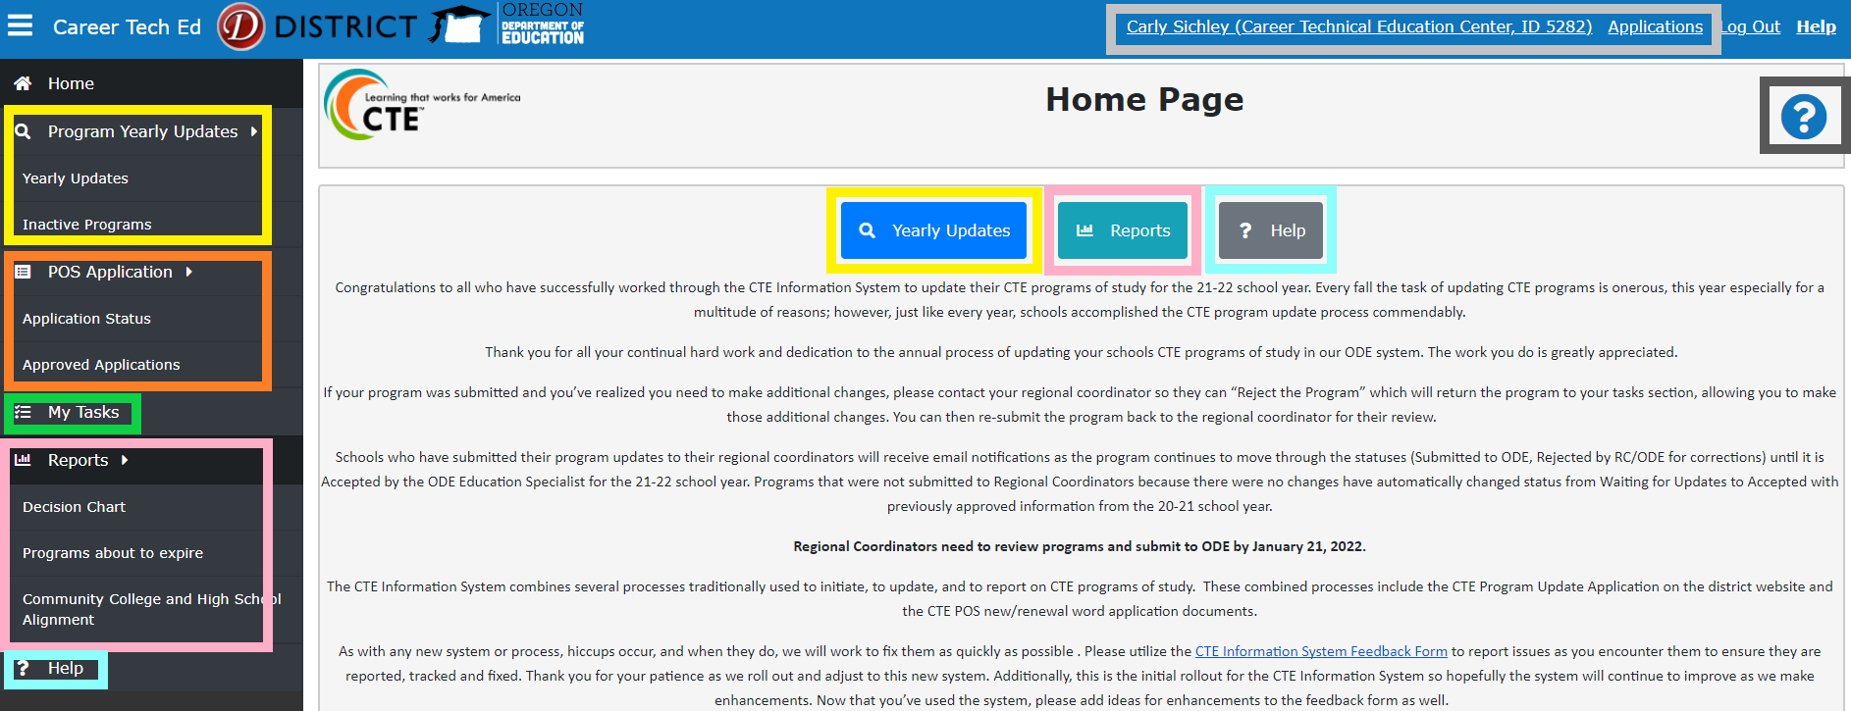
Figure 3 CTE IS Yearly Update Page sample screenshot
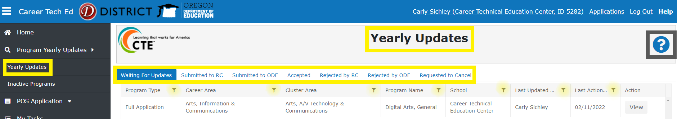
Figure 4 CTE IS My Tasks page sample screenshot
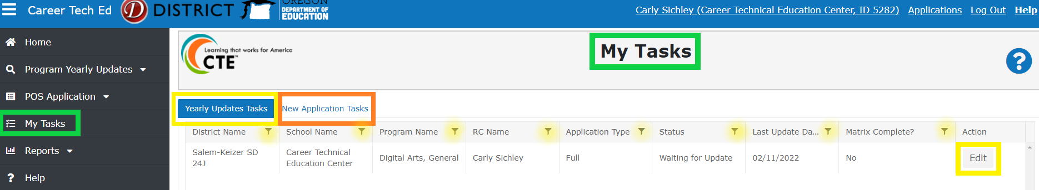
Figure 5 CTE IS Program of Study Yearly Update page screenshot part 1
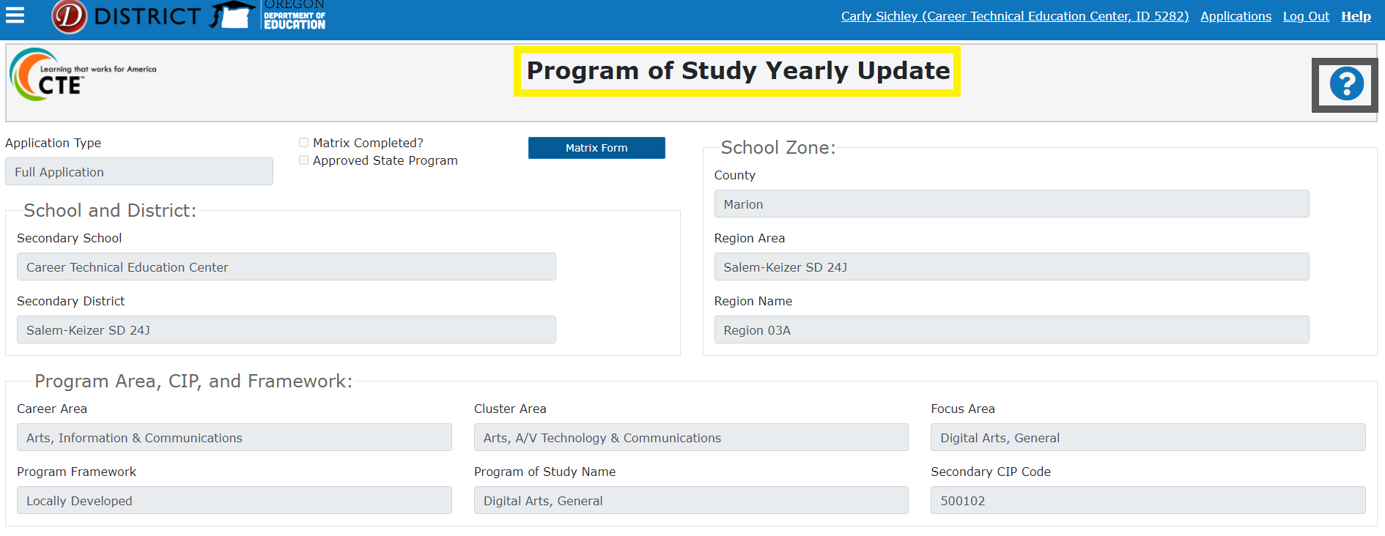
Figure 6 CTE IS Program of Study Update page part 2
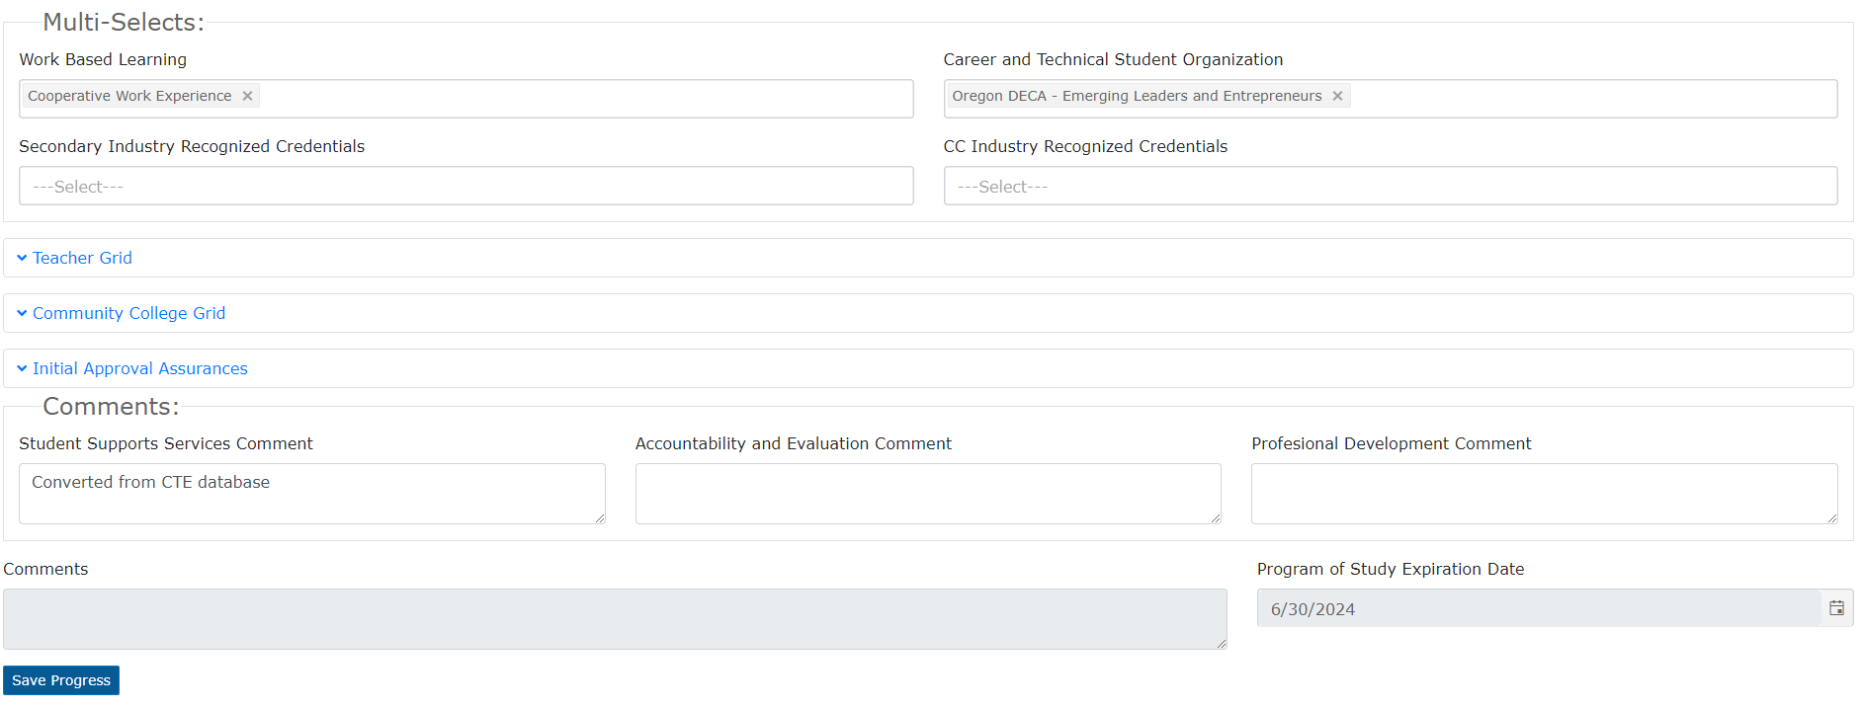
Figure 7 CTE IS Program Matrix sample screen shot part 1
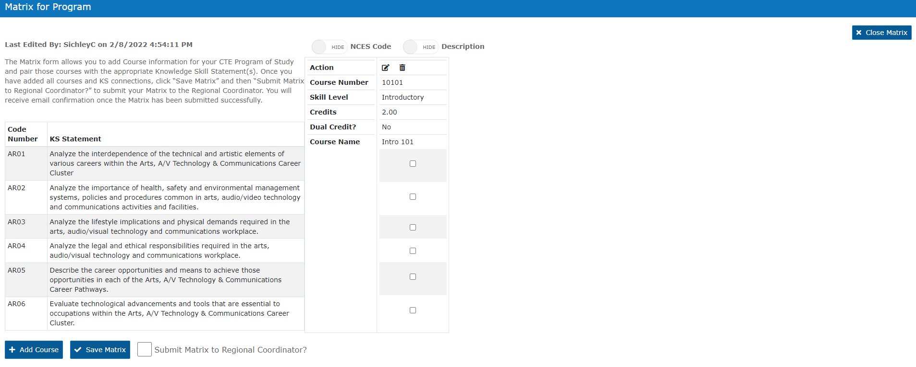
Figure 8 CTE IS Program Matrix screen shot part 2
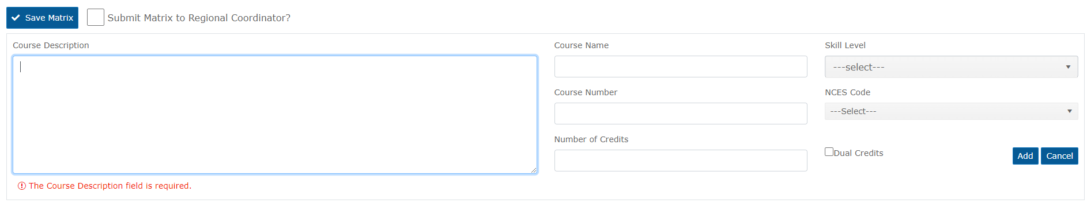

Spring Collections
There are two (2) CTE data collections in the spring: 1. CTE Student 2. CTE Course

Resources & FAQ for Spring Collection Commonalities
The CTE spring collections page is here and contains links to many ODE Resources including any collections-related trainings. The names below are hyperlinks for convenience/ specific to the respective document. Last updated date is shown after each hyperlink for static documents.
- Consolidated Collections Student Collections User Guide 05/16/2016
- File Format User Guide 02/02/2010
- Consolidated Student Collection FAQ's for Common Errors 09/28/2010
- SSID User Guide (05/16/2016)
- Approved CTE Programs Detail Report shows CIP codes and CTE Class Numbers by institution.
The CTE System (aka CTE IS) is another valuable resource in preparing for CTE Student and CTE Course collections. This is a web interface (like Consolidated Collections) accessed through the ODE District Site. It houses program and course information for each secondary CTE Site (school, learning center, etc. directly providing secondary Perkins CTE programs). Find instructions for accessing the interface in this document’s section Fall Collection, CTE Program Update. The CTE System page on the District Site is here.
FAQ
- Q: Where is the spring collections’ interface?
  - A: The spring collections are accessed through District Site login then clicking into the Consolidated Collections application for the appropriate institution.
- Q: Who submits to the spring CTE Collections?
  - A: The responsibility is technically at the school level, but many school districts have district-level data managers who submit for their schools. Please check with your CTE coordinator or local CTE data team regarding the arrangement your institution follows.
- Q: How can I make my CTE spring data submissions easier? Does ODE help with data submission?
  - A: Yes, ODE has many ways of helping with CTE data submissions.
    - In-App resources: Consolidated Collections offers some incredibly useful reports for planning and verifying your institution’s CTE spring collections data submissions.
      - Help Section: Access the Consolidated Collections help section for detailed information on:
        - Submission parameters
        - Collection point person contact information
      - Key Reports:
        - Production Download Report: This crucial report is available separately for each of the spring CTE data collection submissions in progress and from past years. This is available at either the school or district level
        - CTE Combination Summary PDF Report: This report is available at the CTE Site level only. You must be logged in at the CTE Site level, not at a School District or ESD level. This report is very useful to use when School Districts or ESD’s want CTE Site data managers and/or CTE coordinators to review what has been submitted for their respective site.
    - Best practice includes pulling a preliminary or sample submission file from your in EARLY SPRING, before the collections open and before school is out. When end of year reporting is simulated in early spring, teachers are still available and can review sample submissions for their programs or courses to let you know if the basic information is complete and correct. Examples of basic info to check for completeness include
    - These data components represent the majority of errors that slow down the CTE spring data submissions processes as well as the majority of large-scale submission issues such as leaving out potentially large amounts of CTE data the institution intended to report
      - Make sure all grade levels 9 and higher are included.
      - Ensure all CTE program CIP codes are included and correct and in the correct number format.
      - CTE course numbers active in the current school year are all represented and have the appropriate level of credit available in each course. Enter the full value of credit available to all students who take/took that specific CTE Course Section. Do not enter a GPA-type credit value.
      - Also check the above field entries against the CIP codes and CTE course numbers in the Approved Programs List for your institution(s). CTE site, CIP code, course, and section number combinations must be entered to match the CTE site, CIP code, and course number value.
    - If there are discrepancies regarding the CIP codes or CTE course numbers between local and ODE records, contact the CTE Program Quality Analyst with questions.
    - If the SIS report used to prepare the CTE Student and CTE Course data needs updating, contact your institution’s representative for SIS assistance.
- Q: Do institutions have to submit CTE WBL data each spring?
  - A: Yes. The WBL type code field is mandatory in the CTE Student collection. If a student does not have a CTE related WBL experience to report for the current year, use the code Z for not applicable.
- Q: Why is my CIP code getting an error flag?
  - A: The CIP codes are validated by the system along the following metrics:
    - Is the CIP code recognized as active in ODE records overall?
    - Is the CIP code registered to the attending school institution in the CTE Information System?
    - Is the associated CTE program active (rather than expired / due for renewal)?

Collections Page
The collection page is the primary resource for collection information and submissions. Collection pages display important dates for the relevant collection and house links to documents, historical institution reports, instructions, file templates, and more. Sample screen snips are below. The CTE spring collections page is here.
Figure 9 important dates for CTE Spring Collections
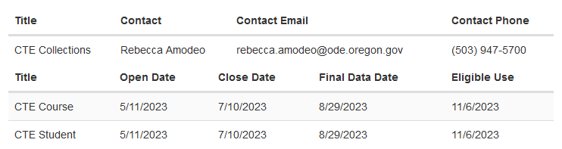
Figure 10 Training Calendar embedded on Collections Page
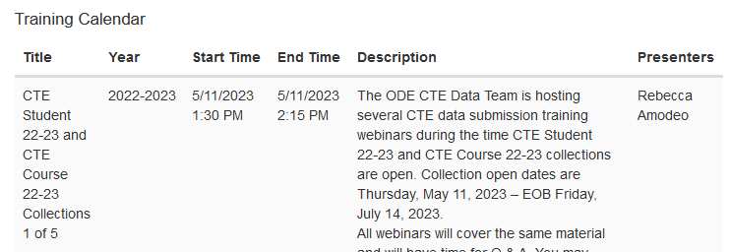
Figure 11 Links section of CTE Spring Collections Page
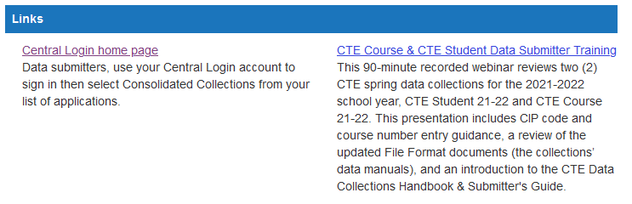
Figure 12 Collection Secure Reports
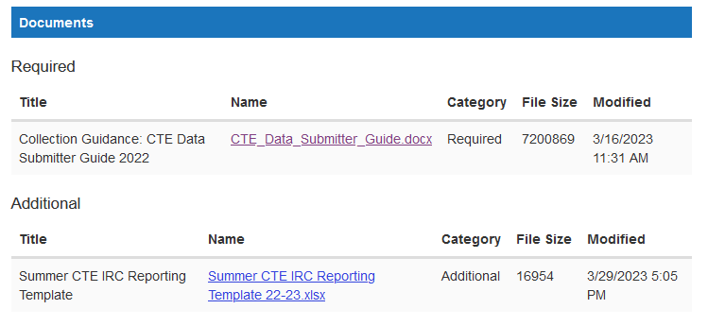
Figure 13 in Consolidated Collections, Use the Help Menu in the Dark Blue Horizontal Menu Bar
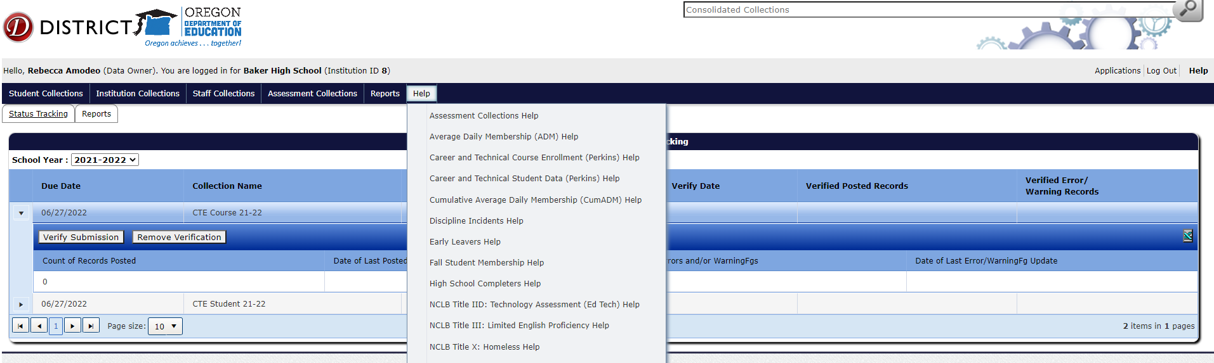

Consolidated Collection Tab Menus
General Application Tabs
The top row of tabs apply to the overall Consolidated Collections app and will display dashboard-style information for all collections you have assigned to you in the current school year. The two (2) top tabs “Status Tracking” and “Reports” operate independently of the tab menus that reveal when working in a specific collection.
The Status Tracking tab opens the Consolidated Collections Home Page.
The Reports tab opens the Consolidated Collections Reports page
Note: System advances to new school year each July 1. Use the dropdown menu to access correct year.
Figure 14 Screen snip of "School Year" dropdown menu on the "Status Tracking" tab in Consolidated Collections.

In-Collection Tabs
Select a specific collection in the hover-to-reveal menu starting with “Student Collections” to open the in-collection tabs.
Hover Over | To Reveal
Student Collections | All open collections you have permissions to in Consolidated Collections.  This is where you access CTE Student and CTE Course.  Each Collection name is also specified by the applicable report year.
CTE Student Y1-Y2  or CTE Course Y1-Y2 | Top level of in-collection tabs. There are three (3).  1. Data Submission 2. Error Management 3. Record Management
Data Submission | The two (2) options for submitting data to the collection.  1. File Upload 2. Web Submission
Error Management | The five (5) options for error management.  1. Review Queue 2. Review Email 3. Review Errors  4. House Keeping 5. Download Errors
Record Management | The options for managing records – does not include entries with outstanding error flags. This tab set is not often used for the CTE spring data collections. Please contact an ODE CTE Data Analyst if you need guidance on this submenu.

Pre-Collection Guidance
Best practice includes pulling a preliminary or sample submission file from your SIS in EARLY SPRING, before the collections open and before school is out.
When end of year reporting is simulated in early spring, teachers are still available and can review sample submissions for their programs or courses to let you know if the basic information is complete and correct.
Example Checklist of basic pre-collection preparation
- Pull a preliminary or sample submission file from your SIS in EARLY SPRING, before the collections open and before school is out
- Make sure all grade levels 9 and higher are included.
- Ensure all CTE program CIP codes are included and correct and in the correct number format.
- CTE course numbers active in the current school year are all represented and have the appropriate level of credit available in each course.
- Also check the above field entries against the CIP codes and CTE course numbers in the Approved Programs List for your institution(s).
- If there are discrepancies regarding the CIP codes or CTE course numbers between local and ODE records, contact the CTE Program Quality Analyst with questions.
- Review credit values and ensure the credit offered by the course-section is reported directly and not a GPA-scaled amount. All students in a given course-section should be reported with the same number in the credit column.
- Ensure all CTE IRC attempts are reported; do not filter out records of student CTE IRC attempts that did not result in a passing grade/full certification.
- Ensure all CTE course attempts are reported; do not filter out records of student CTE course attempts that did not result in a passing grade. Include student course enrollments that resulted in failing grades, incompletes, no-passes, and withdraws.
- Review notes regarding previous institution-specific data submission sticking points and review sample report for correct data handling to avoid those issues in the upcoming collection.
If the SIS report used to prepare the CTE Student and CTE Course data needs updating, contact your institution’s representative for SIS assistance.

CTE Student

Resources & FAQ
The CTE spring collections page is here and contains links to the ODE resources for this collection.
The Approved CTE Programs Detail Report shows CIP codes and CTE Class Numbers by institution. The CTE IS page on the District Site is here.
FAQ
- Q: Which data are in the CTE Student Collection?
  - A: CTE Student collection requires one (1) row per student in the entire school regardless whether the student engages with CTE.
    - Student enrollment data – enter this for all students grade 9 and up.
    - CTE IRC data – max two (2) entries per student per year; only applies to some CTE students; each CTE IRC reported requires the following four (4) fields:
      - CTE IRC code
      - CTE POS CIP code for which the CTE IRC was earned
      - Date of final testing or of awarded credential
      - CTE IRC pass code indicating whether the student passed the credentialing process – both failed and passed CTE IRC attempts should be reported for each year.
    - CTE WBL data – max four (4) entries per student per year, only applies to some CTE students; each CTE WBL reported has two (2) required fields and one (1) optional field:
      - CTE WBL Type code (required)
      - CTE POS CIP code to which the CTE WBL was earned (required, effective school year 2022-2023)
      - CTE WBL hours code (optional)
- Q: Why are CTE IRC and CTE WBL data part of the Student collection instead of the Course collection?
  - A: The CTE IRC and CTE WBL data are collected in CTE Student because schools must have the CTE IRC and the CTE WBL connected to a specific CTE program (i.e., a CIP code) but may choose whether they are tied to any specific CTE course within the program. Because these elements are not required to be tied to specific CTE Course activity, the CTE IRC and CTE WBL data cannot be collected in CTE Course and must be collected in CTE Student.
- Q: Do institutions still need to submit CTSO (Student Leadership Orgs) information?
  - A: It is an optional field. If the information is available, please submit it.
- Q: Which Students are included in CTE Student?
  - A: There are three categories of students in the CTE Student Data Collection. For each category, different data must be entered into the CTE Student Data collection. They are:
    - Category 1: Students who attended class for at least 20 days but did not attend class in an approved CTE Program of Study (POS)
    - Category 2: Students who attended class for at least 20 days in an approved CTE Program of Study but neither attempted completion of an approved CTE Industry Recognized Credential (CTE IRC) nor engaged in a CTE WBL (CTE Work-Based Learning) experience in the current school year.
    - Category 3: Students who attended class in an approved CTE Program of Study and attempted completion of an approved CTE IRC and/or engaged in a CTE WBL experience in the current school year.

CTE IRC Data
CTE IRC codes are established through a process that begins with schools requesting an Industry Recognized Credential be recognized as part of their CTE POS curriculum. This request is first submitted to the appropriate Education Specialist for the program.
CTE IRCs are tracked as a part of the Secondary Career Pathways process. That is an Oregon state grant /article of legislation. CTE IRCs are not a component of the federal Perkins V grant nor the Perkins V Performance Indicators. For more information on CTE IRC from a programmatic lens, click here.
CTE IRC Basics
- Report credentials only in the school year they were earned.
- CTE Industry Recognized Credentials (IRCs) are reported through the CTE Student data collection each school year.
- Credential codes can be found in the lookup table of values for CTE IRC codes (IRCCd) here. If you have any difficulty locating your desired IRC code(s), please contact the ODE Education Program Specialist(s) associated with the program(s) the IRC is (are) at your institution. They will help you locate the appropriate code(s).
- Report data on all 9th through 12th grade students who attempted to earn a CTE IRC even if they did not meet the requirements. All IRCCd must be reported with an associated IRC Pass Indicator.
  - The code M is used when a student has met the requirements for (passed) the CTE IRC set for the respective IRCCd.
  - The code D is used when a student did not meet the requirements (failed to pass) the CTE IRC set for the respective IRCCd.
- All IRCCd must be reported with an associated IRC Administration date.
  - Any credentials earned after the close of the CTE Data collection and before July 31st of the same summer should be reported using this template.
  - All other CTE IRCCd must be reported through the CTE Student collection for the school year in which the CTE IRC was completed (or attempted completion and failure to pass).

CTE WBL Data
CTE WBL stands for CTE Work-Based Learning. Not all work-based learning qualifies as CTE WBL. For additional CTE WBL resources, visit ODE’s work-based learning webpage where you can also find contact information for the ODE CTE WBL Specialist.
Oregon’s definition of CTE WBL is a “structured learning in the workplace or simulated environment that provides opportunities for sustained interactions with industry or community professionals that foster in-depth, firsthand experience of the expectations and application of knowledge and skills required in a given career field”.
CTE Work Based Learning must satisfy all four criteria below and be in one of the six types specified.
The 4 Criteria that must all be met for CTE WBL:
- Aligns with CTE POS curriculum and Instruction.
- Includes Sustained Interaction with industry, business, or community professionals outside the student-teacher relationship.
- Leads to Earning of Credit or Outcome Verification.
- Offered in-person, virtually, or in a simulated workplace setting.
CTE WBL Types CTE WBL has been categorized into the following six types as measurable experiences for Perkins V and can be submitted in the CTE Student collection:
- Clinical | Internship| Practicum
- Cooperative Work Experience
- Pre-Apprenticeship
- School-Based Enterprise
- Service Learning
- Workplace Simulation

The CTE Work-Based Learning Type Code (WBLTypCd) and CTE Work-Based Learning Hours Code (WBLHrsCd) Lookup Tables can be found by clicking the Public Reports for CTE Student link on the CTE Spring Collections Page. For ease of access, the tables are also pasted below.
Table 2 Table of CTE WBL Type Codes with their Names and Descriptions
CTE WBL Type Code | CTE WBL Type Name | CTE WBL Type Description
A | Cooperative Work Experience | Offered for academic credit at a secondary or postsecondary level, they combine classroom studies with structured work-related experiences, mostly for those enrolled in CTE programs, but may also be part of a transfer program.
B | Clinical / Practicum / Internship | A limited duration professional learning experience that offers meaningful, practical work to learn about a particular industry or occupation, gain professional skills, and make connections; supervised work evaluated; experience may be paid/unpaid
C | Pre-Apprenticeship | An OSATC approved program designed to prepare individuals to enter and succeed in a Registered Apprenticeship program
F | Service-Learning | Structured, sustained learning experiences in organized community service projects that meet actual community needs, linked to classroom learning outcomes and career related knowledge and skills through a cycle of service and reflection.
H | School Based Enterprise Experience | An entrepreneurial operation in a school setting that provides goods/services. Student manages and operate the enterprise as a hands-on learning laboratory with interaction with industry, business, or community professionals.
K | Workplace Simulation/Technology-Based Learning | An experience that replicates workplace tools, processes, and/or environments that offer students realistic hands-on opportunities to practice, reinforce, and grow technical, employability, and academic knowledge at current educational institution.
Z | Not Applicable | Not Applicable
CTE WBL Hours code lookup table
CTE WBL Hours Code | CTE WBL Hours Name | CTE WBL Hours Description
0-25 | 0-25 hours | 0-25 hours
26-50 | 26-50 hours | 26-50 hours
51-75 | 51-75 hours | 51-75 hours
76-100 | 76-100 hours | 76-100 hours
101-125 | 101-125 hours | 101-125 hours
126-150 | 126-150 hours | 126-150 hours
151-175 | 151-175 hours | 151-175 hours
176-200 | 176-200 hours | 176-200 hours
200+ | More than 200 hours | More than 200 hours

Data Submission Tabs
Steps to access the collection interface:
- Login to your account on the ODE District Site.
  - If you do not have a Password or are unable to log-in, please reach out to the District Security Administrator (DSA).
  - If you do not know the DSA, please contact the district office or click on “Locate your District Security Administrator” on the login page.
- Click / select the Consolidated Collections application for the appropriate institution.
Figure 15 ODE District Site Applications page
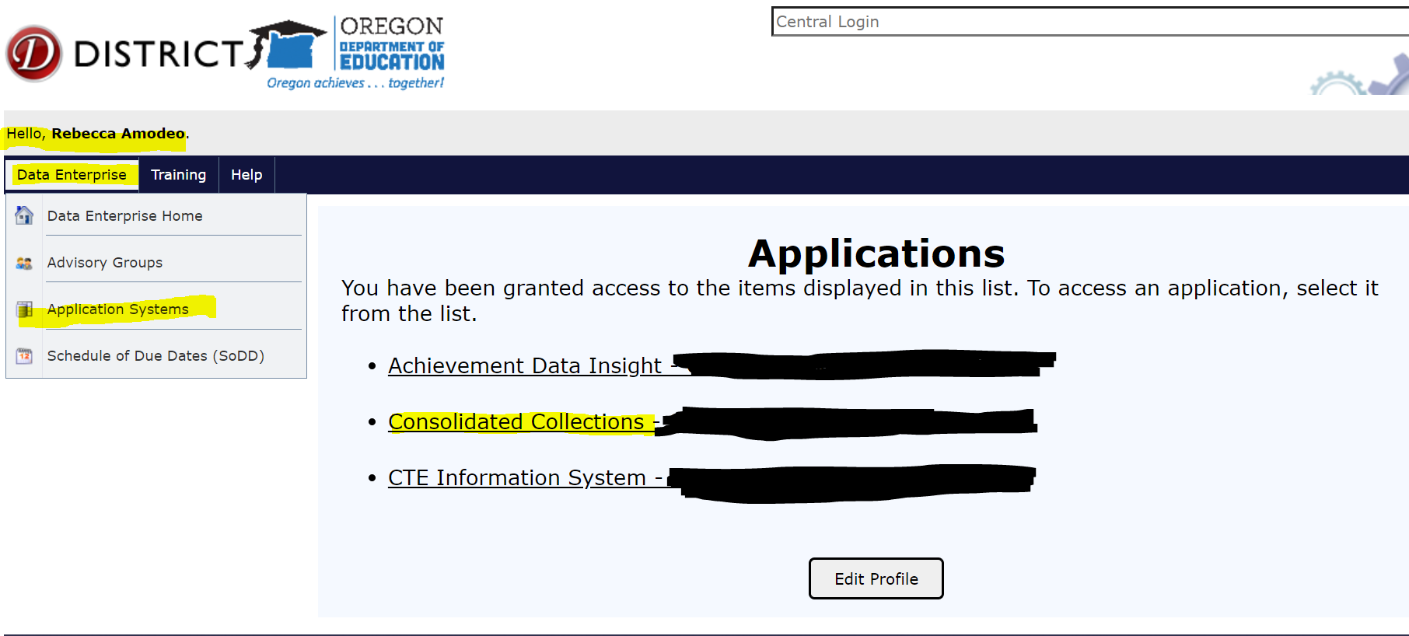
- Verify that you are logged into the correct institution in the grey header bar. Text reads: “Hello, [Your Name (Your System Role)]. You are logged in for [Selected Institution] (Institution ID [X]).”
Figure 16 Consolidated Collections App Home Screen
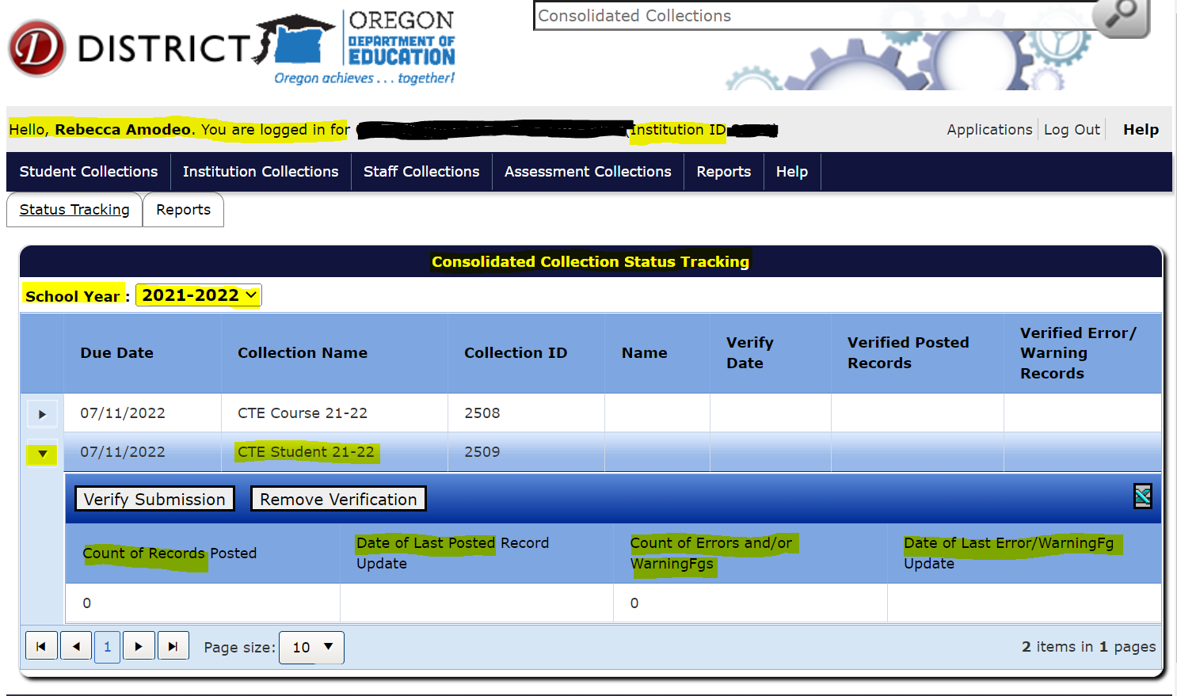
- Activate a series of pop-out menus: Hover over the “Student Collections” option on the horizontal, dark blue menu bar under the grey header to activate the dropdown menu; hover over “CTE Student 21-22”; then hover over “Data Submission” to activate a final pop-out menu.
Figure 17 Pop-out menus to CTE Student submission options
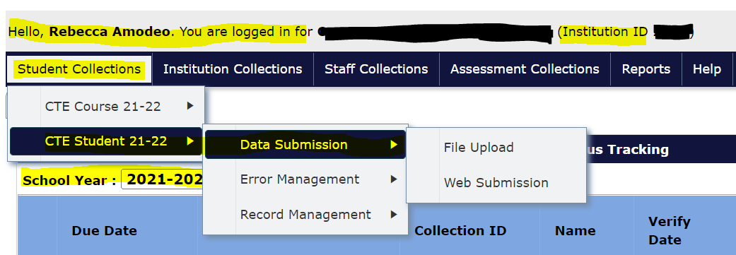
- Click “File Upload” or “Web Submission” as appropriate.

File Upload, Student
Steps to submit CTE Student via file upload
- Download the CTE Student Data file template here.
- Enter the correct data, in the correct formats, in the correct fields.
- Click “Choose File” in the Consolidated Collections app for CTE Student 21-22.
Figure 18 CTE Student File Upload part 1
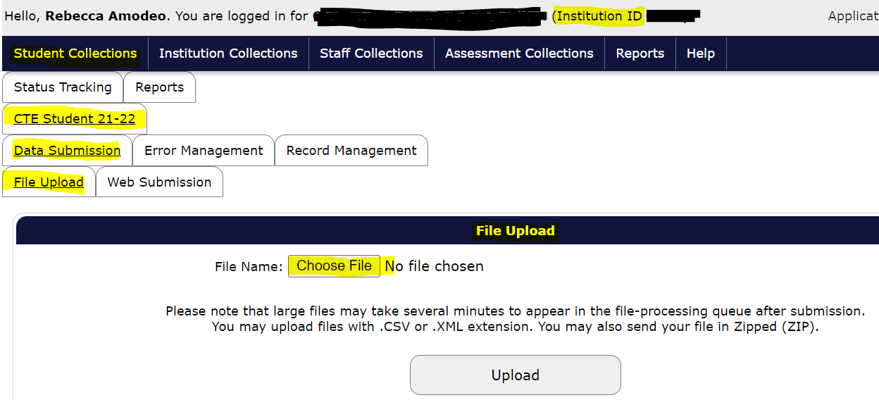
- Use the resulting file browser/selector to identify the exact file you prepared to upload for CTE Student 21-22 and click “Open.”
- Click “Upload.”
Figure 19 CTE Student File Upload part 2
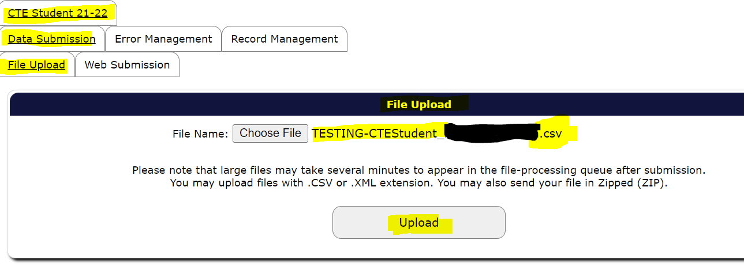
- Wait for the file to complete the pre-processing. If CTE Course is submitted prior to complete processing (and error resolution) in CTE Student, CTE Course will accumulate errors based on inability to verify SSIDs against the CTE Student records.
Figure 20 CTE Student File Upload part 3
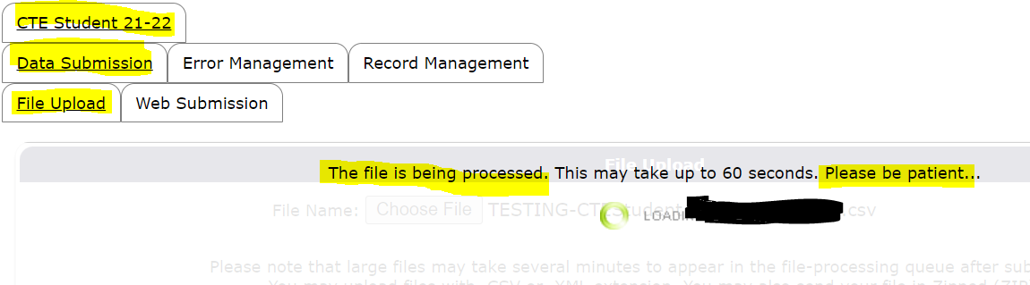
- Read the resulting confirmation; this is where you will get information on any errors on the submitted data.
Figure 21 CTE Student File Upload part 4, Info Screen with Error Messages
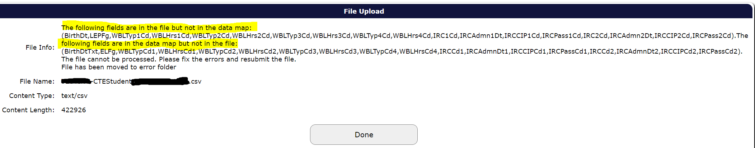
- Review the information to make sure the file was sent to the processing queue.
- If the upload contains errors, see the Error Management Tab section under Spring Collections, CTE Students.
- Follow up successful, error-free submission of all students grade 9 and higher (even if they did not engage with CTE programs) with the steps in Verify the CTE Student Submission sub-section in Spring Collections, CTE Student.

Web Submission, Student
Steps to complete CTE Student via web submission
- Click “Web Submission.”
  - Hover over Student Collections; hover over CTE Student 21-22 (or the appropriate year for CTE Student); hover over Data Submission; select Web Submission.
Figure 22 CTE Student Web Submission part 1
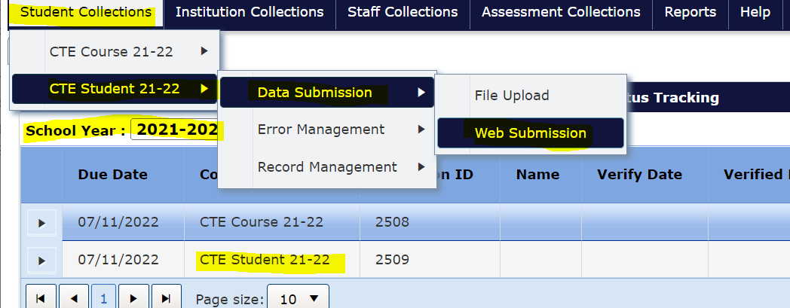
- Select the institution for which you are uploading data to the collection and click “Search”. Search using the “current students” option.
Figure 23 CTE Student Web Submission part 2
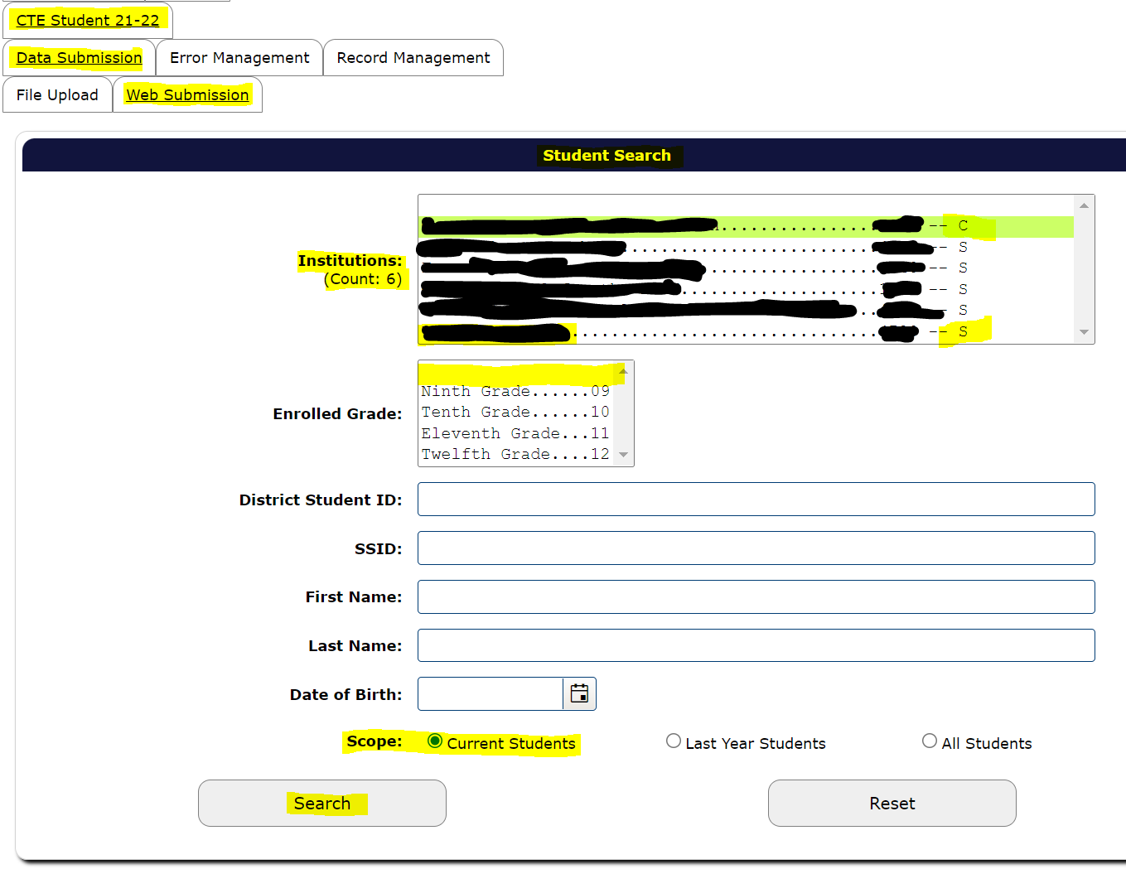
- Select desired student by clicking on the green check mark in the “Select” column in the search results.
Figure 24 CTE Student Web Submission part 3, Search Results Screen Snip
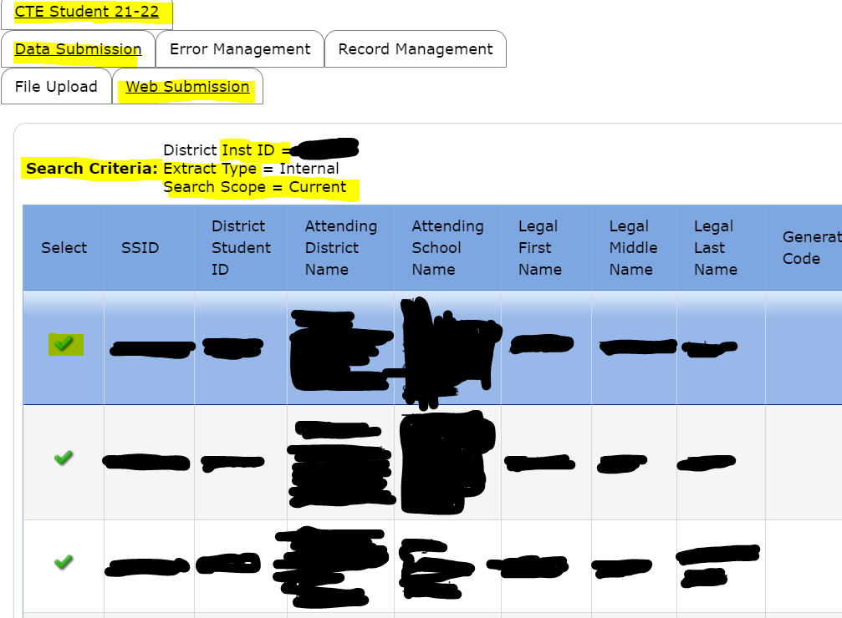
- Enter the correct data for the selected student in the required fields.
  - The CTE-specific fields are in the top panel for Web Submission.
Figure 25 CTE Student Web Submission part 4, Student Detail View
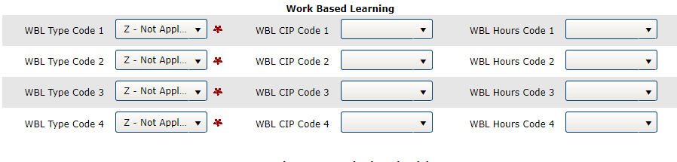
  - CTE IRC Data part 1, IRC Code and CIP Code are required report elements for all students who attempted (whether passed or failed the attempt) to earn a CTE IRC in the relevant school year. For students who did not attempt a CTE IRC, bypass these elements as they are prepopulated with the codes for “Not applicable.”
Figure 26 CTE Student Web Submission part 5,CTE IRC Data part 1 Zoom-in of IRC code and IRC CIP code
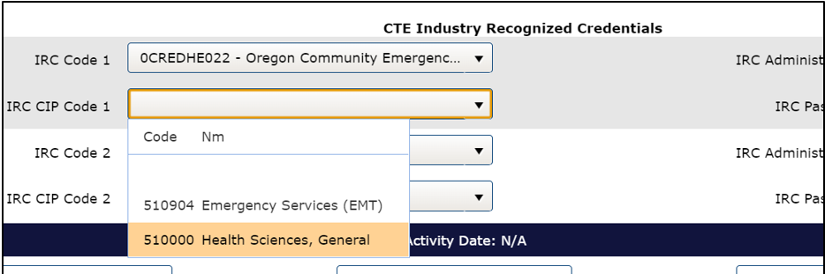
  - IRC Data part 2, Admin Date and Pass Code are required report elements for all students who attempted (whether passed or failed the attempt) to earn a CTE IRC in the relevant school year. For students who did not attempt a CTE IRC, bypass these elements; that is, leave them blank.
Figure 27 CTE Student Web Submission part 6, CTE IRC Data part 2, IRC code date and pass indicator
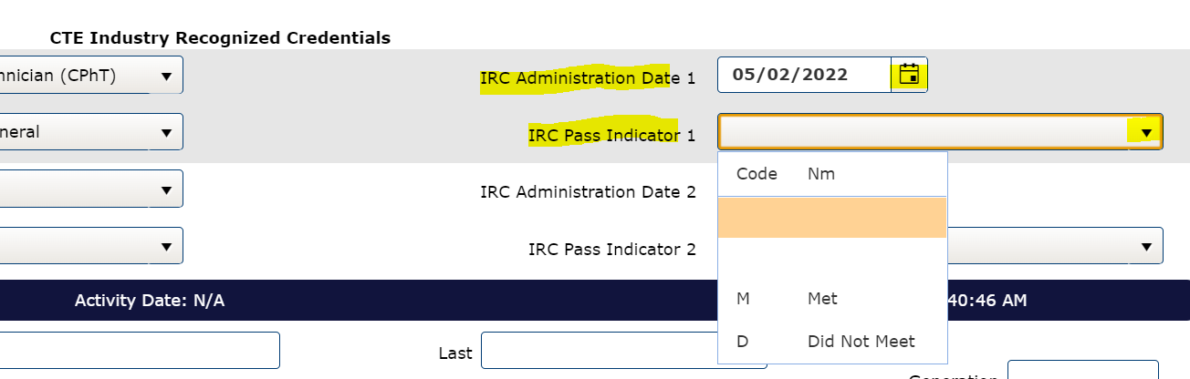
- Review data in student entry.
- If all data are correctly entered, click “Save.”
- Wait for the system to process the entry.
- If the entry remains open after processing, it has error flag(s) and has not yet become an official record in the collection. When this occurs,
  - Review the error(s) specified in the red alert bar at the top of the student entry.
  - Use the relevant year’s CTE Student File Format document for assistance understanding the error flag messages and how to correct the error(s).
- Follow up a successful, error-free web submission in CTE Student by repeating Web Submission steps 3 through 8 for each student grade 9 and higher.
- Follow up completion of all successful, error-free web submissions with the steps in Verify the CTE Student Submission sub-section in Spring Collections, CTE Student.

Error Management Tabs
- Accurate data are free of validation errors; they are also correct and complete.
- Regardless of whether an institution’s CTE Student collection is completed using the File Upload or Web Submission, submitters are responsible for uploading accurate and complete data. If you are not able to determine whether the numbers accurately represent the students in the institution(s), please reach out to someone who can verify that the collection is valid, correct, and complete (Lead CTE Teacher, Principal, CTE Regional Coordinator, etc.).
- After uploading data to the collection, be sure to check for, resolve, and clear validation errors.
- Entries with unresolved validation errors are not preserved with records in the collection, and all outstanding error-flagged entries will be deleted by the system at the time the collection closes.

Review Errors Tab
Steps to review errors:
- Hover over Student Collections; hover over CTE Student 21-22; hover over Error Management; select Review Errors.
  - If there are validation errors in the collection, each type will appear with an Error Count, an Error Type, and an Error Description.
Figure 28 CTE Course Pop-out menus to Review Errors
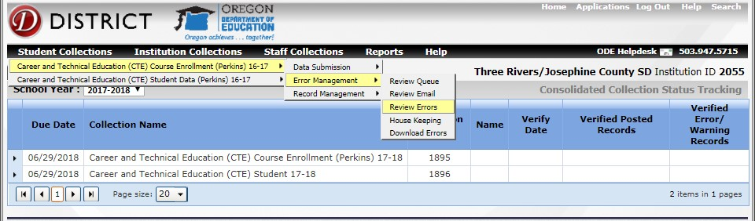
- Select which from the two (2) options below you will use to resolve each error. Then correct error-flagged entries until all error flags are resolved.
Options for Error Correction
- Error Correction Option 1: Correct individual student records in the Consolidated Collections app.
- Error Correction Option 2: Download a CSV containing all the errors; correct the entries; then resubmit.
Error Correction Option 1: The steps for correcting individual records follow.
- In the Review Errors tab, select an individual student by clicking the green check next to their name to fix the error.
Figure 29 View of Error Management tab in CTE Course
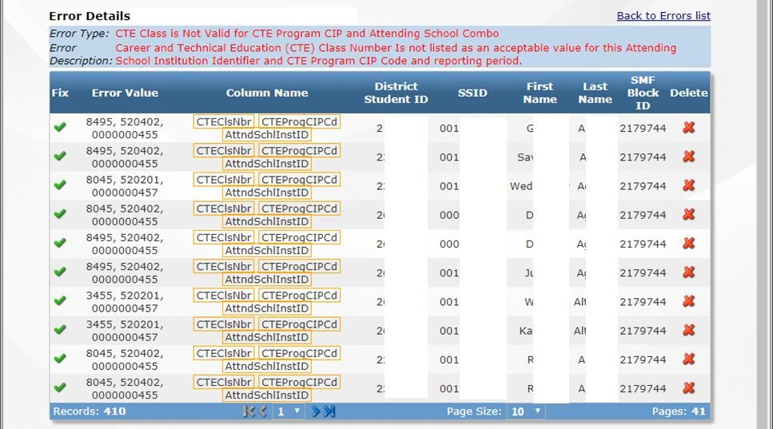
- Review the student entry detail and correct fields indicated in the error description that displays at the top of the entry detail. Remember that the system validates the entry in column-batches, so correction of the displayed error(s) may be followed by notification of new error flags to review and correct.
- Click Save.
- If the entry detail remains open, there are new errors identified or the original error was not corrected. In such cases, repeat steps 2 and 3 until the entry is saved successfully without additional error-flags.
- Repeat steps 1 – 4 until there are no errors in the submitted files and then proceed to House Keeping Tab.
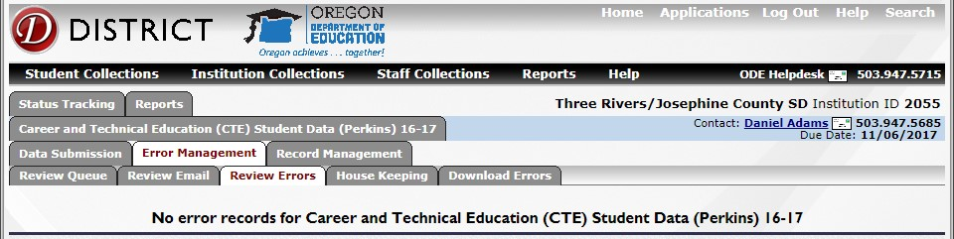
Figure 30 CTE Student Review Errors Tab view with no remaining errors
Error Correction Option 2: Steps for batch-correcting and resubmitting entries follow.
- Click on the Error Management tab
- Click on Download Errors tab
- Click on CSV. – An ODE Help Desk email will be sent to the email address you use for your District Site login.
Figure 31 File Transfer confirmation email sample
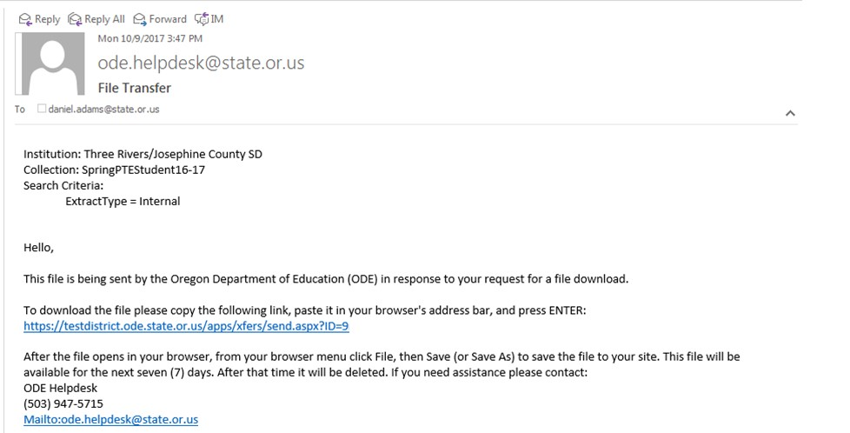
- Still in the Error Management tab, click on the House Keeping tab.
- Delete the file for your institution that appears in the House Keeping tab. If a file appears here but is not deleted prior to entry correction and resubmission, the system will flag both the original entries and the corrected entries as near-duplicates and prevent proper evaluation of the resubmitted data.
- Open the email from the ODE Help Desk and click on the link in the email to go to the secure file transfer interface.
- Click on Download.
Figure 32 Download Screen in the Secure File Transfer system
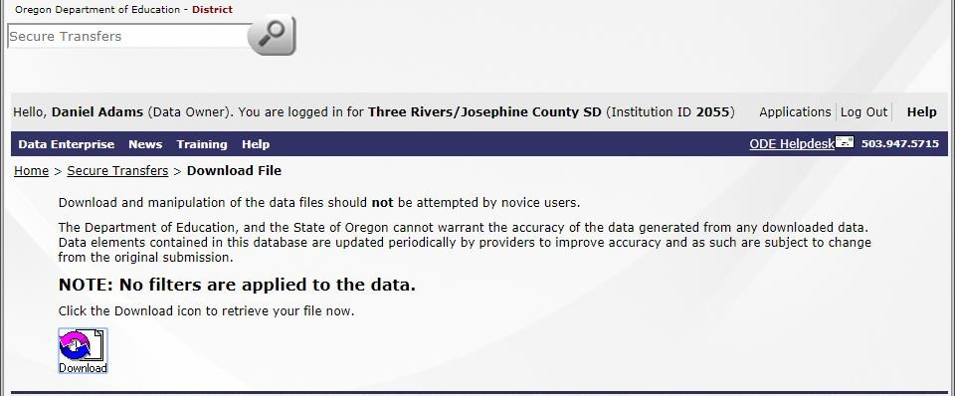
- Save the file with a clear, distinctive name in a secure location. (There is a significant amount of student PII in these downloads.)
- Open the saved error file and correct each record with a validation error.
- When the correct data are in the correct formats and in the correct fields on your spreadsheet that has only the entries for resubmission, follow the directions for File Upload Student, submitting only the corrected entries and none of the previously validated records.
- Once the file uploads free of error flags, proceed to Validating the Submission.
Figure 33 CTE Student Review Errors Tab view with no errors remaining

House Keeping Tab
- After resolving all validation errors, there may still be some housekeeping errors.
- To clear housekeeping errors, click on Error Management and click on House Keeping.
- Deleted files / entries from the House Keeping tab are no longer included in the collection.

Verify the CTE Student Submission
Error-flag-correction is a crucial part of submission verification, but this process requires additional steps. The following list of steps for Verifying the Submission includes the error review described in the Error Management Tabs section.
This section provides instruction on steps 3 and 4, reviewing the submission for errors that cannot be identified by collection interfaces and confirming submission verification.
Steps to Verify the CTE Student Submission
- Resolve all error-flagged entries.
- Confirm there are no outstanding House Keeping items.
- Review submission for errors that cannot be identified by collection interfaces nor by ODE. These are errors that require institution-specific knowledge to identify.
  - Generate CTE Student Reports
  - Compare CTE Student Reports to local records.
- Confirm submission verification.

Step 3a) Generate CTE Student Reports
Each collection has interface-generated reports to assist with reviewing the submission. When validating the CTE Student submission, use the following two (2) reports.
- The Combined CTE Collection Summary PDF – The Combined Report displays summary statistics of the successfully entered data in the collection.
  - If you are not able to determine whether the numbers accurately represent the students in the building(s), please reach out to someone who can verify that the collection is valid, correct, and complete (Lead CTE Teacher, Principal, CTE Regional Coordinator, etc.).
- The Production Download Report – This report is a complete account of all accepted records in the collection.
  - Records do not include entries that had error flags.
  - Entries with error-flags outstanding are not records, and they will be deleted by the system when the collection closes.

Steps-to access CTE Student reports for validating the submission in CTE Student
- Hover over “Reports” on the dark blue horizontal menu bar in Consolidated Collections.
- Click “Reports Tab” option that reveals as you follow step 1.
Figure 34 Screen snip of Reports Tab option in Consolidated Collections
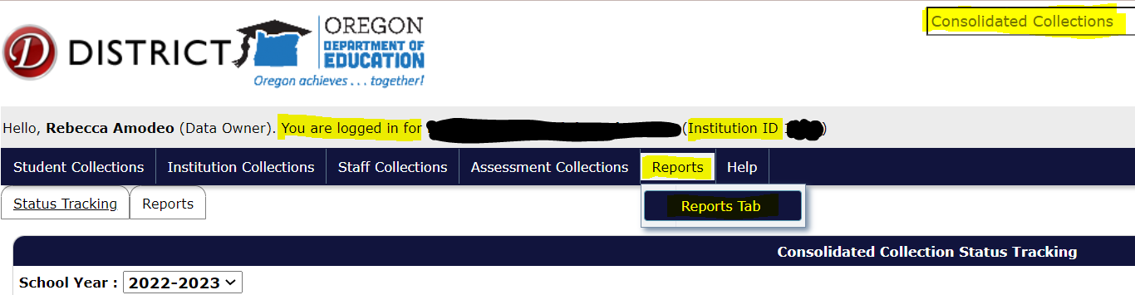
- Select “Career and Technical Student Data (Perkins)” to reveal the available report years. Note: The image below shows access to the CTE Course reports, simply use the option just below “CTE… Course… (Perkins)” titled “Career and Technical Student Data (Perkins)” to activate the corresponding pop-out menu to access the CTE Student Reports.
Figure 35 Screen snip of the Reports tab and the options Collection, Report Year, and Report
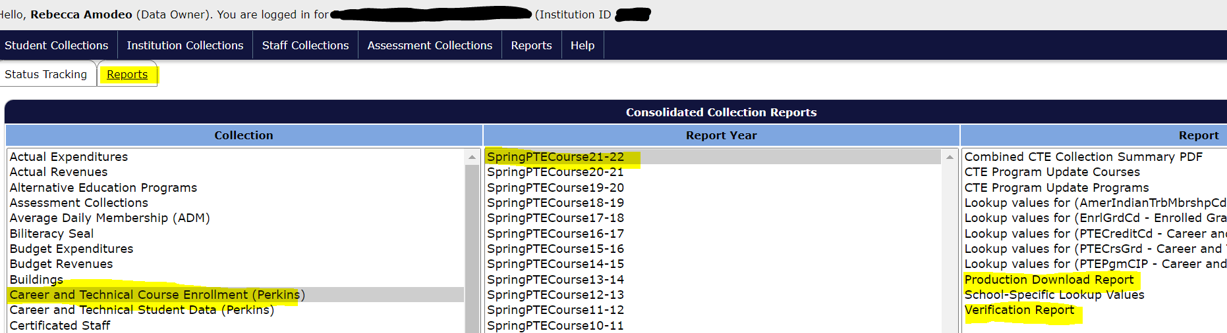
- Select the relevant (most recent) year of the collection.
- Click “Production Download Report” to generate a secure file transfer to yourself of a spreadsheet showing all the accepted (error-flag-free) records for the specified collection and institution.
- Review the message in the window that opens once the report is selected. If the message confirms a copy of the report is forthcoming, confirm the correct institution is showing in the pop-up window. Once both report elements are confirmed (generation and proper institution), close the confirmation / pop-up window.
- Click “Combined CTE Collection Summary PDF” to generate that report.
- Save a copy of the PDF report that displays in a new / pop-up window.
- Retrieve and save the secure file transfer of the Production Download Report using the link in the email you receive from ODE Helpdesk. Save these documents in secure file locations.

Step 3b) Compare Student Report to Local Records
Accurate data are correct and complete, please ensure this by comparing your Student Report to Local Records. Correct all identified discrepancies.
Many errors can only be identified by local, institution-specific knowledge.
This is especially true for errors omitted entries.
Review the two (2) CTE Student Reports for completeness and correctness for each institution you report for. If you are not able to determine whether the Production Download Report accurately represents the students in the institution(s), please reach out to someone who can verify that the collection is valid, correct, and complete (Lead CTE Teacher, Principal, CTE Regional Coordinator, etc.).
The following notes and questions do not represent an exhaustive list.
Review your CTE Student submission carefully before confirming submission validation.
- CTE Student should include all students grade nine (9) and above even if they did not engage with CTE at all.
  - Are all grade levels and other types of student groupings represented in the CTE Student Production Download? Ensure all high-school level students are included.
- All CTE IRCs earned before submission to the CTE Student collection (in the relevant school year) must be reported in the CTE Student collection.
  - CTE IRCs earned before submission of the collection may not be submitted using the Summer CTE IRC Supplemental Reporting Template.
  - Are all CTE IRCs attempted thus far in the most recently ended school year reflected in the CTE Student Production Download? Confirm they are all present.
- Excel can be used to sort and/or filter the Production Download Report as you compare it to your local/SIS records and what you know of your institution’s activity.

Step 4) Confirm CTE Student Verification
Once you complete your comparison of Student Reports to local records and reconcile all errors and other discrepancies, confirm the submission verification.
Steps to Confirm CTE Student Submission Verification
- Login to the District Site.
- Open the Consolidated Collections app for the correct institution.
- Select the appropriate report year in the “school year” dropdown if it is not already displayed on the homepage of the Consolidated Collections app.
- Click the arrow button at the left of the CTE Student Collection row displayed.
Figure 36 Screen snip of Verify Submission button under the Status Tracker tab
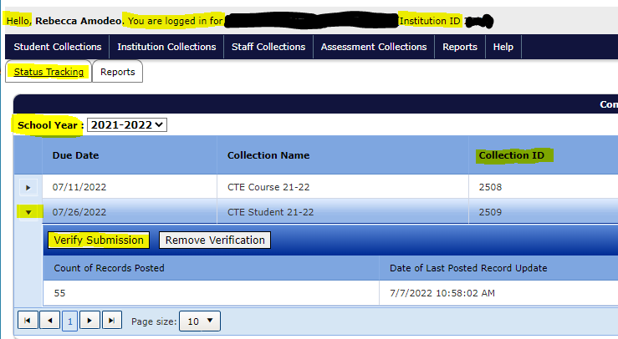
- Click “Verify Submission.”

Remove Verification, Student
If you become aware of errors or incompleteness in your submission after verifying the submission, use the Remove Verification option. After removing a verification, resolve the data issues and return to “Verify the CTE Student Submission” Step 3a to run new reports and continue from there with a new verification review.
Steps to Remove Verification
- Login to the District Site.
- Open the Consolidated Collections app for the correct institution.
- Select the appropriate report year in the “school year” dropdown if it is not already displayed on the homepage of the Consolidated Collections app.
- Click the arrow button at the left of the CTE Student Collection row displayed.
- Click “Remove Verification” and follow through with any interface requests to confirm your selected action.
Figure 37 Screen snip of the Remove Verification button under the Status Tracking tab

CTE Course

Resources & FAQ
The CTE collections page is here and contains links to the ODE resources for this collection.
The Approved CTE Programs Detail Report shows CIP codes and CTE Class Numbers by institution. The CTE System page on the District Site is here.
Note: CTE Course collection uses the student information submitted in the same year’s CTE Student collection to verify each record. This means CTE Course cannot be performed prior to the institution’s complete submission to CTE Student.
FAQ
- Q: What is in CTE Course collection?
  - A: CTE Course requires one (1) row per CTE course attempt per student for the applicable school year regardless of whether the student completed and/or passed the course.
    - CTE Course inclusion of incomplete course attempts, student withdrawals from class, and failing grades are essential to equity assessments and must be reported.

Data Submission Tabs
Steps to access Data Submission Tabs
- Complete the CTE Student collection for the current year prior to submitting CTE Course.
  - CTE Course filters entries through the list of students represented in CTE Student, so if CTE Student is incomplete at the time of CTE Course submission, the system will error-flag all entries associated with missing students.
- Login to your account on the ODE District Site.
- Click the Consolidated Collections application.
- Select / click the appropriate institution.
- Verify that you are logged into the correct institution in the grey header bar. Text reads: “Hello, [Your Name (Your System Role)]. You are logged in for [Selected Institution (Institution ID X].”
- Use / click the “Student Collections” option on the horizontal, dark blue menu bar under the grey header to activate the dropdown menu and click “CTE Course 21-22” to activate a pop-out menu.
- Click “File Upload” or “Web Submission” as appropriate.
Figure 38 Choose File Upload or Web Submission as appropriate.
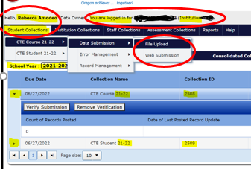

File Upload, Course
Steps to submit to CTE Course via file upload
- Click “Choose File.”
- Use the resulting file browser/selector to identify the exact file you want to upload for CTE Course 21-22.
- Click “Upload File.”
- Wait for the file to complete the pre-processing.
- Read the resulting confirmation; this is where you will get information on any errors on the submitted data.
- If the upload contains errors, see the Error Tab section under Spring Collections, CTE Course.
- Follow up successful, error-free submission of all CTE course data for all students (even for courses that did not earn passing grades) with the steps in Verify the CTE Course Submission sub-section in Spring Collections, CTE Course.
Figure 39 CTE Course File Upload part 1
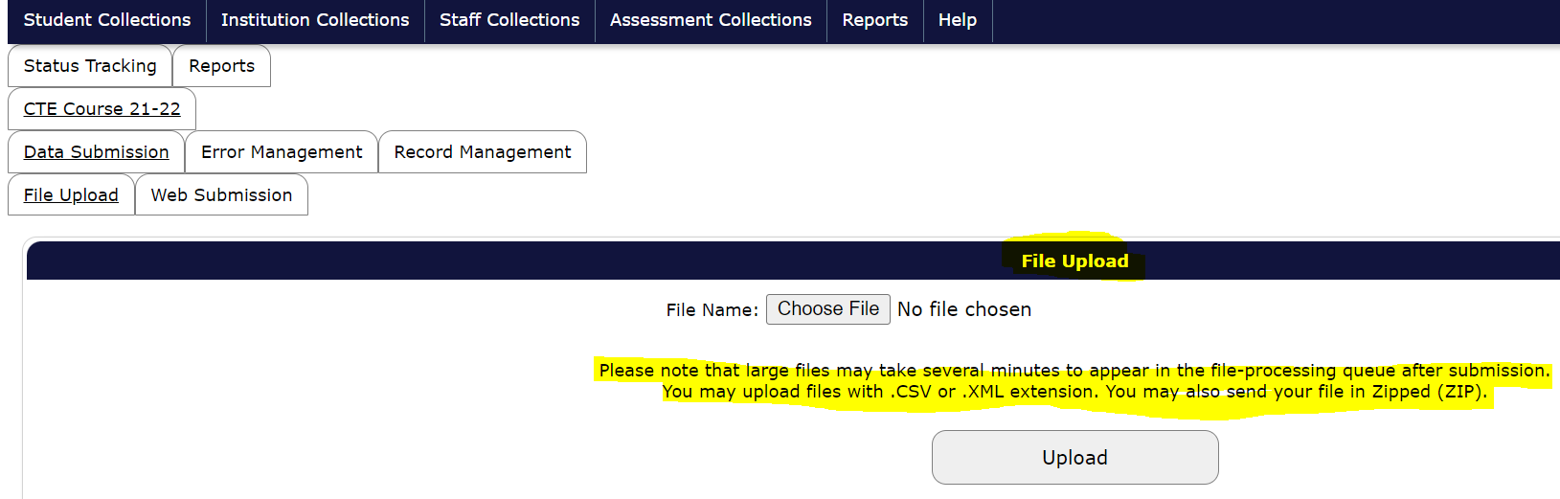
When a CTE Course file upload is successfully completed, the screen will display a message stating “The file has passed some preliminary testing and has been sent to the processing queue.”
Figure 40 Course File Upload part 2
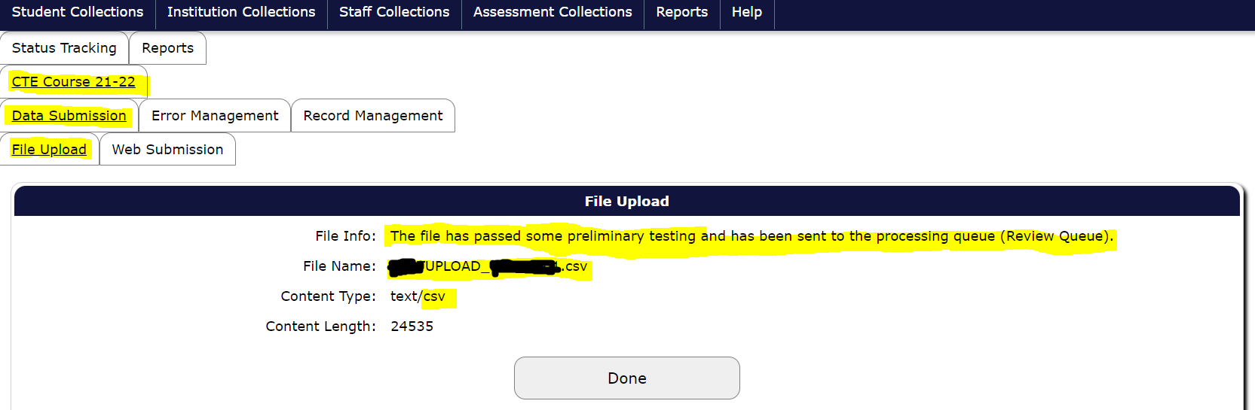

Web Submission, Course
Steps for CTE Course via web submission
- To begin web submission for CTE Course, open the Web Submission tab in CTE Course for the appropriate reporting year.
- Select the attending institution in the student search area and select the “Current Students” option in “scope” to access all the records submitted in CTE Student of the same year. Click “Search.”
Figure 41 CTE Course Web Submission part 1
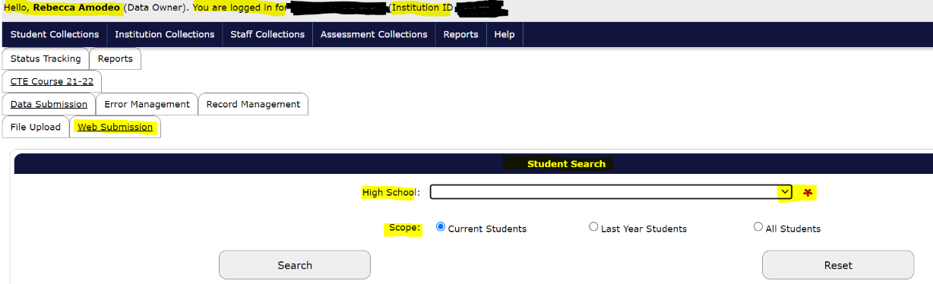
- FOR EACH COURSE-SECTION (If your institution does not use sections, follow these directions for each course.)
  - Select the course location, CIP code of associated CTE program, and Course Number, from the dropdown menus.
  - Enter the section number (enter 1 if your institution does not use section numbers).
  - Select/Add the teacher name (you may use add teacher instead of using the lengthy drop-down).
  - Set the Default Credit (do this before adding students). Set the credit for the course that is section-specific for courses with section divisions.
  - Select-in the students who enrolled in that class using the green plus sign(s) next to the appropriate student record(s) on the left.
  - You must manually engage earned grade drop-down menu for each student’s course grade code (grade earned in the course) including W if they withdrew, I for incomplete, etc.
  - Once you have a complete and correct roster entry for that specific course in Web Submission, save the record.
  - Wait for the interface to finish processing before moving on to Step 4.
Figure 42 Web Submission part 2 for CTE Course
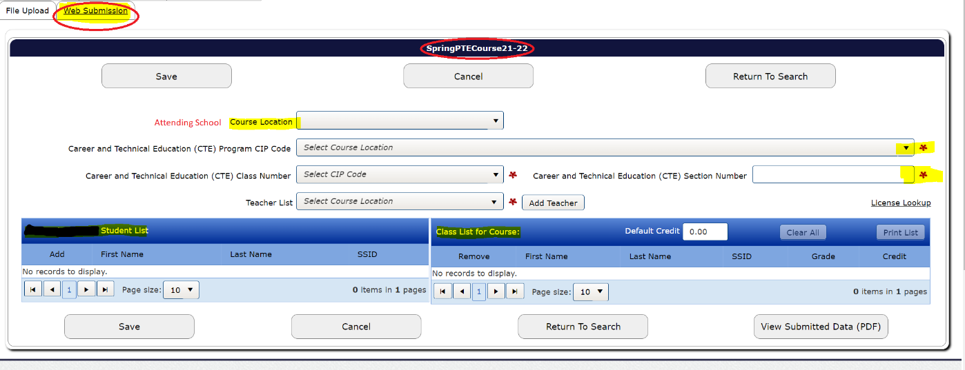
- The student list will refresh after each saved course entry, so students may be entered for more than one course each. Repeat steps 3 a-3h for each CTE course your institution has to report.
Note:
The default credit must be set prior to adding the students to be properly applied to the submission. Below is a screen snip showing that if you add a student (second row) prior to setting the default credit, the credit amount will not be updated.
Figure 43 Web Submission part 3 for CTE Course
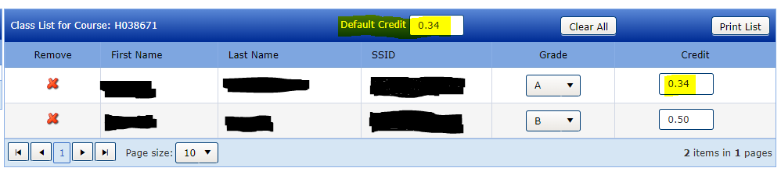
Following is a larger/ zoomed-out screenshot of the CTE Course 21-22 Web Submission page 2.
Figure 44 Web Submission part 4 for CTE Course
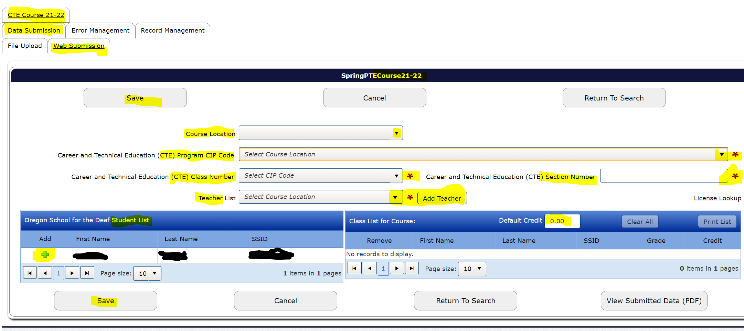

Error Management Tabs
On data accuracy
- Accurate data are free of validation errors; they are also correct and complete.
- Regardless of whether an institution’s CTE Course collection is completed using the File Upload or Web Submission, submitters are responsible for uploading accurate and complete data. If you are not able to determine whether the numbers accurately represent the students in the institution(s), please reach out to someone who can verify that the collection is valid, correct, and complete (Lead CTE Teacher, Principal, CTE Regional Coordinator, etc.).
- After uploading data to the collection, be sure to check for, resolve, and clear validation errors.
- Entries with unresolved validation errors are not preserved with records in the collection, and all outstanding error-flagged entries will be deleted by the system at the time the collection closes.

Review Errors Tab
Steps to Review Errors
- Hover over Student Collections; hover over CTE Course 21-22; hover over Error Management; select Review Errors.
  - If there are validation errors in the collection, each type will appear with an Error Count, an Error Type, and an Error Description.
Figure 45 Activating the Pop-out menu for reviewing errors
- Select which from the two (2) options) below you will use to resolve each error. Then correct error-flagged entries until all error flags are resolved.
Figure 46 View of the Review Error Tab with types, categories, and counts of errors in submission
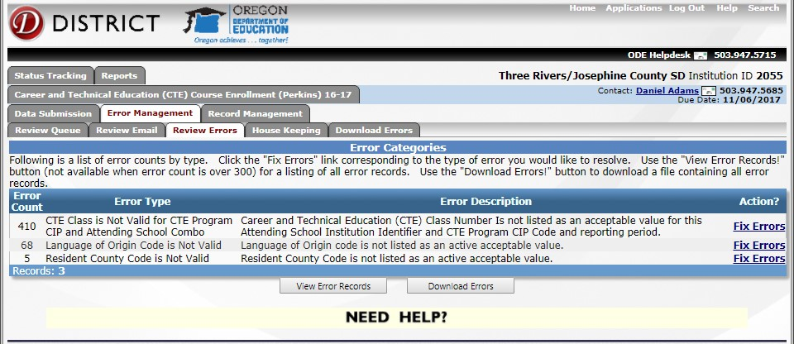
Options
- Error Correction Option 1: Correct individual student records in the Consolidated Collections app.
- Error Correction Option 2: Download a CSV containing all the errors; correct the entries; then resubmit.

Error Correction Option 1: The steps for correcting individual records follows.
- In the Review Errors tab, select an individual student by clicking the green check next to their name to fix the error.
Figure 47 CTE Course Review Errors Tab showing error summaries
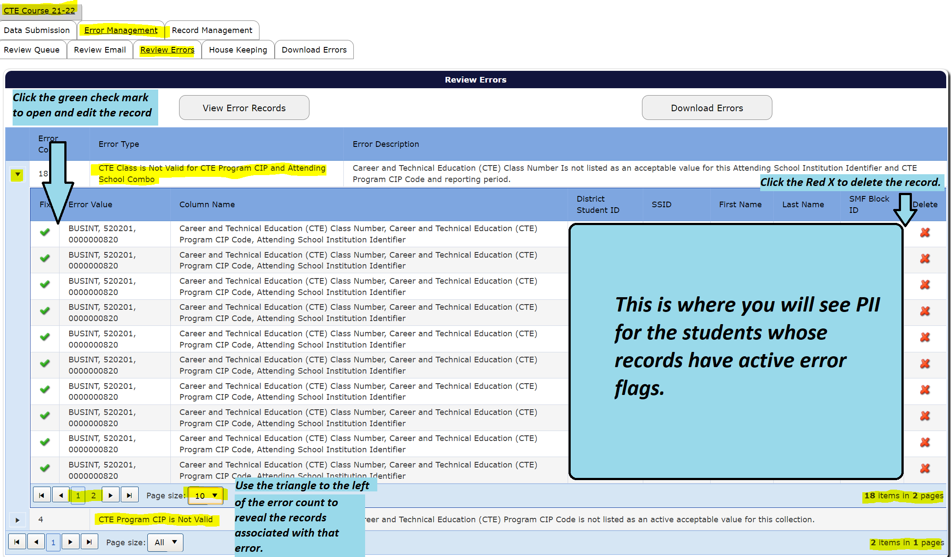
- Review the course entry detail and correct fields indicated in the error description that displays at the top of the entry detail. Remember that the system validates the entry in column-batches, so correction of the displayed errors may be followed by notification of new error flags to review and correct.
- Click Save.
- If the entry detail remains open, there are new errors identified or the original error was not corrected. In such cases, repeat steps 2 and 3 until the entry is saved successfully without additional error-flags.
Figure 48 Review Error Tab showing no error flags remain in CTE Student
- Repeat steps 1 – 4 until there are no errors in the submitted files; then proceed to the House Keeping Tab.
Error Correction Option 2: The steps for batch-correcting errors and resubmitting follow
- In CTE Course, click on the Error Management.
- Click on the Download Errors tab.
- Click on CSV. – An ODE Help Desk email will be sent to the address you use for your District Site login.
Figure 49 Download Errors Tab view
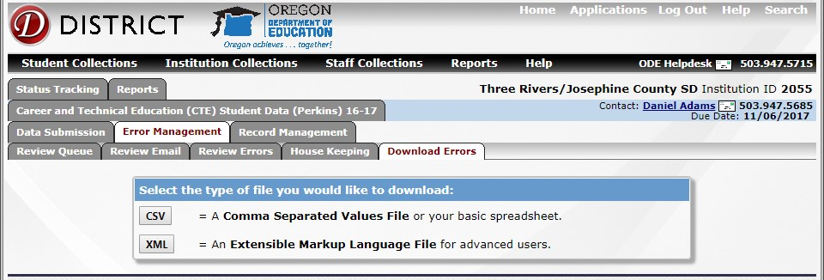
- Still in the Error Management tab, click on the House Keeping tab.
- Delete the file for your institution that appears in the House Keeping tab. If a file appears here but is not deleted prior to entry correction and resubmission, the system will flag both the original entries and the corrected entries as near-duplicates and prevent proper evaluation of the resubmitted data.
Figure 50 Sample of email confirmation of file creation
- Open the email from the ODE Help Desk and click on the link in the email to go to the secure file transfer interface.
- Click on Download.
- Save the file with a clear, distinctive name in a secure location. (There is a significant amount of student PII in these downloads.)
- Open the saved error file and correct each record with a validation error.
Figure 51 View of Secure File Transfer screen
- When the correct data are in the correct formats and in in the correct field on your spreadsheet that has only the entries for resubmission, follow the File Upload Course directions, submitting only the corrected entries and none of the previously validated records.
- Once the file uploads free of error-flags, proceed to Verify the CTE Course Submission.

Housekeeping Tab
- After resolving all validation errors, there may still be some housekeeping errors.
- To clear housekeeping errors, click on Error Management and click on House Keeping.
- Deleted files / entries from the House Keeping tab are no longer included in the collection.

Verify the CTE Course Submission
Error-flag-correction is a crucial part of submission verification, but this process requires additional steps. The following list of steps for Verifying the Submission includes the error review described above. This section provides instruction on steps 3 and 4, reviewing the submission for errors that cannot be identified by collection interfaces and confirming submission verification.
Steps to Verify the CTE Course Submission
- Resolve all error-flagged entries.
- Confirm there are no outstanding House Keeping items.
- Review submission for errors that cannot be identified by collection interfaces nor by ODE. These are errors that require institution-specific knowledge to identify.
  - Generate CTE Course Reports
  - Compare CTE Course Reports to local records.
- Confirm submission verification.

Step 3a) Generate CTE Course Reports
Each collection has interface-generated reports to assist with reviewing the submission. When verifying the submission, use the following two (2) reports.
- The Combined CTE Collection Summary PDF – The Combined Report displays summary statistics of the successfully entered data in the collection. Not available post-collection.
  - If you are not able to determine whether the numbers accurately represent the students in the building(s), please reach out to someone who can verify that the collection is valid, correct, and complete (Lead CTE Teacher, Principal, CTE Regional Coordinator, etc.).
- The Production Download Report – This report is a complete account of all accepted records in the collection.
  - Records do not include entries that had error flags.
  - Entries with validation errors/error-flags outstanding aren’t records; they will be deleted by the system when the collection closes.
Steps-to access CTE Course reports for verifying the submission in CTE Course:
- Hover over “Reports” on the dark blue horizontal menu bar in Consolidated Collections.
- Click “Reports Tab” option that reveals as you follow step one (1).
- Select “Career and Technical Course Data (Perkins)” to reveal the available report years.
- Select the relevant (most recent) year of the collection.
- Click “Production Download Report” to generate a secure fil transfer to yourself of a spreadsheet towing all the accepted (error-flag-free) records for the specified collection and institution.
- Review the message in the window that opens once the report is selected. If the message confirms a copy of the report is forthcoming, confirm the correct institution is showing in the pop-up window. Once both report elements are confirmed (generation and proper institution), close the confirmation / pop-up window.
Figure 52 Production Download Confirmation Window
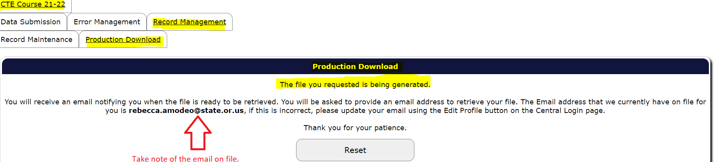

- If you are in Consolidated Collections at the CTE Site level, click “Combined CTE Collection Summary PDF” to generate that report.
Figure 53 Reports Tab view showing Combined CTE Collection Summary PDF for CTE Course
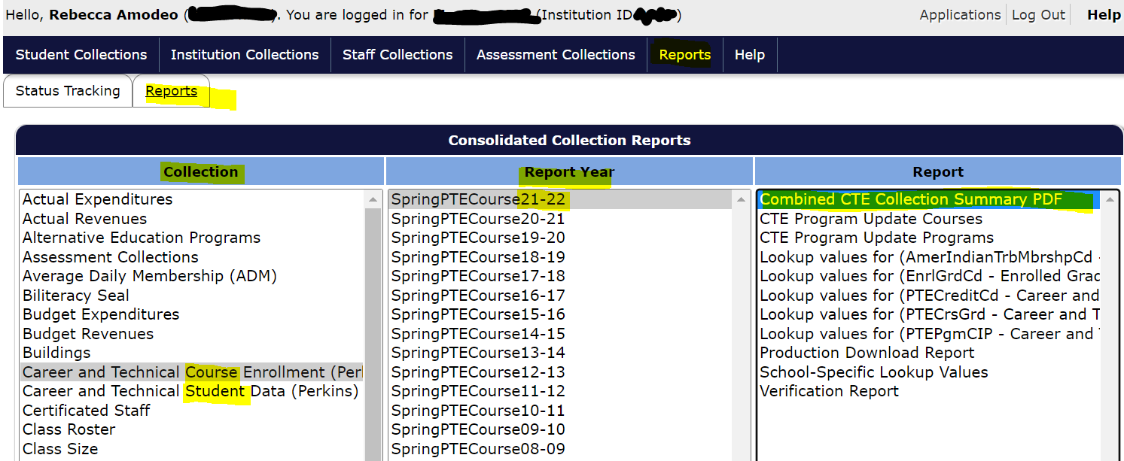
- Save a copy of the PDF report that displays in a new / pop-up window.
- Retrieve and save the secure file transfer of the Production Download Report using the link in the email you receive from ODE Helpdesk.

Step 3b) Compare Course Reports to Local Records
Accurate data are correct and complete, please ensure this by comparing your Course Reports to your Local Records. Correct all identified discrepancies.
Many errors can only be identified by local, institution-specific knowledge.
This is especially true for errors of omitted entries.
Review the two (2) CTE Course Reports for completeness and correctness for each institution you report for. If you are not able to determine whether the reports accurately represent the true CTE activity in the institution(s), please reach out to someone who can verify that the collection is valid, correct, and complete (Lead CTE Teacher, Principal, CTE Regional Coordinator, etc.).
The following notes and questions do not represent an exhaustive list.
Review your CTE Course submission carefully before confirming submission verification.
- CTE Course should include all student-course records for CTE classes even if the student did not complete or pass the course.
  - Are students who withdrew, had incompletes, or failed the courses included in the CTE Course Production Download? Ensure they are represented.
- Sometimes newer CTE programs or course numbers are left out of SIS reports that were developed at earlier times.
  - Neither the system nor ODE can tell if all CTE programs active and all CTE courses active in the school year are included.
    - Are all CTE programs represented in the CTE Course Production Download? Ensure they are all represented.
    - Are all active CTE courses from the school year represented in the CTE Course Production Download? Ensure they are all represented.
- Use Excel to sort and/or filter the Production Download Report as you compare it to your local/SIS records and what you know of your institution’s activity.

Step 4) Confirm CTE Course Verification
Once you complete your comparison of Student Reports to local records and reconcile all errors and other discrepancies, confirm the submission verification.
Steps to Confirm CTE Course Submission Verification
- Login to the District Site.
- Open the Consolidated Collections app for the correct institution.
- Select the appropriate report year in the “school year” dropdown if it is not already displayed on the homepage of the Consolidated Collections app.
- Click the arrow button at the left of the CTE Course Collection row displayed.
Figure 54 Screen snip of the Verify Submission button under the Status Tracking tab
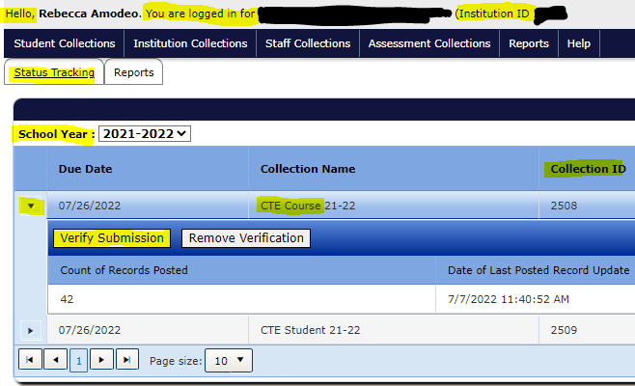
- Click “Verify Submission.”

Remove Verification, Course
If you become aware of errors or incompleteness in your submission after verifying the submission, use the Remove Verification option. After removing a verification, resolve the data issues and return to “Verify the CTE Course Submission” Step 3a to run new reports and continue from there with a new verification review.
Steps to Remove Verification
- Login to the District Site.
- Open the Consolidated Collections app for the correct institution.
- Select the appropriate report year in the “school year” dropdown if it is not already displayed on the homepage of the Consolidated Collections app.
- Click the arrow button at the left of the CTE Course Collection row displayed.
- Click “Remove Verification.”
Figure 55 Screen snip of the Remove Verification button under the Status Tracking tab
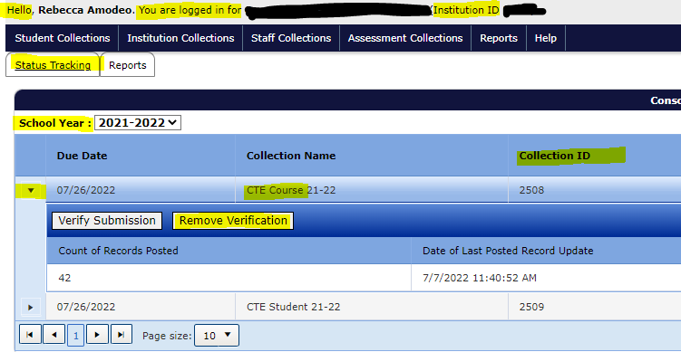

Post-Collection Guidance
Please reach out to the ODE CTE data team with all questions or concerns, well before the collection’s closing date.
There is never any guarantee ODE can facilitate corrections or updates to any given collection errors once the collections close.
Once the collection closes, several functions are no longer available in Consolidated Collections.
- All entries with unresolved errors are deleted.
- All error messages and descriptions specific to flagged entries are deleted.
- The Tab menus are not available for closed collection(s).
The Production Download Report is still active and available as the primary resource in reviewing your data submission. Please refer to Generate CTE Student Reports and Generate CTE Course Reports as necessary to access this report for each collection.
After the collections close, the ODE CTE data team does their best within the few weeks that have been allotted to perform data review and to work with schools/districts to resolve outstanding errors and data issues.
Potential re-open windows are roughly fifteen (15) minutes each; re-opening closed collections cannot not be relied on.
Timely submission of institution data is always expected.

Errors and Missing Data
Your institution(s) may have outstanding errors or data omissions at the time of collections’ close. If you discover errors after the collections have closed, contact an ODE CTE Data Analyst as soon as possible with details.
The ODE CTE Data Team needs the following information to address your data issue:
- Institution Name
- Institution ID
- Names and email addresses of everyone on the Local CTE Data Team(s) who should be included in ODE emails about potential updates to your institution’s current CTE data submissions
- Description of the nature and scale of each of the errors you are aware of in the institution’s submission. Never send student PII (personally identifying information) by email. Files containing student PII must be sent using Secure File Transfer.
Guidelines for correcting submissions
- Once you download the Production Download Reports, compare them to your local/SIS records and what you know of your institutions’ activity.
- Use Excel to sort and/or filter the Production Download Report as you compare it to your local/SIS records and what you know of your institution’s activity.
- Use the CTE Data Submitter Guide sections Verify the CTE Student Submission and Verify the CTE Course Submission for instructions on comparing the collection report with your records.
- Keep in close, regular contact with the ODE CTE Data Analyst who is assisting you in preparing your new file for upload.
- Corrected files must be completed and reviewed with an ODE CTE Data Analyst before a re-open window is scheduled.

Summer CTE IRCs
Supplemental IRC Reporting is used to report students who earn approved CTE Industry Recognized Credentials (IRCs) after the complete submission of CTE Student and before July 31 of the same year. For information on submitting IRC data from the regular school year, see CTE Student sub-section CTE IRC Data.
Supplemental Reporting for summer CTE IRCs must be submitted to ODE by EOB August 18, 2023 and must use secure file transfer.
Where: X is the respective institution ID;
A is the final digit of the calendar year the applicable school year (sy) began;
B is the final digit of the calendar year the applicable school year (sy) ended.
Make sure you use the following convention for file naming.
For Schools submitting: CTEIRCCd_Summer_SchoolX_sy202A202B.xlsx
For Districts submitting: CTEIRCCd_Summer_DistX_sy202A202B.xlsx
Once the spreadsheet is complete and named according to the convention above, submit to ODE through Secure File Transfer by EOB August 18, 2023. Select Career.Pathways@ode.state.or.us as the recipient. You will receive an email receipt from the automated transfer system if the file uploaded successfully.
- The Summer CTE IRC Reporting template is available here and on the CTE Collections page.
- Please see the Glossary if you need clarification on “resident” and “attending” schools or districts.

A description of each Summer IRC Reporting template field follows.
- SSID – A unique identifier assigned to each student in Oregon by ODE. This is not necessarily the student ID number used in a school or district on the day-to-day.
  - This number is critical to match the student to the rest of our records.
- ResdDistInstID – The student’s resident district institution ID.
  - This number is critical to match the supplemental records with data from CTE Student and must be filled in for each IRCCd reported for each student.
- ResdSchlInstID – The student’s resident school institution ID.
  - This number is critical to match the supplemental records with data from CTE Student and must be filled in for each IRCCd reported for each student.
- AttndDistInstID – The student’s attending district institution ID.
  - This number is critical to match the supplemental records with data from CTE Student and must be filled in for each IRCCd reported for each student.
- AttndSchlInstID – The student’s attending school institution ID.
  - This number is critical to match the supplemental records with data from CTE Student and must be filled in for each IRCCd reported for each student.
- IRCCdSu– The unique code used to identify a specific CTE IRC.
  - The general format for the code is 0CREDXXNNN.
  - That is “0”, a zero for front-fill, “CRED” (short for CTE IRC credential set). XX is the abbreviation for the respective Career Learning Area, and NNN is a 3-digit number specifying the IRCCd within the Career Learning Area.
  - Listing of approved CTE IRCCd can be found in the public reports section of the CTE Student collection page. A direct link is provided here.
- IRCAdmnDtSu – The MM/DD/YYYY which the student was awarded / completed the final component of the CTE IRCCd.
  - Please note: This date must be after the end of the regular school year. All CTE IRCs completed within the regular school year must be reported through CTE Student for consideration.
- IRCCIPCdSu – Code indicating the CIP code associated with the CTE IRC earned by the student.
- IRCPassCdSu – Code indicating whether the student passed/did not pass the credential.

Slides from Presentations
Slides from presentations related to CTE Data Collections. Slide sets are included for the current year only.

CTE Program Update
This set of slides is from the CTE Information System and Program Yearly Update training events that took place August through October of 2022. A recording of this training can be found on the Oregon CTE YouTube channel.
Figure 0-56 Overview of the Program Yearly Update:
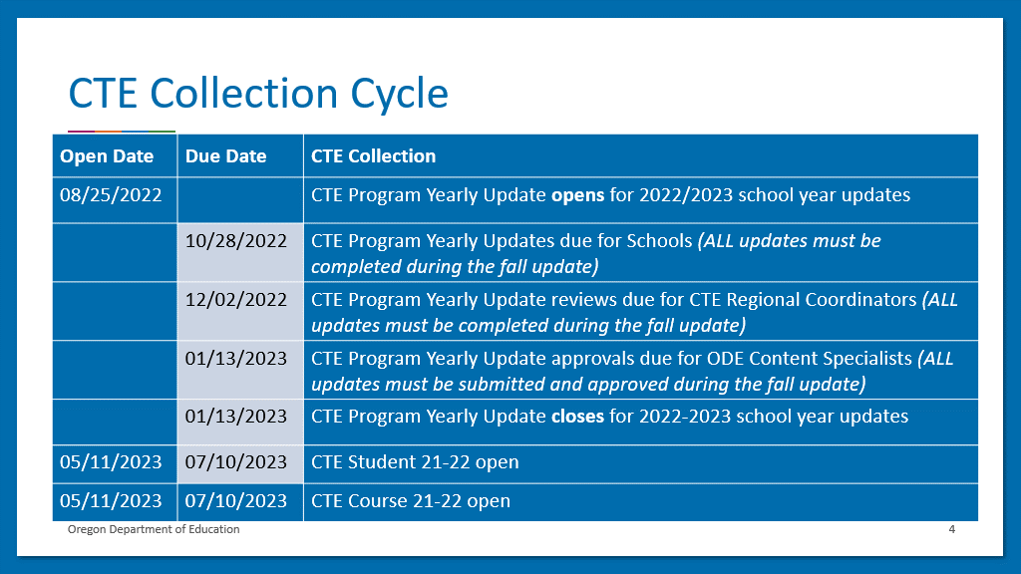
Figure 0-57 Overview of the Program Yearly Update:
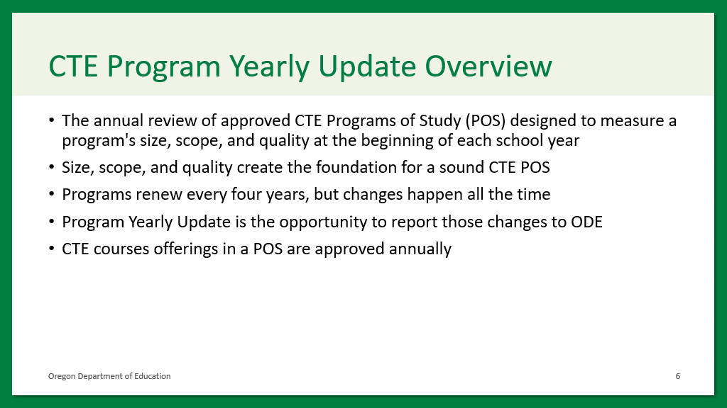
Figure 0—58 Overview of the Program Yearly Update Relation to Data:
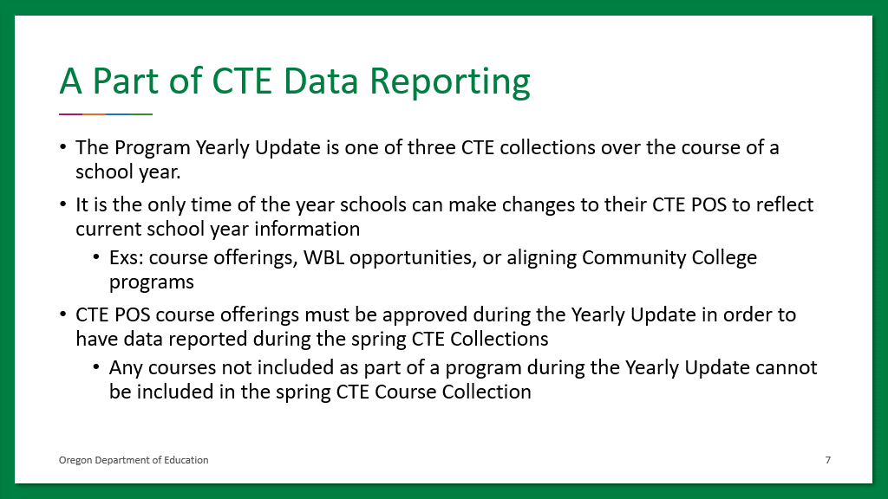
Figure 0—59 Overview of a Successful Program Yearly Update
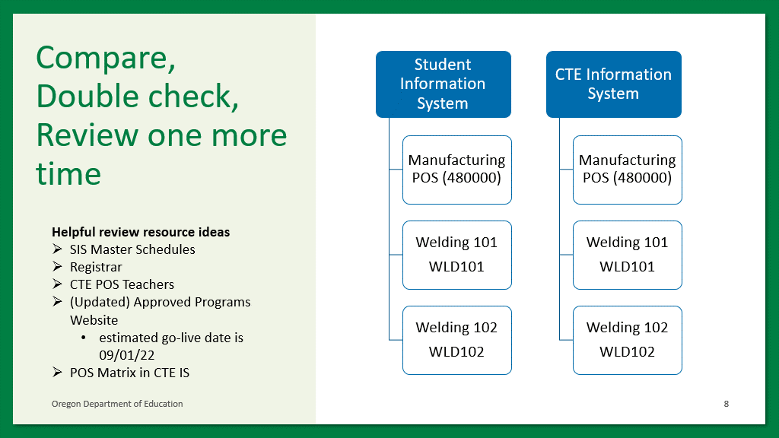
Figure 0—60 Importance of CTE CIP Codes
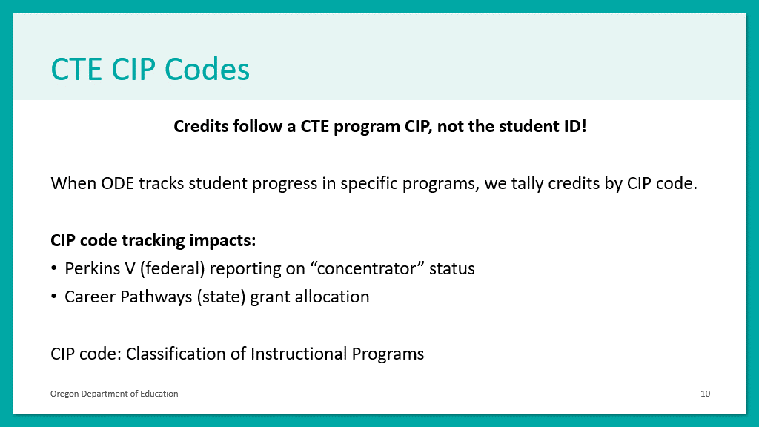
Figure 0—61 Course Number Validation
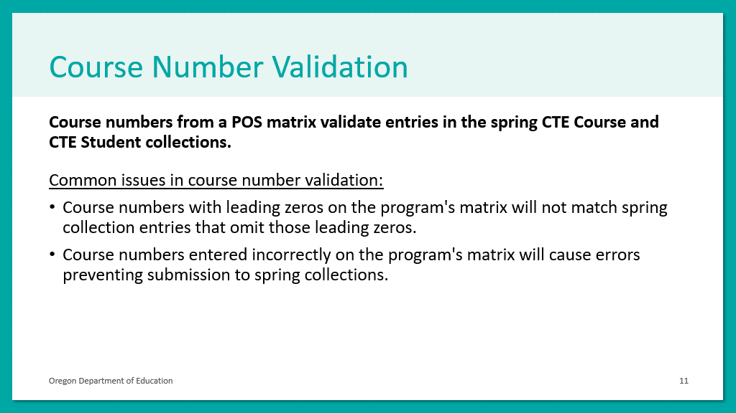
Figure 0-61 Mismatched Information Systems Visual
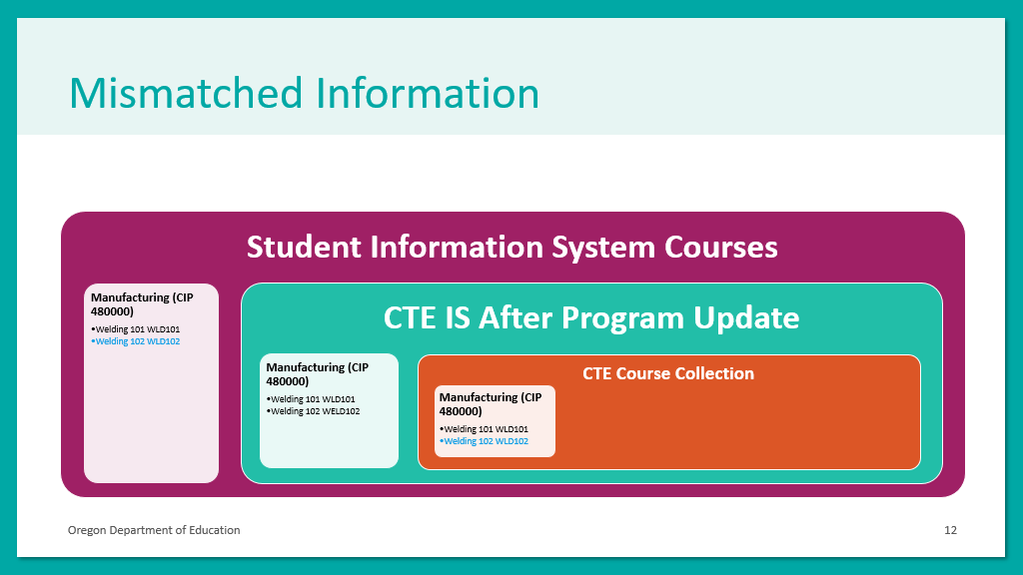
Figure 0–62 Course Numbers for Multi-Term Courses
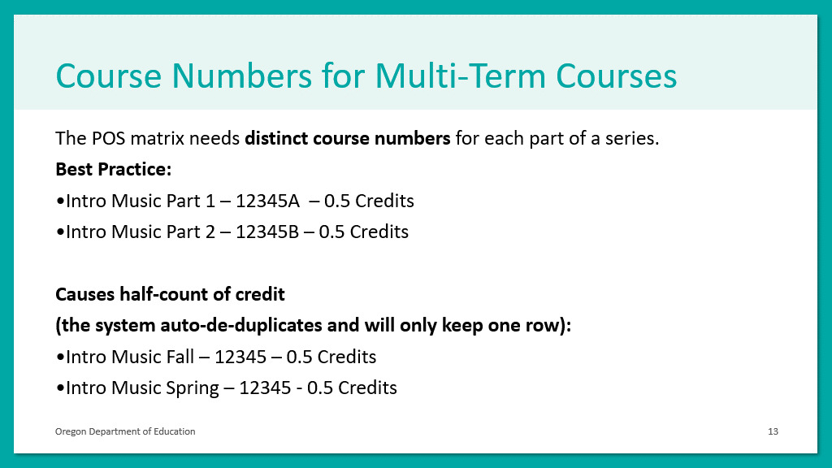
Figure 0-63 Course Numbers for Multi-Term Courses Continued
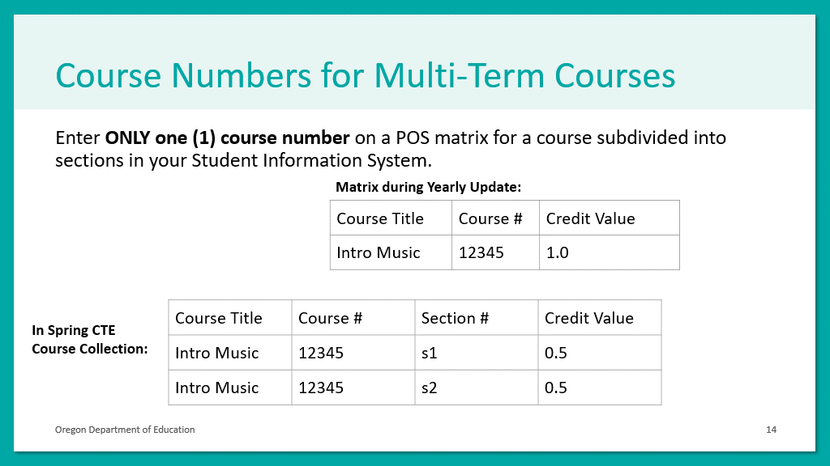

Figure 0–64 Data Entry Reminders
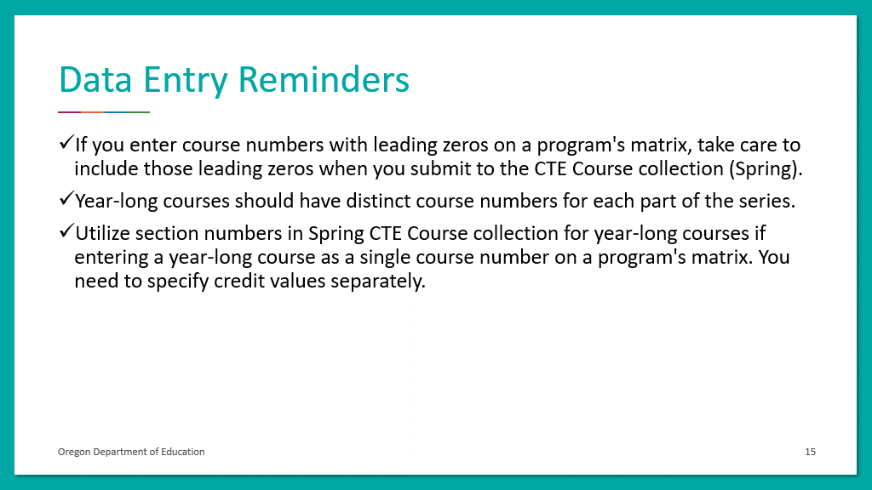
Figure 0-65 Accessing the CTE Information System
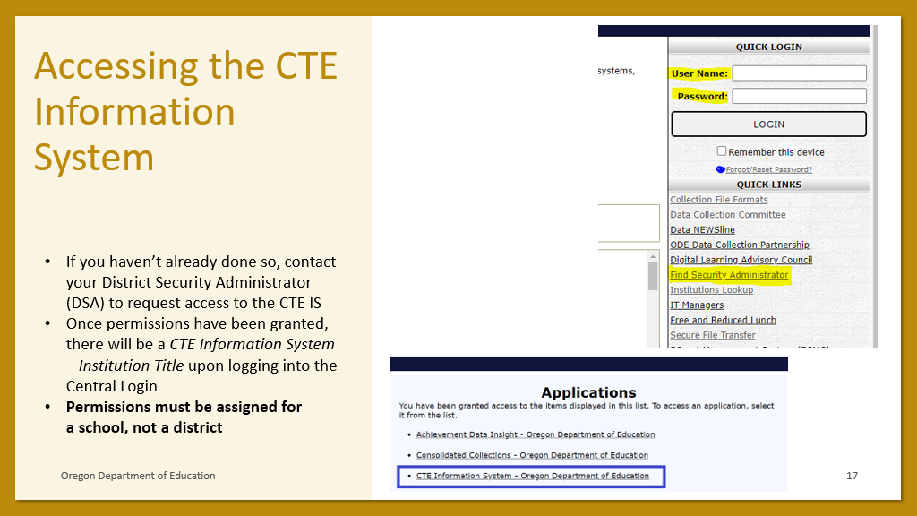

Figure 0-66 CTE Information System Roles
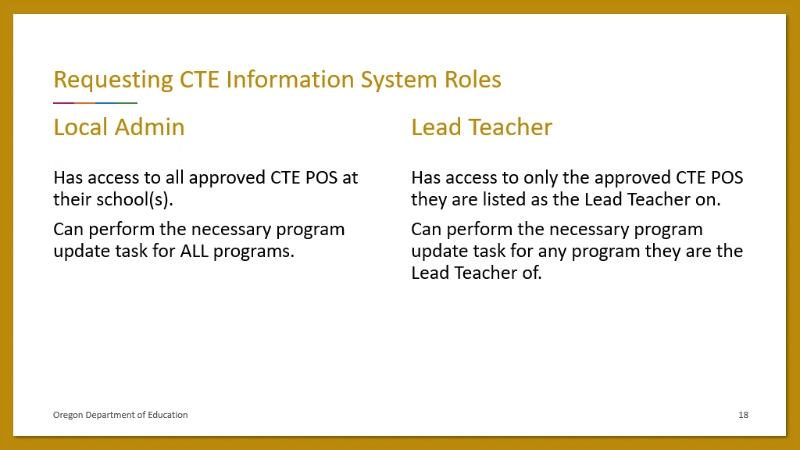
Figure 0-67 CTE Information System Home Page
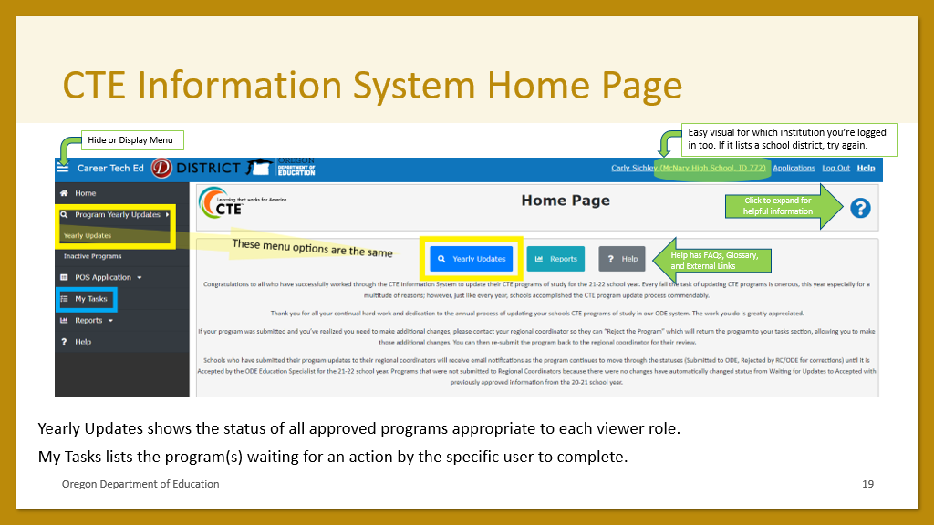
Figure 0-68 My Tasks in the CTE Information System
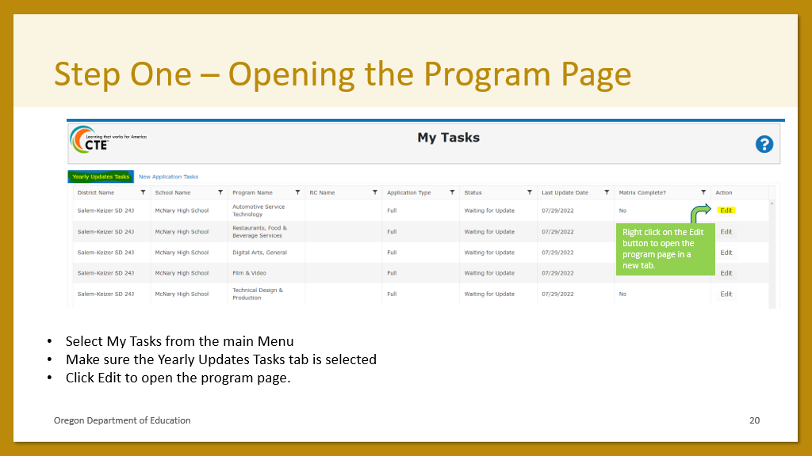
Figure 0-69 Reviewing a Program of Study in the CTE Information System
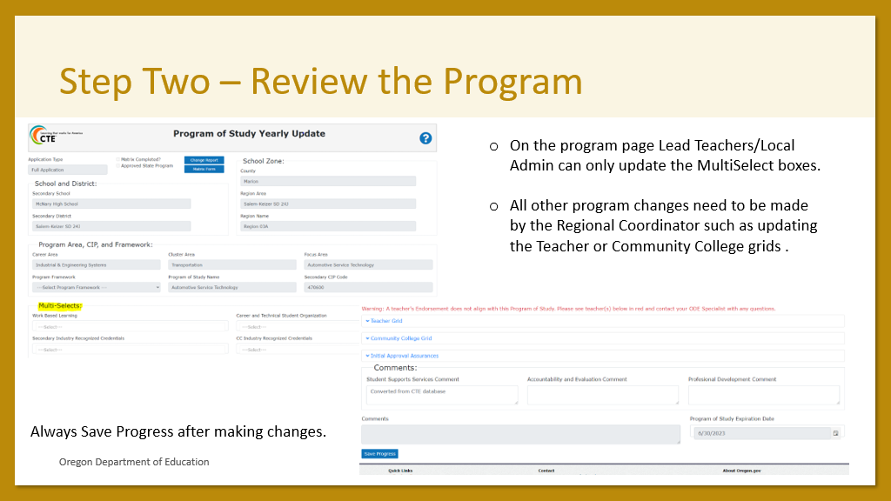
Figure 0-70 Reviewing a Matrix in the CTE Information System
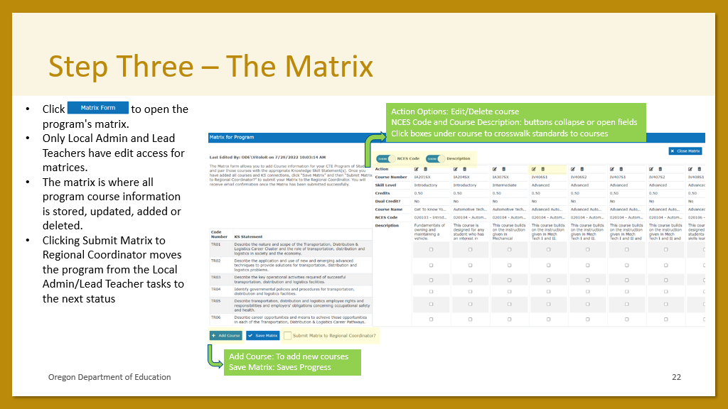
Figure 0-71 Completing the Program Yearly Update
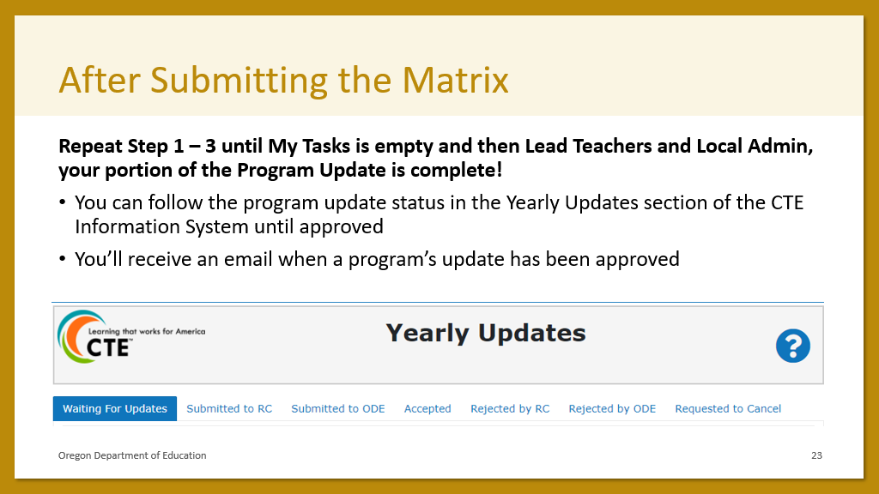
Figure 0-72 CTE Information System Program Change Report
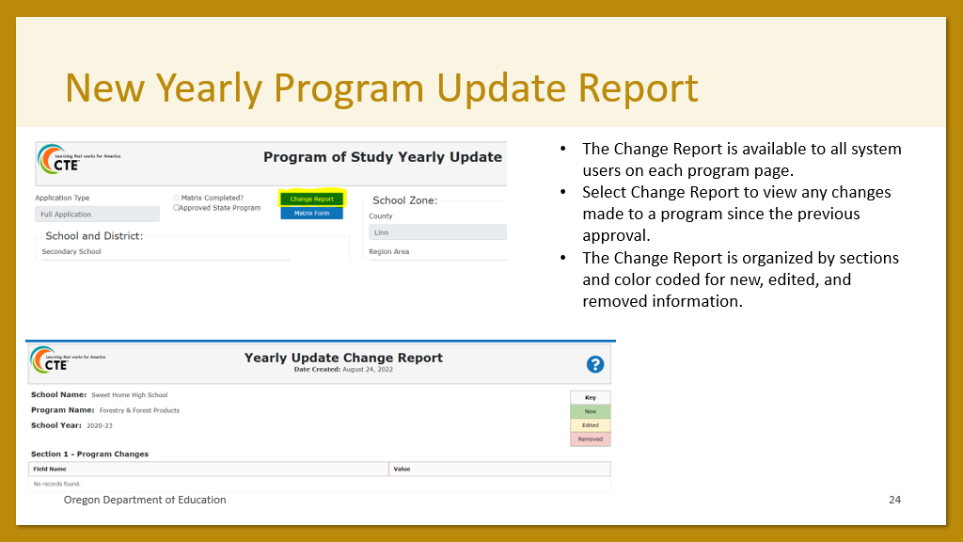
Figure 0-73 CTE Information System Process Improvement
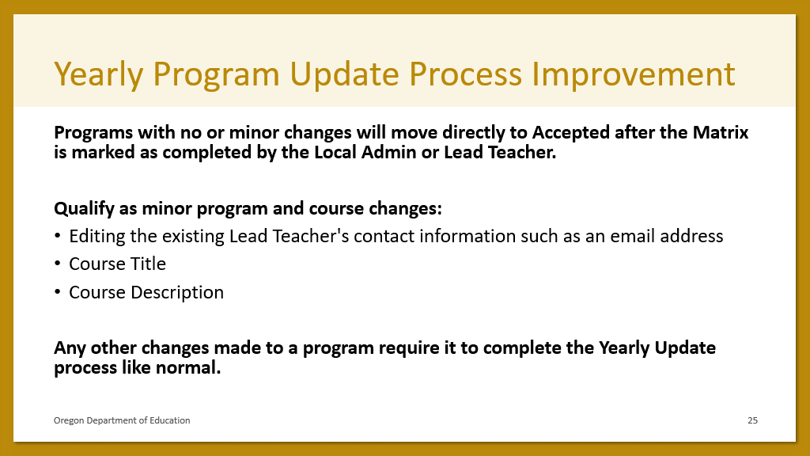
Figure 0-74 Program Yearly Update Best Practices
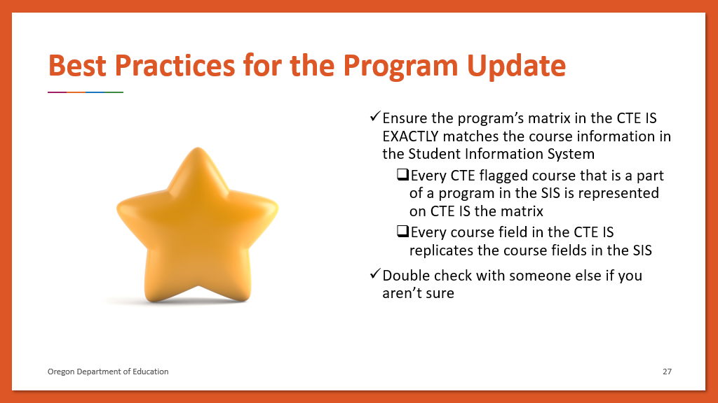

CTE Student and CTE Course
This set of slides is from the CTE Student and CTE Course Collection Training for report year 2022-2023.
Each slide is followed by its speaker notes from the Power Point document, available on the CTE Spring Collections homepage.
A recording from the training series is on the Oregon CTE YouTube channel.
Figure 56 CTE Data Collection Basics, part 1
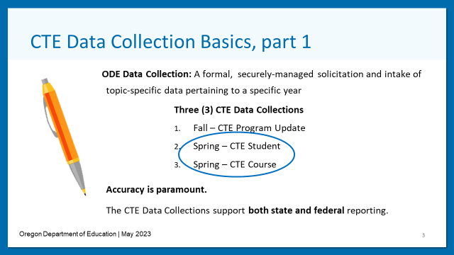
- Accuracy includes completeness.
- Incorrect information can interrupt funding (as in remove funding not just delays).
- State = Secondary Career Pathways.
- Federal = Perkins
Figure 57 CTE Data Collection Basics, part 2
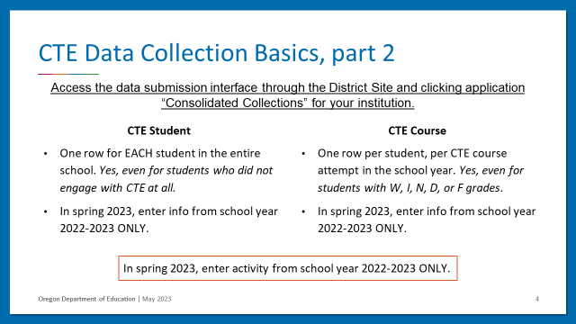
Figure 58 CTE Data Security Alert
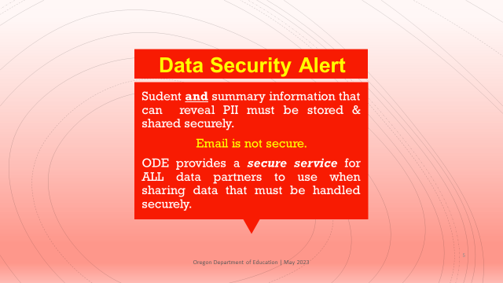
- You may use the ODE Secure File Transfer to send to institution colleagues, not only ODE employees.
- Reach out to your Data Security Administrator (DSA) for details on data privacy and security. Lookup your DSA here.
Figure 59 CTE Data Submitter Resource List
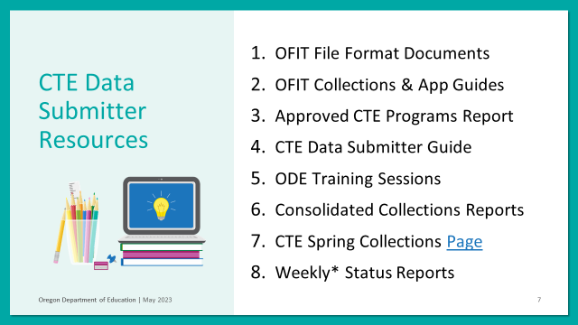
- OFIT stands for Office of Finance and Information Technologies. OFIT is an ODE office and houses the ODE IT department.
- Links / Resources for the CTE Student and CTE Course 22-23 Training Sessions:
- Link to presentation slides is on the CTE Spring Collections page (linked below)
- Link to updated CTE Data Submitter Guide is on the CTE Spring Collections page (linked below)
- Link to File Format Page
  - Link to CTE Student 22-23 File Format Document
  - Link to CTE Course 22-23 File Format Document
- Link to CTE Spring Collections Page
- Link to ODE’s work-based learning webpage
- Link to Approved CTE Programs Detail Page
Figure 60 OFIT File Format Documents
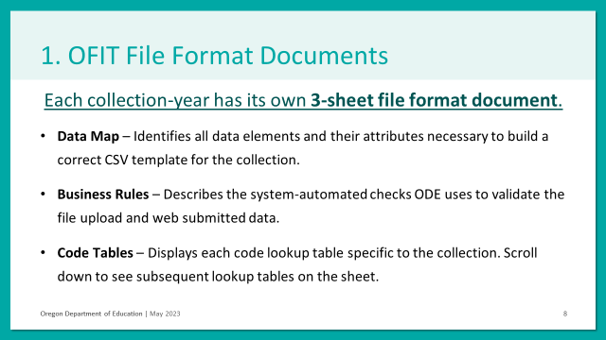
- Data Map:
  - The Data Map identifies all data elements and their attributes for a data collection. Each data collection has its own unique data map.
  - Each row holds a unique data element for a data collection and each column identifies specific information about the data element that assists in building a CSV template, text, or XML file that can be used to successfully upload data to ODE data collections.
  - Fields: Row, Column, Field Name, Data Element Name, Width, Start, End, Data Type, Zero Padded, Required, Data Element Description.
- Business Rules:
  - The business rules are a way to let everyone know what it is that system-automated checks ODE uses to validate the file upload and web submitted data. This sheet helps everyone understand why a given error occurred and how to fix the error.
  - Please be aware that ODE systems cannot identify errors of incomplete submissions or submissions containing inaccurate data that complies to the business rules. Basically, the system can’t tell you about everything that may negatively impact your data submission.
  - Fields: Rule ID, Field Name, Rule Type, Business Rule, Error Summary, Error Detail.
- Code Tables:
  - This sheet contains each code lookup table specific to the collection. The Code Tables are part of the business rules. If the “Table Lookup” is under the Rule Type column of the business rules tab, then the column will have a lookup section for the codes table. The Code Tables will explain what types of codes are allowed for each column when filling out the submission file.
  - Remember to check the Effective Date and End Date columns in these tables to avoid confusion around active/allowable codes.
  - Scroll down to see all the lookup tables on the sheet. The tables are one on top of each other with a blank row separating each table on their top and bottom.
  - Each code lookup table has a table title row followed by a row containing the column headers then the rows containing table data.
  - Code lookup Table Fields: Code, Name, Description, Effective, End.
Figure 61 OFTI Collections & App Guides
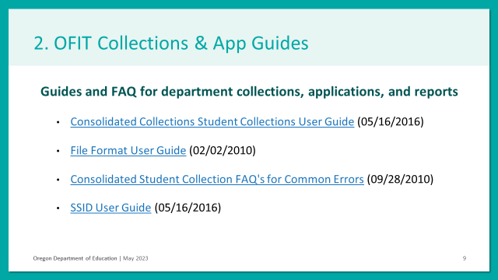
- I know the edition dates (in parentheses) are all more than 5 years ago, but the data are relevant and helpful.
- Guides and FAQ for department collections, applications, and reports
  - Consolidated Collections Student Collections User Guide (05/16/2016)
  - File Format User Guide (02/02/2010)
  - Consolidated Student Collection FAQ's for Common Errors (09/28/2010)
  - SSID User Guide (05/16/2016)
Figure 62 Approved CTE Programs Public Reports
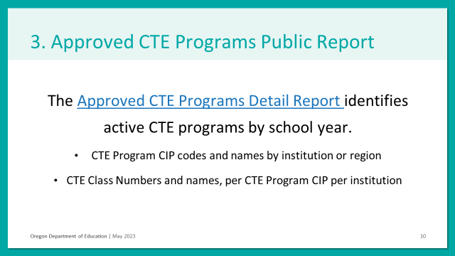
- The Approved CTE Programs Detail Report identifies active CTE programs by school year.
Figure 63 CTE Data Submitter Guide
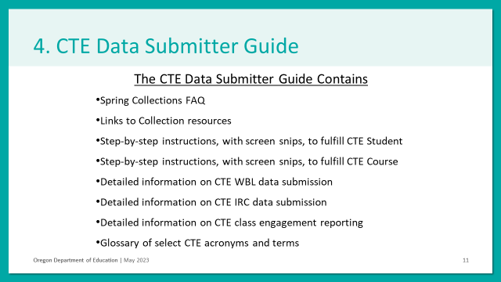
- Find the CTE Data Submitter Guide on the CTE Spring Collections homepage.
Figure 64 ODE Training Sessions
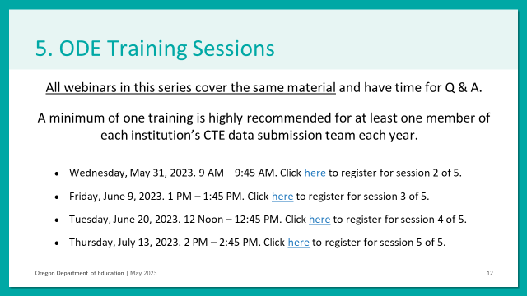
- Find training calendar and slides for the CTE Spring Collections on the collections’ homepage.
Figure 65 Consolidated Collections Reports
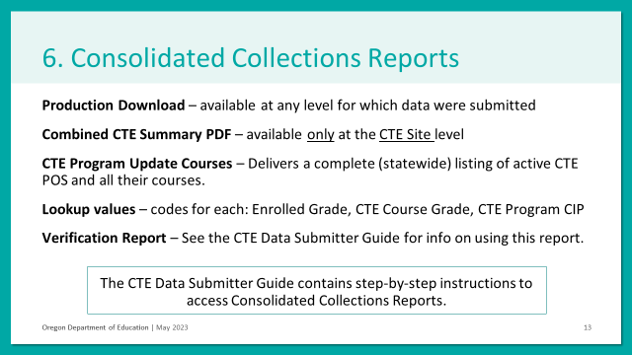
- Find the CTE Data Submitter Guide on the CTE Spring Collections homepage.
Figure 66 CTE Spring Collections Homepage
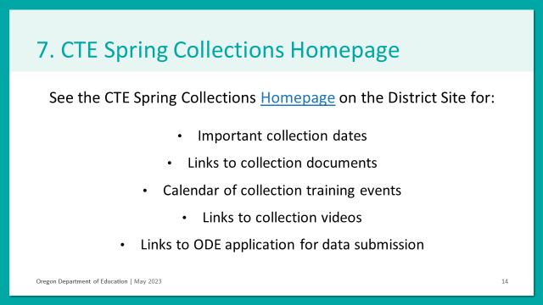
- Find the CTE Spring Collections Homepage here.
Figure 67 Weekly* Status Report
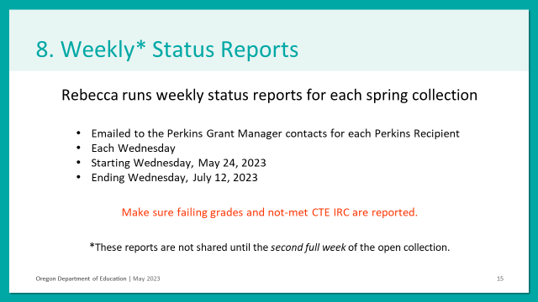
Figure 68 Three Basic Types of Info in CTE Student
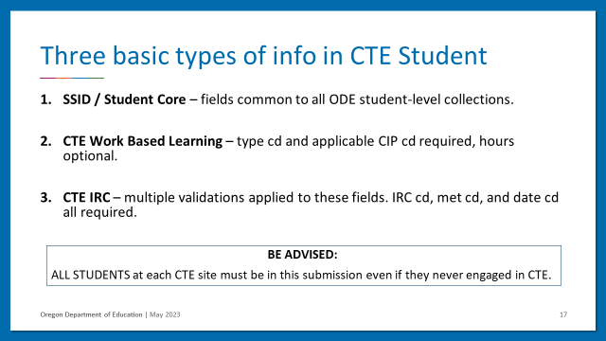
Figure 69 CTE WBL Data in CTE Student, part 1
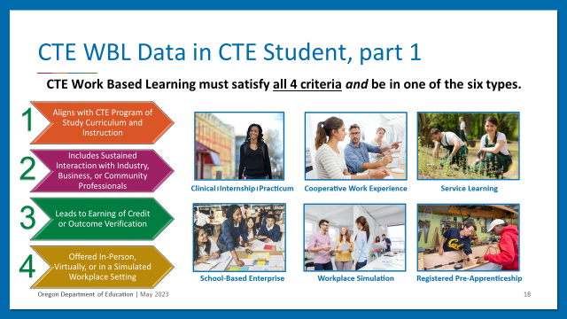
- Not all work-based learning is CTE Work-Based-Learning.
- CTE Work Based Learning must satisfy all 4 criteria and be in one of the six types specified.
- More information is available at the CTE WBL webpage here.
- The 4 Criteria that must ALL be met by the experience:
  - Criteria 1: Aligns with CTE POS curriculum and Instruction.
  - Criteria 2: Includes Sustained Interaction with industry, business, or community professionals outside the student-teacher relationship.
  - Criteria 3: Leads to Earning of Credit or Outcome Verification.
  - Criteria 4: Offered in-person, virtually, or in a simulated workplace setting.
- The 6 Types:
  - Type A: Cooperative Work Experience
  - Type B: Clinical / Practicum / Internship
  - Type C: Pre-Apprenticeship
  - Type F: Service-Learning
  - Type H: School Based Enterprise Experience
  - Type K: Workplace Simulation/Technology-Based Learning
Figure 70 CTE WBL Data in CTE Student, part 2
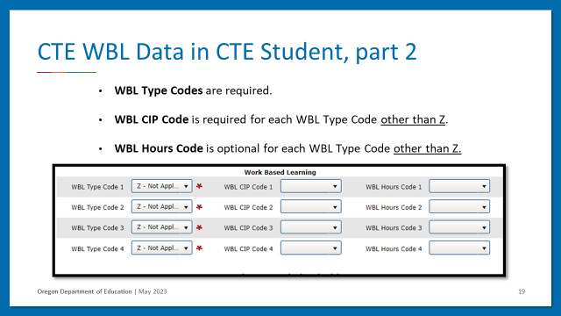
- Not all work-based learning is CTE Work-Based-Learning.
- CTE Work Based Learning must satisfy all 4 criteria and be in one of the six types specified.
- More information is available at the CTE WBL webpage here.
Figure 71 CTE RIC Data in CTE Student
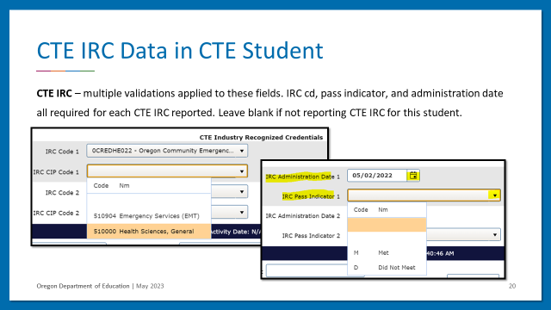
Figure 72 the Three Basic Types of Info in CTE Course
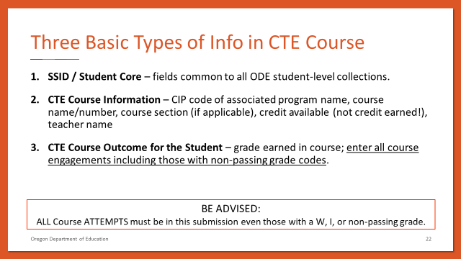
- BE ADVISED: ALL Course ATTEMPTS must be in this submission even those with a W, I, or non-passing grade.
Figure 73 CTE Course Data in CTE Course
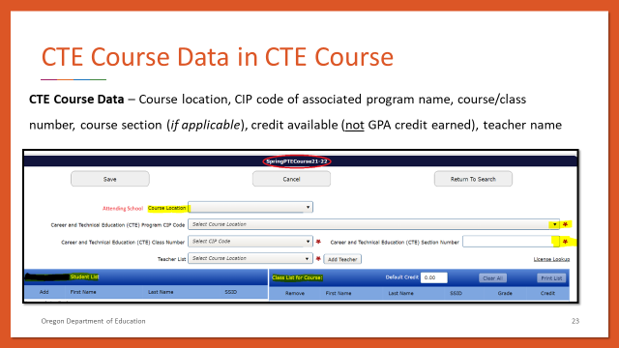
- Do not enter a GPA credit value; enter the course-section’s specific value of credit available.
- An example of one type of data problem that will happen if GPA values are used: C-students will be forced to take twice as many courses as their A-student counterparts to achieve any given CTE Enrollment Status (i.e., CTE Participant; CTE Concentrator)
Figure 74 CTE Course Outcome for the Student in CTE Course
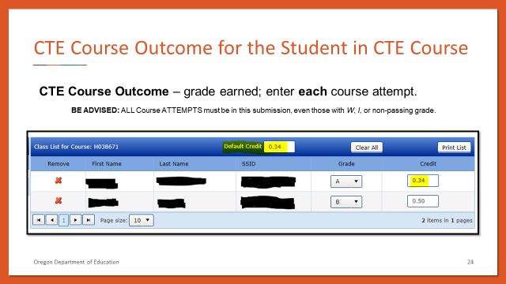
- ALL Course ATTEMPTS must be in this submission, even those with W, I, or non-passing grade.

Glossary

Abbreviations in this Document

- CIP code – Classification of Instructional Programs code
- CTE – Career and Technical Education
- DSA – District Security Administrator (also known as: SA for Security Administrator)
- IS – shorthand for the new CTE Information System
- LA – Local Admin
- LT – Lead Teacher
- POS – Program of Study
- RC – CTE Regional Coordinator
Attending school / district – This term specifies the relationship between a school /district institution and an individual student. A school / district is a student’s attending institution if the student is NOT in that institution’s fall or spring enrollment data but does use the institution for a single class (or select multiple classes). An individual student may have multiple attending institutions.
Approved Programs Webpage – This is a public report developed each school year from the information in the CTE IS. It is not complete/updated until the close of the Program Update for the respective school year.
Collection page – The collection page is a web-page for each spring CTE collection, CTE Student and CTE Course, each year that serves as a clearinghouse for files, training recordings, and other important collection info and resources.
Community College and High School Alignment – A CTE System report accessible to all users at any time of year including all listed alignments between specific secondary CTE Programs of Study and Oregon Community College postsecondary CTE programs. The report can be filtered for individualized results by Community College or High Schools.
Consolidated Collections – This is the application (online interface) used for the two (2) spring CTE data collections. It is accessed through login to the ODE District Site.
CTE IS – This is the CTE Information System aka the CTE System, the application (online interface) used for the fall CTE data collection, the Program Yearly Update.
CTE Site – A CTE Site is any school, learning center, or other institution directly providing secondary CTE programming. Please note that school districts are not CTE Sites in Oregon.
Decision Chart – A CTE System report accessible to all users at any time of year including all the approved programs of study in Oregon. The report can be filtered for individualized results by school year, CTE Regions, individual high schools, and Career Learning Area and can also be downloaded.
District Site – This is the website run by ODE that facilitates access to web applications used to submit to data collections and to view some data reports. It contains both public reports and resources that can be accessed without login as well as institution-specific access (via login) to the applications where data collections occur. AKA ODE District Site. Click here to visit the District Site.
Entry – This is any data entered to the system, whether by File Upload or Web Submission. Entries must pass all system auto-validations without incurring error flags (aka validation errors) before they are counted as “records.”
File Format a.k.a. Consolidated Collection File Layouts – A file format document is a file (CSV/XML files) that shows the structure and types of data that need to be submitted to the collections. Each ODE Consolidated Collections collection has its own file format. The public page of ODE file format documents is here. The File Format User Guide (ODE 2010) is here.
PII – This acronym stands for “personally identifiable information.” All individuals working with student information must be knowledgeable of and comply with ODE privacy policies. Click here for the ODE page linking relevant privacy policies. All education institutions must also follow all applicable federal and state policies.
Programs About to Expire – A CTE IS report accessible to all users at any time of the year that displays all CTE programs, and their respective end dates. The report can be filtered for individualized results by CTE Region and Expiration year and can also be downloaded.
Program Contacts – A CTE IS report accessible to users with Regional Coordinator permissions at any time of the year that displays teacher and local admin listed on program teacher grids and their contact information. The report can be filtered for individualized results by CTE Region, School District, individual high schools, Career Learning Area, and Career Cluster Area and can also be downloaded.
Record(s) – This term only applies to entries that have passed all system validations free of error flags.
Resident school / district – This term specifies the relationship between a school / district institution and an individual student. A school / district is a student’s resident institution if the student IS in that institution’s fall or spring enrollment data even if the student participates in individual courses at other institutions. A student may only have one (1) resident school / district (unless a mid-year transfer occurs then the student may have separate resident schools for the opening and for the closing of the school year).
Secure File Transfer – This is a website by ODE here. It is used to send files that contain personal identifiable information (PII) to ODE staff.
Validation Errors – A validation error shows up during the process when submitted data does not match what is in the system. Validation errors can be viewed under the “Error Management” menu within the option “Review Queue”. Separate validations apply to each collection. Validation errors are not the only types of errors that can occur in data submissions; the validation errors are only available to indicate if a business rule (from the Business Rules tab of the collection’s file format document) has been violated.
Verifying the Submission – This is a four-step process at the end of your collections submission that includes: 1) resolve all error-flagged entries, 2) confirm there are no outstanding House Keeping items, 3) review submission for errors that cannot be identified by collection interfaces nor by ODE (these are errors that require institution-specific knowledge to identify), and 4) confirm submission verification. This process is separate for each the CTE Student and CTE Course collections.

Links & Contact Info
- Search for your DSA
  - If a DSA needs help granting CTE IS app or Consolidated Collections app permissions, they can contact the Helpdesk either by email or on the Helpdesk webpage for assistance.
- District Home - ODE District Site
- CTE Policy Guidebook
- Matrices resources for reference (You do not fill these in.)
  - 2021 Course-to-Standards and Matrices Smartsheet
- Feedback form for the CTE System
- CTE IS video tutorial
- Slides for CTE Student & CTE Course 22-23 here.

For CTE Information System / Program Update / CIP code or CTE course number questions, contact:
- ODE.CTEISHelp@ode.state.or.us or
- Carly Sichley, CTE Program Quality Analyst at Carly.Sichley@ode.oregon.gov
For general CTE Student and CTE Course Questions, contact:
- Rebecca Amodeo, CTE Data Analyst at Rebecca.Amodeo@ode.oregon.gov

These data components represent the majority of errors that slow down the CTE spring data submissions processes as well as the majority of large-scale submission issues such as leaving out potentially large amounts of CTE data the institution intended to report

